Quick Reference Guide to Obtaining Level 2 eAuth Verification with Login.gov
eAuthentication is the online security system that USDA agencies use to grant access to its programs and web applications. Almost all RD systems require users to obtain a Level 2 eAuthentication Account. To access the RD and FSA loan program accounts via the Lender Interactive Network Connection (LINC), you will need a level 2 eAuth account.
New Customer Login Process as of September 11, 2023: The eAuthentication account set up and login processes are transitioning to Login.gov, a sign in service that offers the public easy, secure online-access to participating government programs. With one Login.gov account, a user can complete account verification and sign into multiple government agency resources. A new eAuth login page was introduced on Monday, September 11, 2023, providing Login.gov as an option for login. All new customer accounts will be created with Login.gov, and the full transition to Login.gov (Phase 3) will require all public customers to use Login.gov to access USDA eAuth protected applications. Existing eAuth account holders are highly encouraged to transition to Login.gov and link their accounts to eAuth.

Account Registration: Visit https://usdalinc.sc.egov.usda.gov/
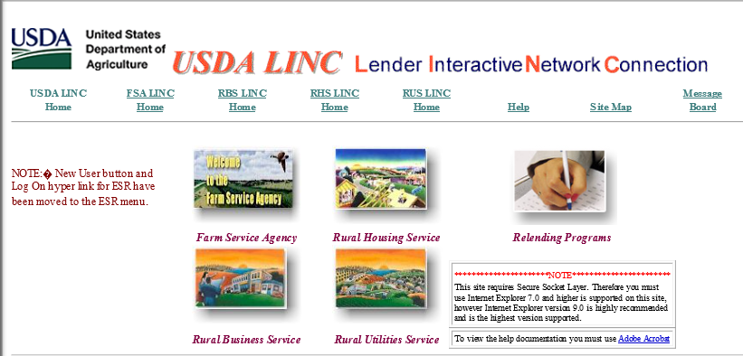
Click on the applicable program LINC Home link.
These instructions use FSA LINC Home. For Rural Business/ Cooperative Service applications, click on RBS LINC Home. Multi-Family Housing and Community Facilities application links can be found under RHS LINC Home. Water & Waste applications are under RUS LINC Home.

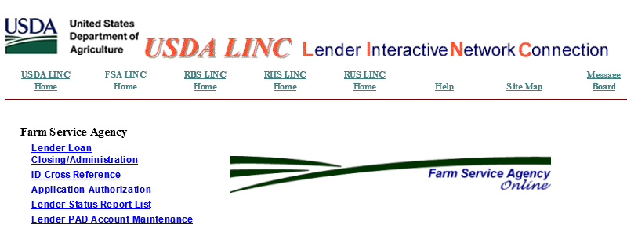
Click on the application you wish to access. (Lender Status Report List; Lender Loan Closing/Administration; ID Cross Reference; or Lender PAD Account Maintenance)

Account Registration: Creating a new account with Login.gov.
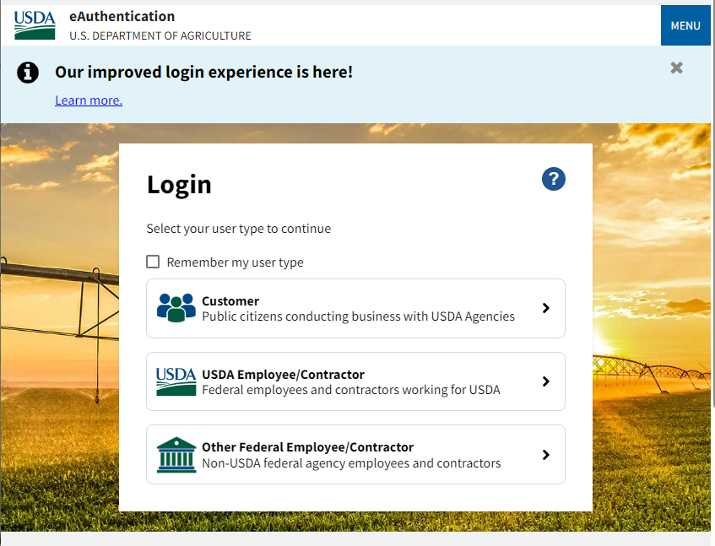
Click Customer

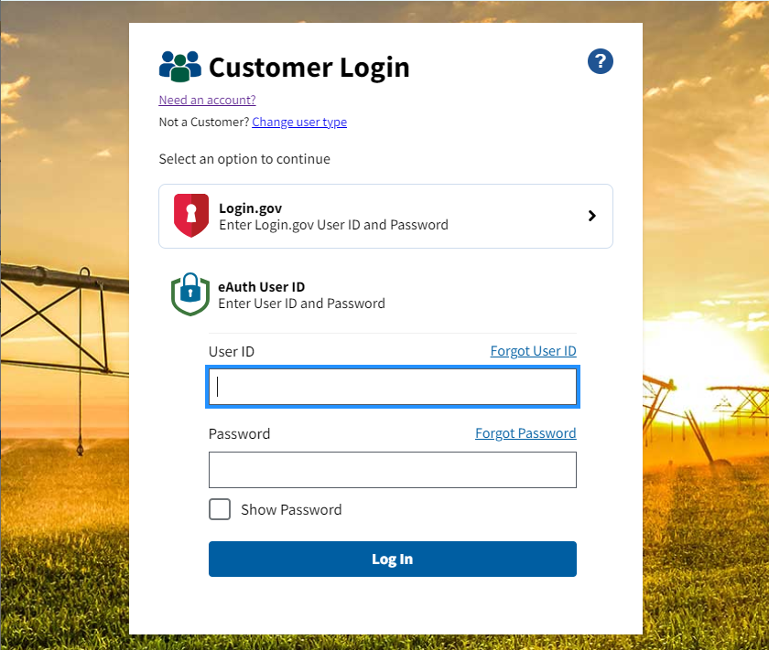
Click Need an Account?

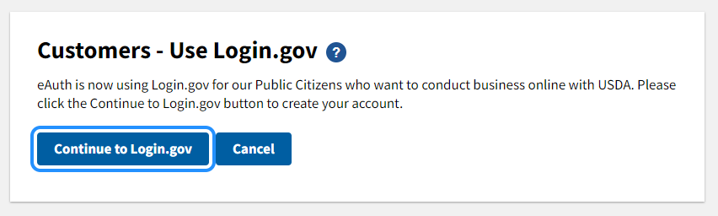
Click Continue to Login.gov

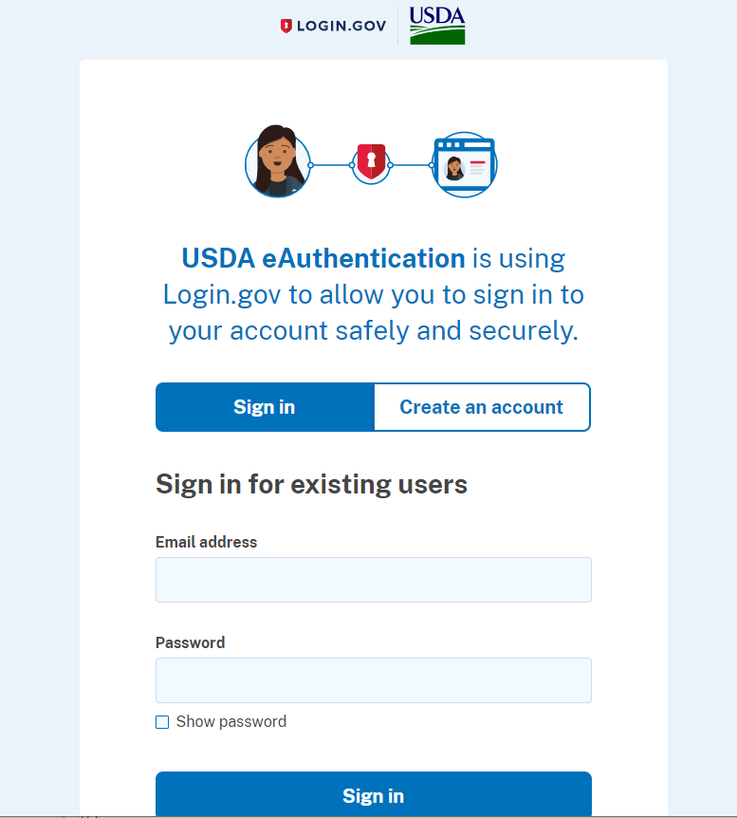
Click Create an account.

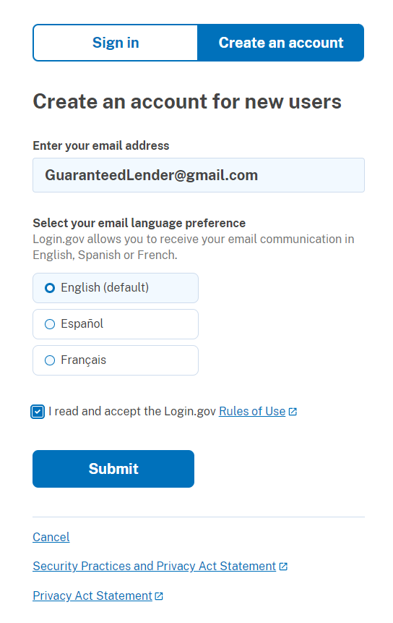
Click Submit
Check box to accept the Rules of Use
Enter your Email Address

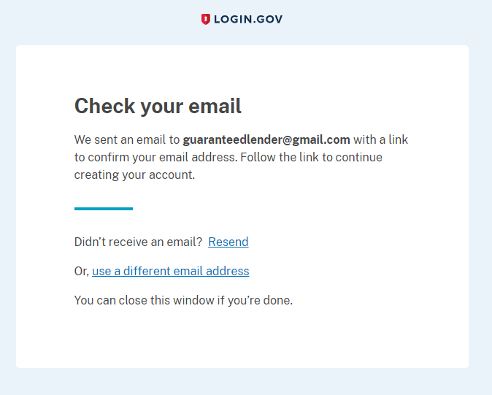
An email from Login.gov will be sent containing a link to continue creating your account.

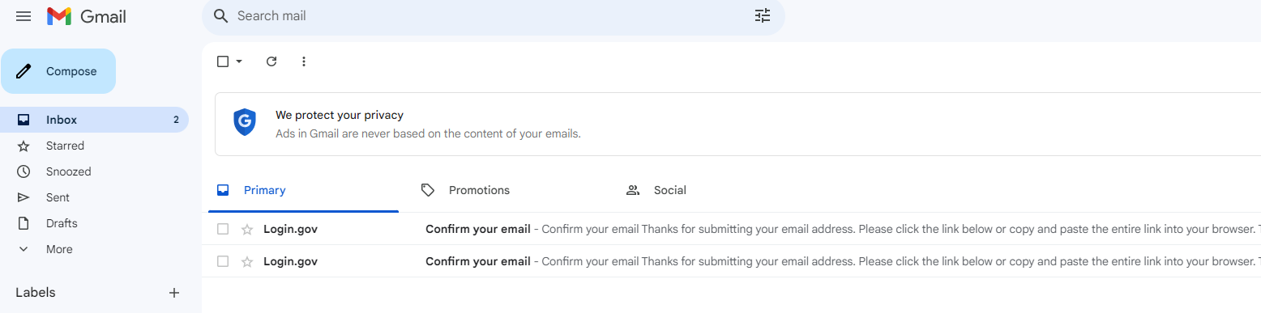

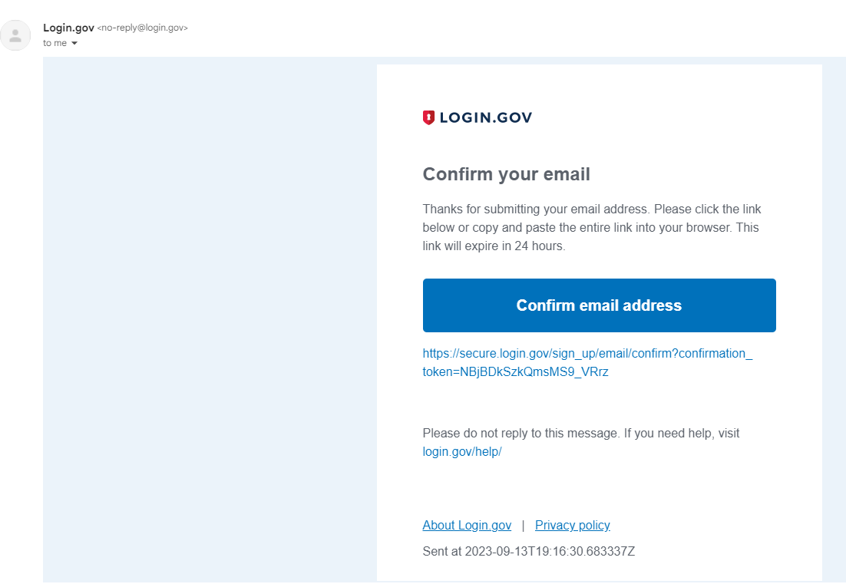
Click Confirm email address to continue.
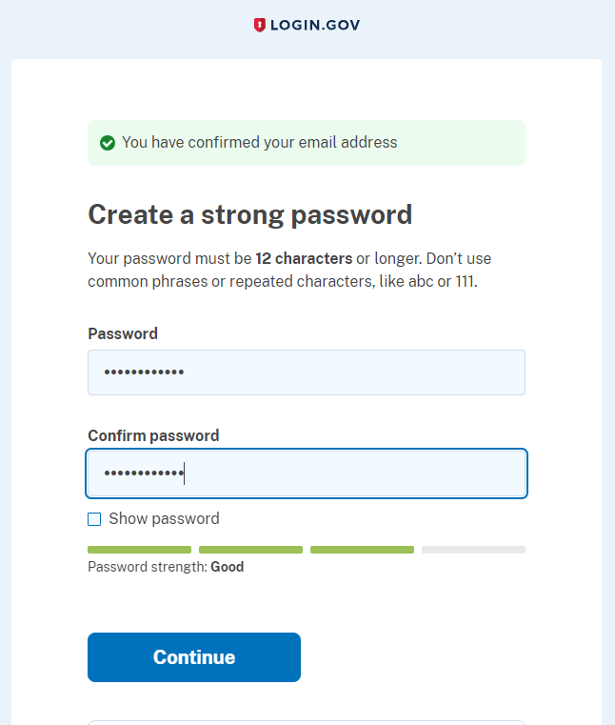
Create a Password and click Continue.

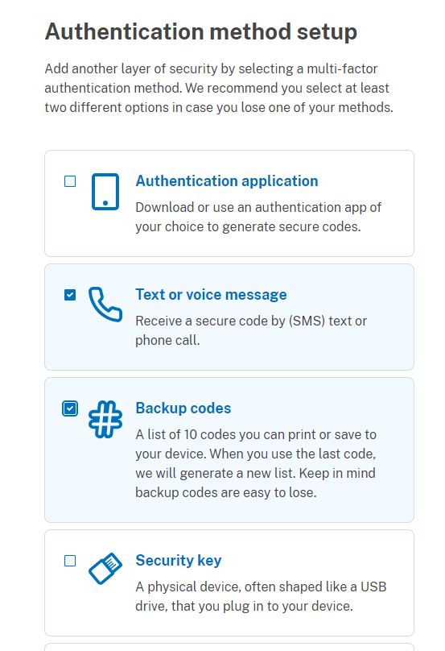
Select your preferred multi-factor authentication methods, then click Continue.
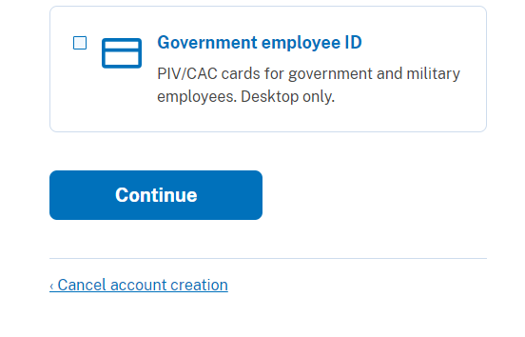
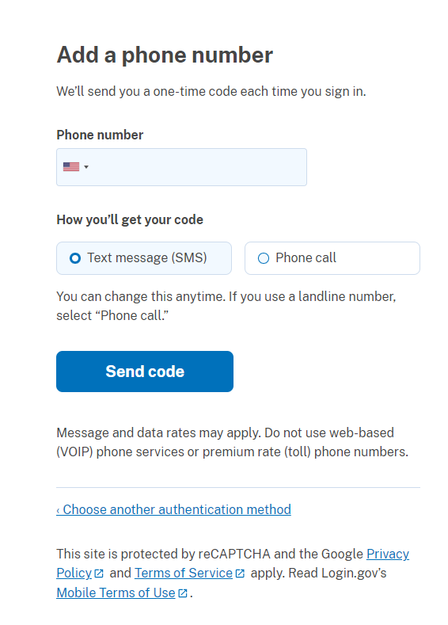
Click Send Code
Enter your Phone number and select how you would like to receive the code.
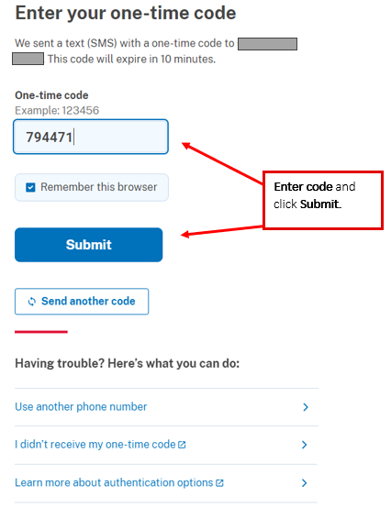

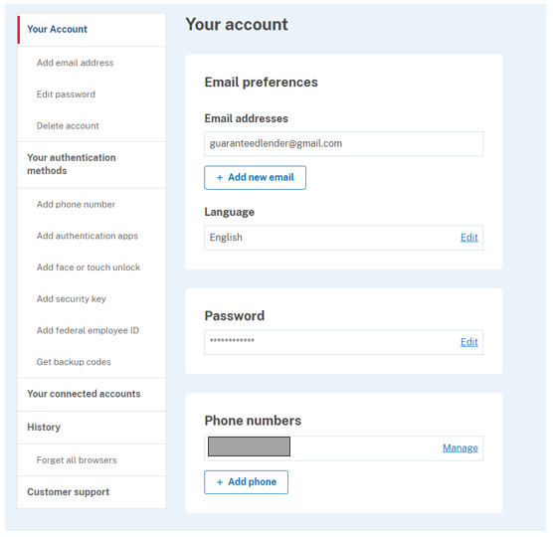
Account Registration Complete! Your account page will be displayed.
If any account updates are needed, they can be managed from this page.
For RD and FSA Applications, Identity Verification must be completed.
Return to the main sign in page at eAuthentication (usda.gov) to continue with Identity Verification.
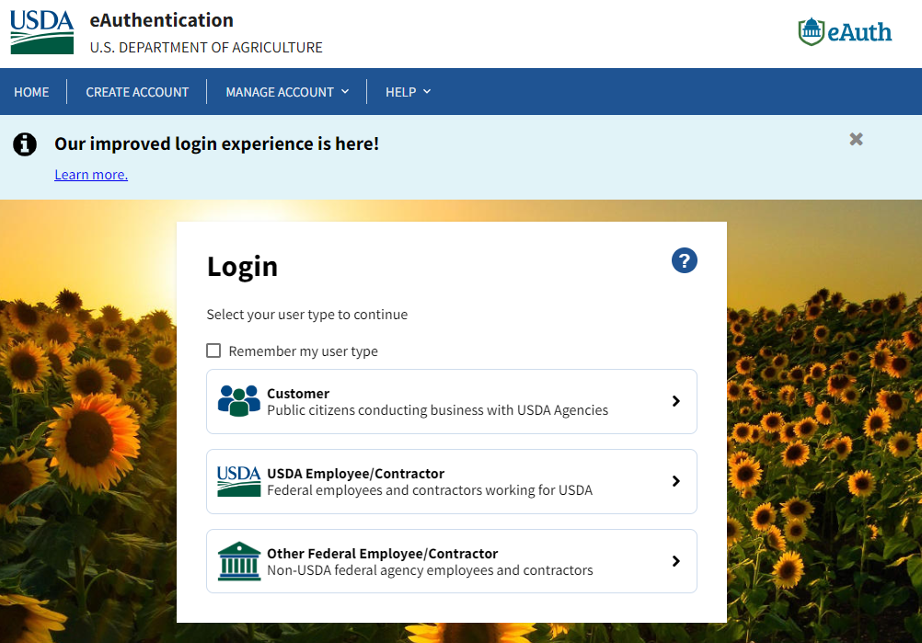
Click Customer
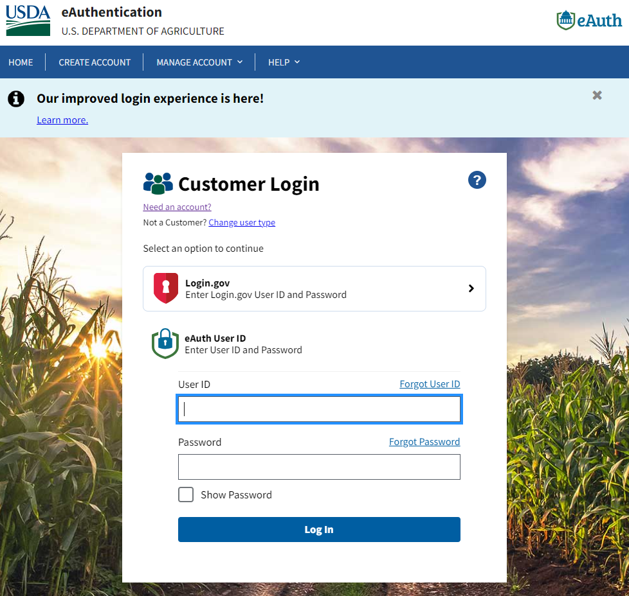
Click Login.gov

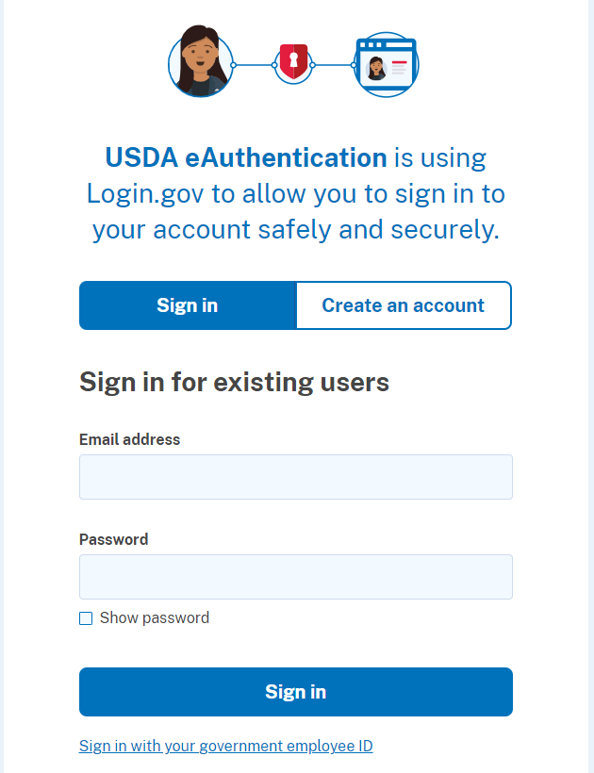
Click Sign In
Enter your Login.gov Email address and Password.

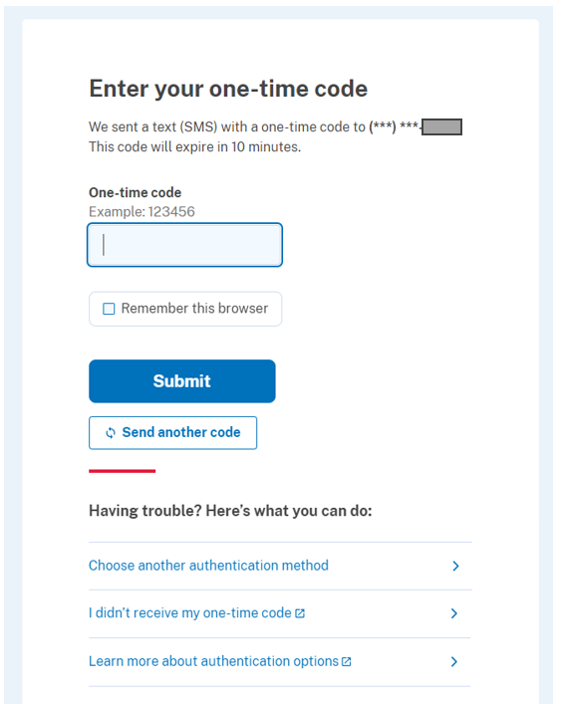
Enter One-time code and click Submit.
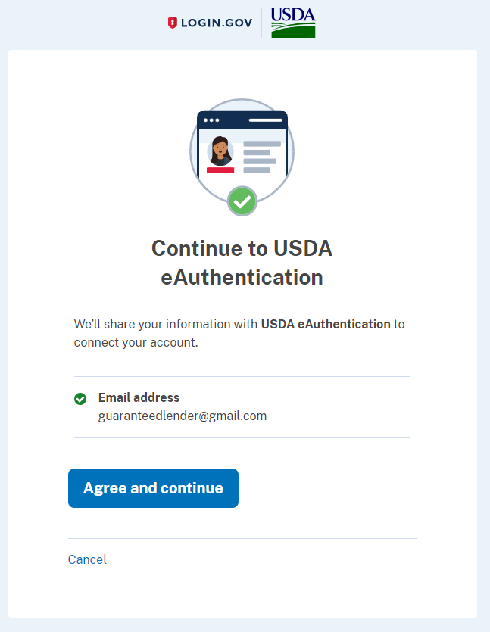
Click Agree and continue.

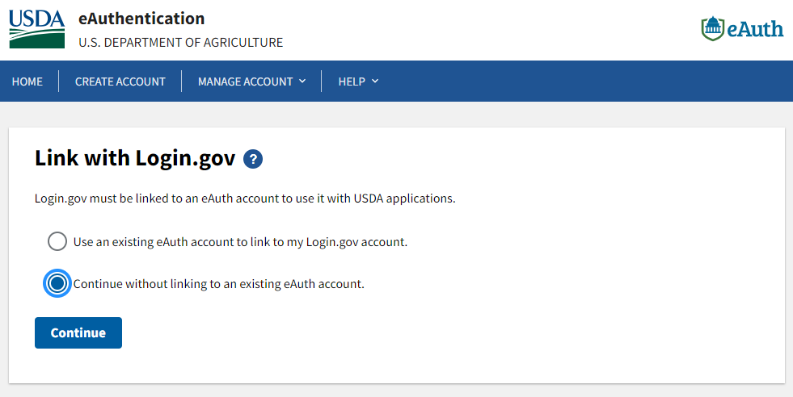

If you have an existing eAuth account, you can select the radio button to link your existing
eAuth account to your new Login.gov account.

To continue without linking to an existing eAuth account select the 2nd radio button, then click continue.

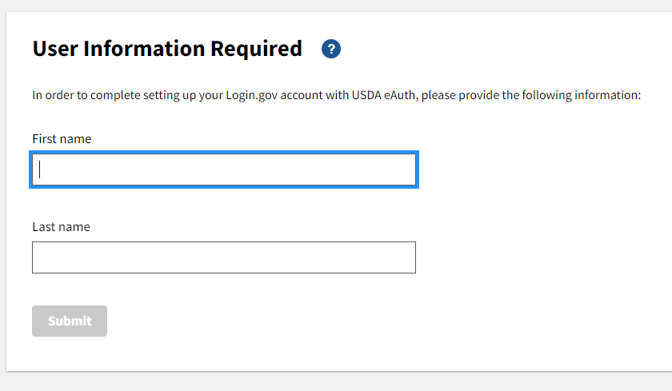
Enter your First and Last name. Then click Submit.
Identity Verification Options
There are two options a customer can use to verify their identity:
- The “Verify my identity with Login.gov” is a self-service option for accounts created with Login.gov. It guides the customer through a process where they use a phone or laptop to upload the front and back images of a State issued photo ID and enter their SSN, personal information and primary phone number. Upon successful identity verification they are issued a Login.gov personal key for account recovery used in the event the customer forgets their password on the verified identity account. If the user fails the online process, they can use the Login.gov US Postal Service in-person option or visit a USDA LRA.
- The “Visit USDA Service Center” option can be used for both Login.gov accounts and existing eAuth accounts. Selecting this option will direct the user back to the account profile where prompted to add the required information for identity verification. This includes their DOB, confirm their name, add a home address and home phone number. User will be taken to the USDA Service Center locator website to find the nearest LRA at a Service Center office. The customer will need to call the office to make an appointment with the LRA to ensure they are available when they visit.

Note: The updates to their eAuth account profile do NOT sync automatically with EIMS. Therefore, it can take up to 2 hours before for the updates will display in EIMS for the LRA to view so they can verify the identity.

Note: For customers outside of the United States who need assistance with in-person identity verification, USDA-LRAs are sometimes located at a US Consulate or US Embassy. These LRAs must be on a USDA Network to access EIMS and use a PIV credintial to log in.

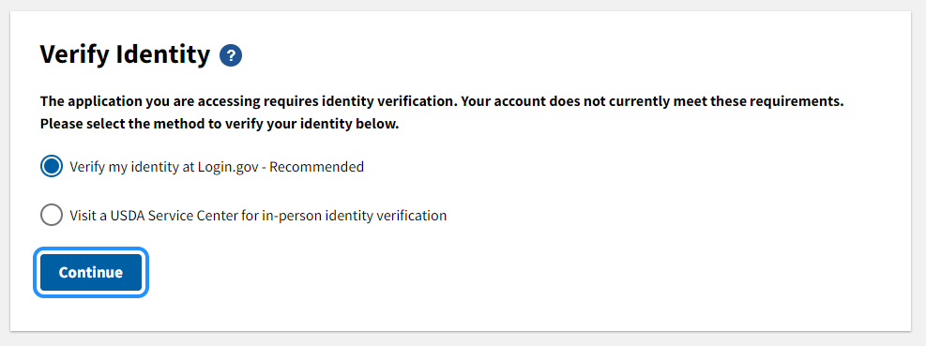
Select the Verify my identity at Login.gov radio button, then click Continue.

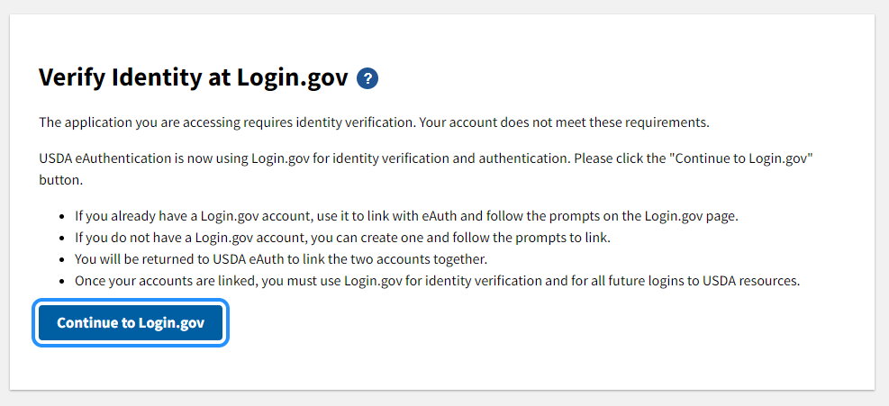
Click Continue to Login.gov
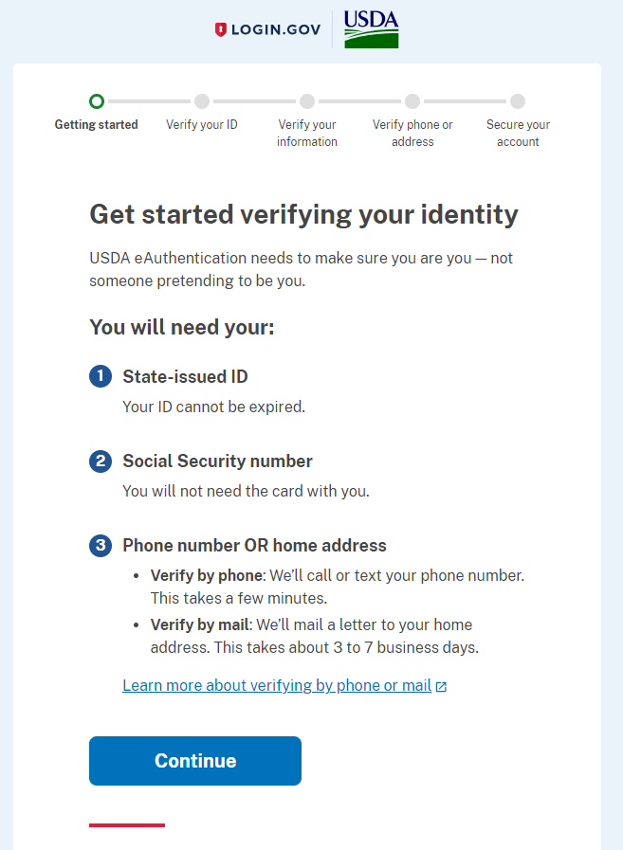
Click Continue
Items you will need to verify your Identity through Login.gov include:
- State-issued ID
- Social Security Number
- Phone Number or Home Address
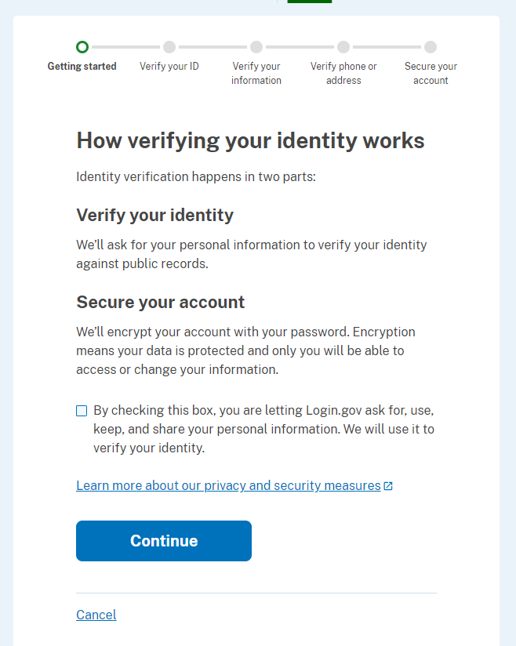
Check box to allow Login.gov to use your information to verify your identity.
Click Continue
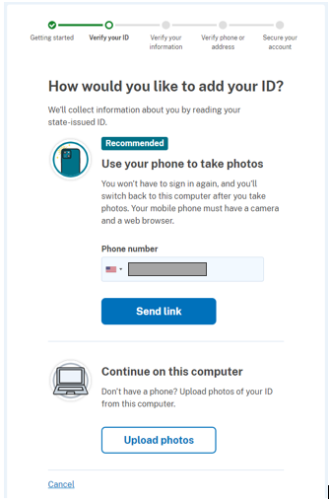
2 options are available to add your ID:
- Take a photo with your phone.
- Upload the photo from your computer.
To take photos with your phone enter your phone number and click Send Link.
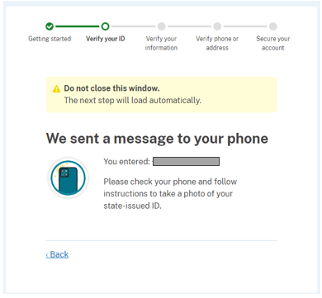

Check your phone for the message and follow the instructions to take a photo of your state-issued ID.
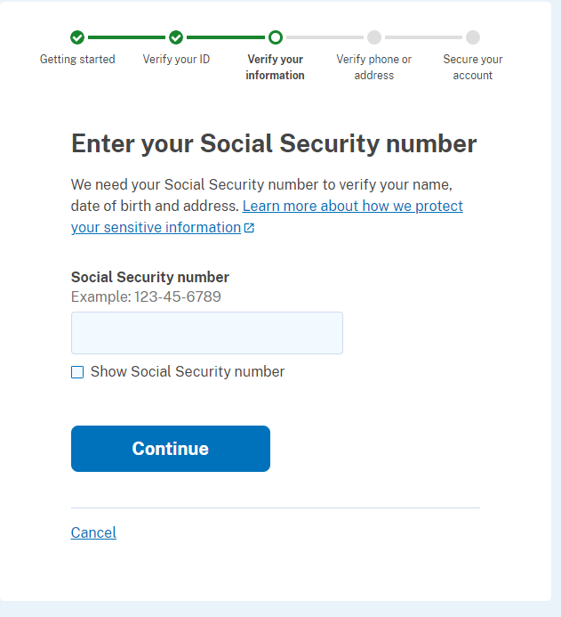
Input your Social Security number, then Click Continue
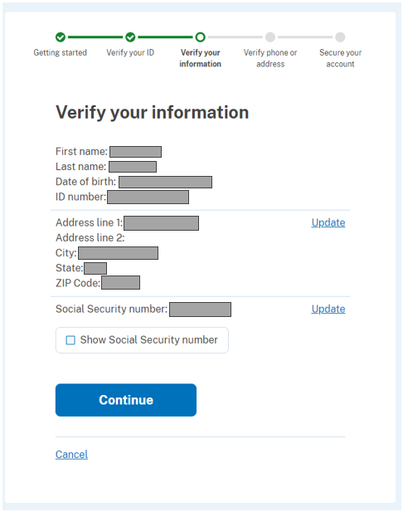

Verify that your information is correct, then click Continue.
Input your one-time code, click Submit.
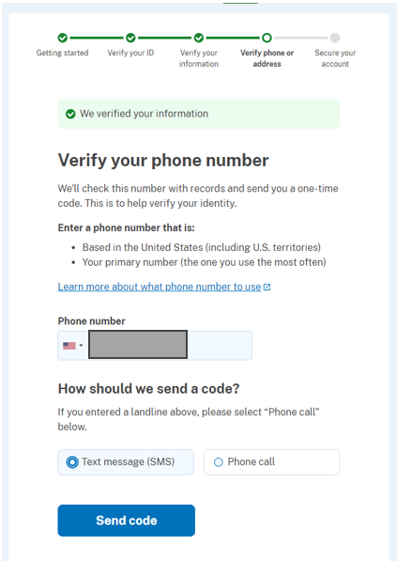
Enter your phone number, click Send Code.
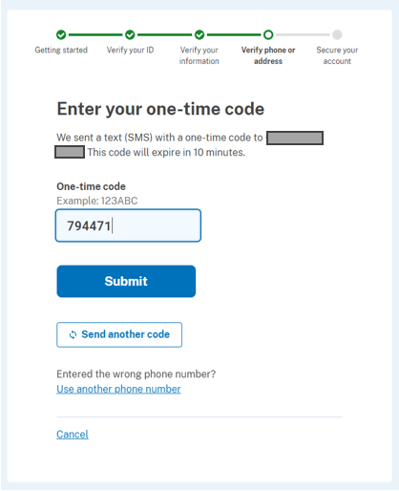
Enter your one-time code, click Submit.

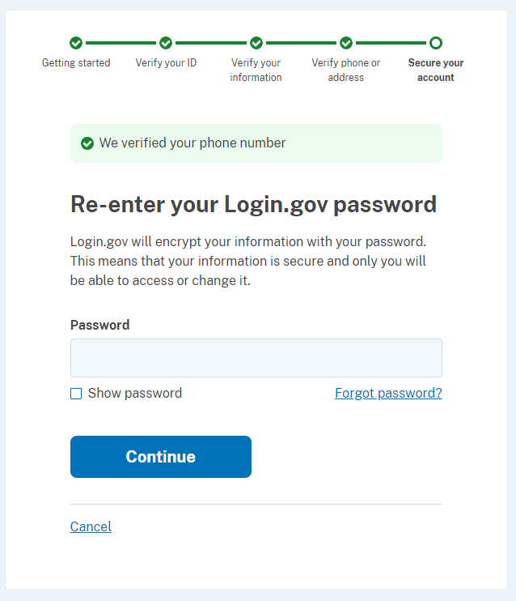
Enter your login.gov password, then click Continue.

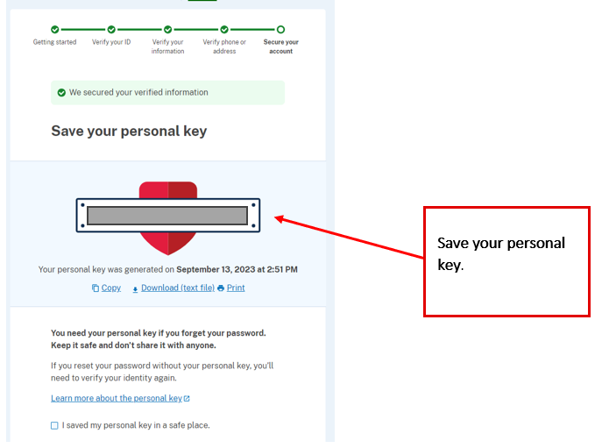

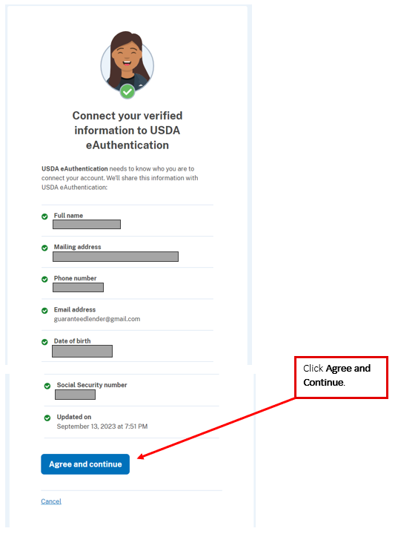
Congratulations! Online Identity Verification Complete!
Continue for further instructions on gaining access to the Lender Interactive Network Connection (LINC). See the instructions for the appropriate loan program listed on the next page.
Please follow additional steps to gain access to the Lender Interactive Network Connection (LINC).
Instructions are listed by USDA program.
Close the browser window.
Congratulations! You have successfully verified your Login.gov account. To access the various Guaranteed Loan Program applications, there are additional steps required. Please read and follow the instructions below:

For Single Family Housing Security Administrator Access
Please refer to the System Access and Security Guide at SFHGLP System Access and Security Guide-Sept23 (usda.gov).

For all other RD Security Administrator Access
Contact your local USDA office to request access for your organization. You may be required to complete an Agreement for Electronic Transactions to get set up as a Lender Security Administrator for applicable Rural Business, Rural Housing, and/or Rural Utilities applications.

For FSA Security Administrator Access
Contact your local FSA office to request access for your organization. Provide your e-Authentication or Login.gov ID to get set up as a Lender Security Administrator for Farm Service Agency applications. Additional information on the Guarantee Farm Loan Program can be found at Guaranteed Loans - Lender Toolkit (usda.gov).

For non-Administrator Access (RD and FSA)
Contact the Lender Security Administrator in your organization and have them establish your authorization for the applicable application.

For Intermediary Re-Lender Access
If you are an Intermediary Re-lender, contact the Rural Development Help Desk for Assistance.

For All Users
If you do not know your Security Administrator, you may contact your local FSA or USDA office for assistance.
Helpful Tips
- ***All existing eAuth account holders are highly encouraged to transition to Login.gov and link their accounts to eAuth.***
To use your Login.gov account with USDA, it must go through a one-time process to link with eAuth. Once it is linked, you can use it to access USDA protected resources. NOTE: Linking to an existing eAuth account will help to retain your relationship with applications you have accessed.
  - Click the Login.gov login option.
  - You will be taken to the Login.gov website, where you will log in with your existing Login.gov account or create a new Login.gov account.
- After logging in or creating the new account, you will be returned to eAuth to link your Login.gov account to eAuth.

The linking process will vary depending on:
    - If the email address on the Login.gov account is using the same email address as an eAuth account, you will link automatically. You are informed the Login.gov account must be used for ALL future logins with USDA, and asked if you want to continue with the link to Login.gov by selecting Yes. You will be taken to the website or application.
    - If you don’t have an eAuth account in the system with the same email address as the Login.gov account, eAuth will ask if you want to use an existing eAuth account to link with Login.gov or continue without linking to an existing eAuth account?
    - If you have multiple eAuth accounts in the system matching the Login.gov email address, you will be notified multiple accounts were found. You will need to select the User ID from the list for the eAuth account you want to link with Login.gov. You will be prompted to log in with the selected User ID and password for the eAuth account to allow the link to continue.

- For all user accounts created after June 24, 2020: Each email address can be associated to only one eAuth account. The email address used at account creation will be used to recover forgotten passwords. Users with current level 2 authority will not be affected by these changes.
- Account Profile Information:
  - Name and date of birth may be updated if the account has not gone through the identity verification process. However, once your identity has been verified, you may not update your personal information.
- If your email address has changed or your account was created before June 24, 2020, then you may be able to update your name by creating a new account. Anytime a user creates a new account, the user must make sure their existing account is not tied to their current email address before creating a new account. (If a new account is created, and the email address matches the address of another account, then eAuth sign in process will not work.) To change an email address, the user must visit https://www.eauth.usda.gov/home/ and click on Manage Account. Users with a Login.gov account must add or delete an email address under Email preferences. Users without a linked Login.gov account can change their email address by clicking on the edit icon next to the account email address as shown below.
Login.gov Email Maintenance
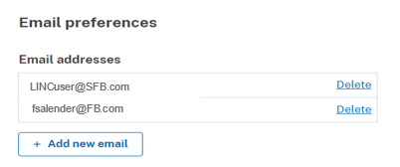

eAuthentication Email Maintenance
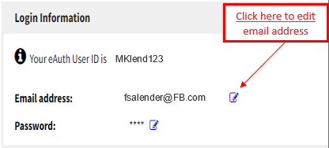
Note: New accounts must be reassociated to the lender ID in AASM.
  - Home address can be updated if the information was entered into the account profile.
  - Contact information (phone & fax numbers) can be updated if the information was entered into your account profile.

- To prevent inactivation of the eAuth account, the user should sign on quarterly at eAuthentication (usda.gov). If your account has been disabled due to inactivity. Your account may be enabled using a password reset via email. A link will be provided to reset your password. If your account has been disabled for other reasons and cannot be enabled by a password reset, you will be instructed to contact the eAuthentication Help Desk, 1-800-457-3642; Option 1.

The links listed below provide additional information and assistance with Login.gov:
eAuthentication (usda.gov)
What is Login.gov? | Login.gov

