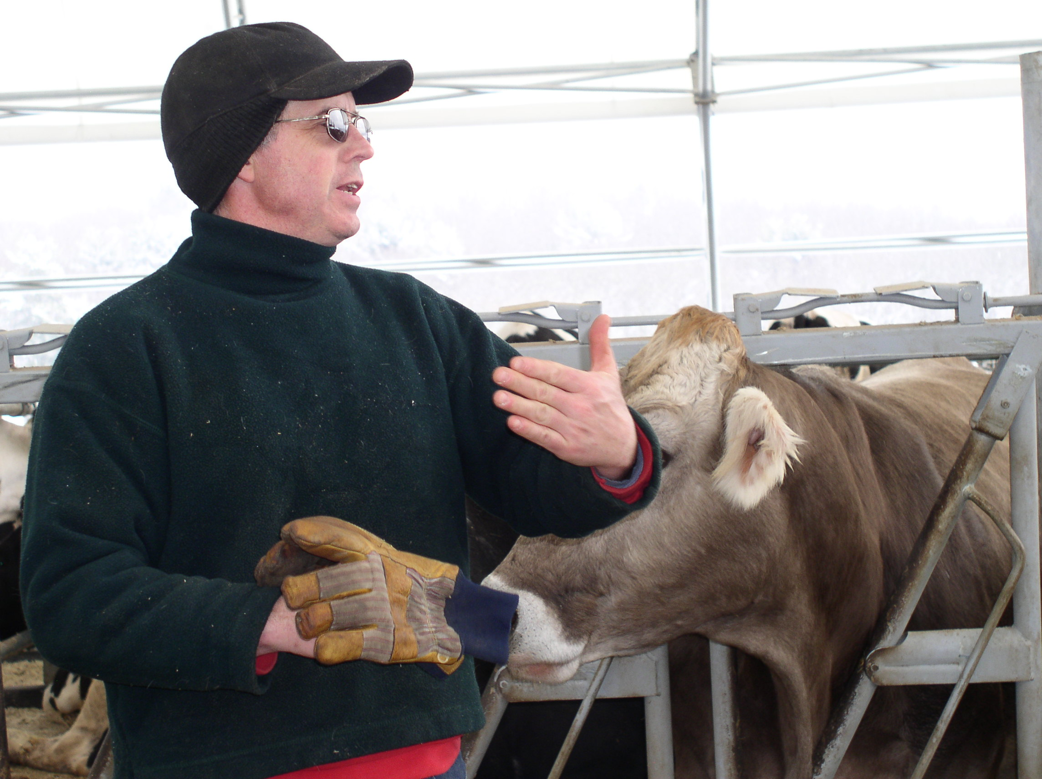
A Newsletter For People Who Care About Agriculture
FSA
Words of Windham
P.O. Box 399 ◊ Brooklyn, CT 06234 ◊ 860-774-8397 x 1 ◊ FAX: 860-779-0148
OFFICE STAFF: Dawn S. Pindell, County Executive Director –x 109  Diane C. Holowaty, Program Technician – x 111 
❖ Sherry L. Roy, Program Technician – x 110  Ron Clark, Farm Loan Manager 860-887-3604 x 3023

COUNTY COMMITTEE: Kenneth Buell, Chairman  Harold Bishop, Vice Chairman  Betsy Molodich, Member

March/April, 2007
Tour Provides Information & Cost-Saving Opportunities

An exchange of ideas and resources for farmers - that was the focus of the Food and Agriculture Committee (FAC) sponsored Winter Dairy Farm Tour held on February 27, 2007. Over 50 people attended the tour, which started at Mayhill Farm in Woodstock, Connecticut. David and Jared Morse, owners of the farm, showed guests around and spoke about their operation. David Morse discussed their new hoop style freestall barn and the newly installed slotted floor for manure capture. The storage pit is a much more efficient way to handle manure, with minimal scraping necessary. The process involves pumping the manure into a holding tank and transporting it to the fields. Morse discussed the pros and cons of the facility, and talked about funding opportunities which were provided in part by NRCS and the Connecticut Department of Agriculture for the project. The group moved on to the Heifer facility while David Morse explained that the 3 sided sheds work great with a minimal cost investment.

One unique aspect of Mayhill Farm is that the Morse family produces their own biofuel. They purchased and installed the production equipment in May of 2006, and have since used biodiesel to run their tractors, trucks and to heat their water. According to Jared Morse, the fuel is made from vegetable oil provided by local restaurants. He explained the production process and the associated costs. According to Morse, the cost to produce a gallon of biodiesel is 70 cents, not including labor costs, and in less than one year the initial investment has paid itself back. Although the process is time consuming, the farm is able to produce 80 gallons per day and the cost savings is great in comparison to conventional diesel fuel.

The next stop on the tour was Valleyside Farm in South Woodstock, where the focus of discussion was the farm’s conservation efforts. Through EQIP funding offered by the USDA National Resource Conservation Service, farm owner Timothy Young was provided with the resources to have a covered structure built over the heavy use area. This structure sheltered the heavy used area and the amount of agricultural waste runoff resulting from the transport of the cows from the milking parlor to the barn was minimized.

After lunch at the Senextet Grange in Woodstock, representatives from CL&P, the USDA, and UConn’s Cooperative Extension System discussed incentives, loans, grants, and other resources for farmers. The Connecticut Department of Agriculture and Farm Bureau spoke about senate bills that could improve the dairy economy. The tour came to a close with a presentation by the Environmental Protection Agency, who informed farmers about the farm inspections that they will be conducting in Connecticut this summer. This allowed an open forum for people to ask questions and gain valuable information about the inspections. The FAC committee wrapped up by thanking everyone who participated, and the farm hosts. The tour served to connect agricultural producers, and to open up a discussion on available resources for increasing the viability of local farm operations.

David Morse of Mayhill Farm talks about farm management on the
2007 Winter Dairy Farm Tour

FSA
Windham County FSA
PO Box 399
Brooklyn, CT 06234-0399
PRESORTED STANDARD
U.S. POSTAGE PAID
MAILED FROM ZIP CODE 06234
PERMIT NO. 25
Local Farmer Nominated for Award
Matthew R. Peckham of Elm Farm LLC was nominated by the County Committee for the United States Junior Chamber (Jaycees) “2006 Outstanding Young Farmer” award. Peckham, 29, is carrying on the family tradition and is the 6th generation to own and operate the dairy farm located in Woodstock, Connecticut.
Peckham got his start in the dairy business from working the farm with his grandfather, who taught him the ins and outs of owning a working dairy farm and encouraged him to take over the operation. Since then, he has worked hard to strive to produce high quality milk. According to Peckham, he started farming because he knew it was always what he wanted to do, and he would like his children to carry on the tradition and become the 7th generation to work the farm.
Each year the Jaycee’s recognize a young person in agriculture who has taken strides to be successful in the areas of business development and management. Peckham has incorporated methods in his farming operation that help to minimize his impact on the land by utilizing soil and water conservation practices. Through his collaboration with NRCS he has purchased a no till corn planter and follows a conservation plan to use minimum till on highly erodible land. In addition he works with the conservation district on nitrate testing.
The County Committee nominated Matthew Peckham as “2006 Outstanding Young Farmer” because they acknowledge his contributions to the farming industry and the community as a whole. The winner of the award will be announced on March 21, 2007 at Agriculture Day at the Capitol.
Update MILCX Contracts
Dairy operations are reminded to inform the county office of any entity or operation changes that may affect your Milk Income Loss Contract (MILCX). The change from an individual to a corporation or partnership, etc. would require an update to your MILCX and other applicable eligibility forms.
If you have changed creameries or dairy plants and have had your production information sent directly from them in the past, an updated authorization would need to be completed. Contact your local FSA office for additional information.

Dates & Events
March 10th - “Cultivating an Organic Connecticut Conference” at Windsor High School, Windsor from 8:30 to 4:45 pm sponsored by CT NOFA and United Natural Foods. Info at 203-888-5146 or www.ctnofa.org

March 15th - Crop Insurance Deadline for corn, corn-crop revenue coverage, fresh market sweet corn, and potatoes. Contact your agent.

March 16th–18th & 23rd–25th – “Maple Sugar Days” sponsored by the Quinebaug-Shetucket Heritage Corridor, features sugarhouse tours and more. Visit www.thelastgreenvalley.org for a schedule of events.

March 21st - Ag Day at the Capitol 10 to 1 Encourage your legislators to attend. OYF Award and Journalist awards, exhibits, networking with farm groups and more. To display or include information for legislator agriculture bags, contact Ron Olsen or Jaime Lizee at 860-713-2503.

March is National Women’s History Month
& National Nutrition Month!

