Draft
Fort Belknap Indian Community
Conservation Reserve Enhancement Program
Programmatic Environmental Assessment
February 2024

Prepared for U.S. Department of Agriculture Farm Service Agency
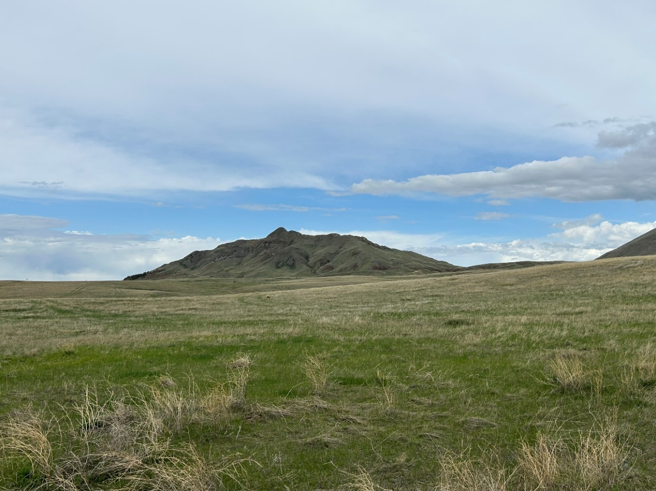
This page intentionally left blank
COVER PAGE

Proposed Action: The United States Department of Agriculture (USDA), Commodity Credit Corporation (CCC) and the Fort Belknap Indian Community propose to implement the Fort Belknap Indian Community Conservation Reserve Enhancement Program (CREP), a component of the Conservation Reserve Program (CRP). USDA is provided the statutory authority by the provisions of the Food Security Act of 1985, as amended (16 United States Code [USC] 3830 et seq.), and the Regulations at 7 Code of Federal Regulations (CFR) Part 1410. In accordance with the 1985 Act and the Agricultural Improvement Act of 2018 (Public Law [PL] 115-334; the 2018 Farm Bill), USDA/CCC is authorized to enroll lands. The Farm Service Agency (FSA) would administer the CREP on behalf of the CCC. CREP is a voluntary land conservation program for agricultural producers.
Type of Document: Programmatic Environmental Assessment (PEA)
Lead Agency: USDA, Farm Service Agency (on behalf of CCC)
Sponsoring Agency: Fort Belknap Indian Community
Prepared By: Morrison-Maierle
172 Timberwolf Parkway
Kalispell, Montana 59901
Further Information: For further information, please contact:

Alexander Dubish, State Environmental Coordinator FSA Montana State Office
PO Box 670
Bozeman, Montana 59771
Comments: This Draft PEA has been prepared in accordance with the National Environmental Policy Act (NEPA) (PL 91-190); implementing regulations adopted by the Council on Environmental Quality (CEQ) (40 CFR Parts 1500-1508); and FSA’s implementing regulations, Environmental Quality and Related Environmental Concerns – Compliance with NEPA (7 CFR Part 799).
FSA will provide a public review and comment period for the Draft PEA from February 28, 2024, to March 29, 2024. The Draft PEA was available for review on the FSA website at www.fsa.usda.gov/mt.
Written comments regarding this PEA shall be submitted to:
Alexander Dubish, State Environmental Coordinator
Address listed in above.

Or emailed to: alexander.dubish@usda.gov

Copies are also available in the Phillips and Blaine County FSA Offices and the Montana State Office.
This page intentionally left blank
TABLE OF CONTENTS

1.0 INTRODUCTION 1-1
1.1 BACKGROUND 1-1
1.2 REGULATORY COMPLIANCE 1-3
1.3 PURPOSE AND NEED FOR THE PROPOSED ACTION 1-4
1.4 ORGANIZATION OF THE PEA 1-4
2.0 DESCRIPTION OF THE PROPOSED ACTION AND ALTERNATIVES 2-1
2.1 PROPOSED ACTION 2-1
2.1.1 Eligible Lands 2-3
2.1.2 Install and Maintain Conservation Practices 2-4
2.1.3 Provide Financial Support 2-5
2.2 SCOPING 2-5
2.3 PUBLIC INVOLVEMENT 2-6
2.4 ALTERNATIVES SELECTED FOR ANALYSIS 2-6
2.4.1 Proposed Action Alternative (Preferred Alternative) 2-6
2.4.2 No Action Alternative 2-6
2.5 COMPARISON OF POTENTIAL ENVIRONMENTAL CONSEQUENCES 2-7
3.0 AFFECTED ENVIRONMENT AND ENVIRONMENTAL CONSEQUENCES 3-1
3.1 RESOURCE AREAS ELIMINATED FROM ANALYSIS 3-1
3.1.1 Prime and Unique Farmland 3-1
3.1.2 Noise 3-1
3.1.3 Coastal Zone Management and Coastal Barriers 3-1
3.1.4 Sole Source Aquifers 3-2
3.1.5 Other Protected Resources 3-2
3.2 ANALYZED RESOURCES AND EVALUATION CRITERIA 3-2
3.3 BIOLOGICAL RESOURCES 3-3
3.3.1 Definition of Resource 3-3
3.3.2 Affected Environment 3-4
3.3.3 Environmental Consequences Evaluation Criteria 3-10
3.3.4 Environmental Consequences – Proposed Action Alternative 3-10
3.3.5 Environmental Consequences – No Action Alternative 3-12
3.4 CULTURAL RESOUCES 3-13
3.4.1 Definition of Resource 3-13
3.4.2 Affected Environment 3-14
3.4.3 Environmental Consequences Evaluation Criteria 3-15
3.4.4 Environmental Consequences – Proposed Action Alternative 3-15
3.4.5 Environmental Consequences – No Action Alternative 3-16
3.5 WATER RESOURCES 3-17
3.5.1 Definition of Resource 3-17
3.5.2 Affected Environment 3-17
3.5.3 Environmental Consequences Evaluation Criteria 3-22
3.5.4 Environmental Consequences – Proposed Action Alternative 3-22
3.5.5 Environmental Consequences – No Action Alternative 3-23
3.6 AIR QUALITY 3-24
3.6.1 Definition of Resource 3-24
3.6.2 Affected Environment 3-25
3.6.3 Environmental Consequences Evaluation Criteria 3-25
3.6.4 Environmental Consequences – Proposed Action Alternative 3-26
3.6.5 Environmental Consequences – No Action Alternative 3-27
3.7 SOILS AND TOPOGRAPHY 3-27
3.7.1 Definition of Resource 3-27
3.7.2 Affected Environment 3-27
3.7.3 Environmental Consequences Evaluation Criteria 3-29
3.7.4 Environmental Consequences – Proposed Action Alternative 3-29
3.7.5 Environmental Consequences – No Action Alternative 3-29
3.8 SOCIOECONOMICS 3-29
3.8.1 Definition of Resources 3-29
3.8.2 Affected Environment 3-30
3.8.3 Environmental Consequences Evaluation Criteria 3-32
3.8.4 Environmental Consequences – Proposed Action Alternative 3-33
3.8.5 Environmental Consequences – No Action Alternative 3-34
3.9 ENVIRONMENTAL JUSTICE 3-34
3.9.1 Definition of Resource 3-34
3.9.2 Affected Environment 3-35
3.9.3 Environmental Consequences Evaluation Criteria 3-36
3.9.4 Environmental Consequences – Proposed Action Alternative 3-36
3.9.5 Environmental Consequences – No Action Alternative 3-36
3.10 CUMULATIVE IMPACTS 3-37
3.10.1 Biological Resources 3-38
3.10.2 Cultural Resources 3-38
3.10.3 Water Resources 3-38
3.10.4 Air Quality 3-38
3.10.5 Soils and Topography 3-38
3.10.6 Socioeconomics 3-39
3.10.7 Environmental Justice 3-39
4.0 REFERENCES 4-1

LIST OF FIGURES
Figure 1-1. Location of the Fort Belknap Reservation and Project Area within Montana 1-2
Figure 2-1. Fort Belknap Reservation and Surrounding Areas 2-2
Figure 3-1. Surface Water on the Fort Belknap Reservation 3-20

LIST OF TABLES
Table 1. Components of the Aaniih and Nakoda Conservation Reserve Enhancement Program Agreement 2-1
Table 2. Comparison of Potential Environmental Consequences of the Alternatives by Resource 2-8
Table 3. Level IV Ecoregions within the CREP Project Area 3-3
Table 4. List of Threatened and Endangered Species and Critical Habitat on the Fort Belknap Reservation 3-8
Table 5. Soil Associations in the Project Area 3-28
Table 6. Average Income and Poverty Rates (2022) 3-30
Table 7: Earning Measures for the Fort Belknap Indian Community 3-30
Table 8. Employment in the State and Fort Belknap Reservation 2015 – 2020 3-31
Table 9. 2017 Agricultural Land Use in Blaine and Phillips Counties and Montana 3-32
Table 10: 2017 Agricultural Producers by Race in Blaine and Phillips Counties 3-36

APPENDICES
APPENDIX A CONSERVATION PRACTICE DESCRIPTION
APPENDIX B AGENCY, TRIBAL, AND PUBLIC COORDINATION
APPENDIX C LIST OF PREPARERS AND CONTRIBUTORS

This page intentionally left blank
LIST OF ACRONYMS AND ABBREVIATIONS
APE Area of Potential Effects
BEA Bureau of Economic Analysis
BLS Bureau of Labor Statistics
BMP best management practice(s)
CAA Clean Air Act
CCC Commodity Credit Corporation
CEC Commission for Environmental Cooperation
CEQ Council on Environmental Quality
CFR Code of Federal Regulations
CH4 methane
CICP Conditions for Implementing Conservation Practices
CO carbon monoxide
CO2 carbon dioxide
COC Community of Comparison
CP Conservation Practice
CRP Conservation Reserve Program
CREP Conservation Reserve Enhancement Program
CWA Clean Water Act
EA Environmental Assessment
EE Environmental Evaluation
EIS Environmental Impact Statement
EO Executive Order
ESA Endangered Species Act
FBIC Fort Belknap Indian Community
FONSI Finding of No Significant Impact
FOTG Field Office Technical Guide
FSA Farm Service Agency
FWP Montana Department of Fish, Wildlife and Parks
GHG Greenhouse gas(es)
GIS Geographic Information Systems
MT Montana
NAAQS National Ambient Air Quality Standards
NASS National Agricultural Statistic Service
NEPA National Environmental Policy Act
NHPA National Historic Preservation Act
N2O nitrous oxide
NOAA National Oceanic and Atmospheric Administration
NO2 nitrogen dioxide
NPDES National Pollutant Discharge Elimination System
NRCS Natural Resources Conservation Service
NRHP National Register of Historic Places
O3 ozone
Pb lead
PEA Programmatic Environmental Assessment
PM2.5 respirable particulate matter (including particulates equal to or less than 2.5 microns in diameter)
PM10 respirable particulate matter (including particulates equal to or less than 10 microns in diameter)
PNS primary nesting season
SDWA Safe Drinking Water Act
SHPO State Historic Preservation Office
SIP State Implementation Plan
SO2 sulfur dioxide
TCP Traditional Cultural Property
TMDL Total Maximum Daily Load
TSP Technical Service Provider
TSS total suspended solids
U.S.C. United States Code
US United States
USACE United States Army Corps of Engineers
USDA United States Department of Agriculture
USEPA United States Environmental Protection Agency
USFWS United States Fish and Wildlife Service
USGS United States Geological Survey
VOC Volatile Organic Compound
WRP Wetland Reserve Program

INTRODUCTION
The United States Department of Agriculture (USDA) Commodity Credit Corporation (CCC) in cooperation with the Fort Belknap Indian Community (FBIC) propose to implement the Aaniiih and Nakoda Conservation Reserve Enhancement Program (CREP) under the Conservation Reserve Program (CRP). This Programmatic Environmental Assessment (PEA) describes the potential environmental consequences resulting from the implementation of the proposed CREP Agreement. The environmental analysis process is designed to ensure the public is involved in the process and informed about the potential environmental effects of the federal action, and to help decision makers take environmental and socioeconomic factors into consideration when making decisions related to the Proposed Action.

BACKGROUND
On behalf of the CCC, the USDA Farm Service Agency (FSA) administers the CRP, the federal government’s largest private-lands conservation program. CRP is a voluntary program that supports the implementation of long-term conservation measures designed to improve the quality of ground and surface waters, control soil erosion, and enhance wildlife habitat on environmentally sensitive agricultural land.
CREP is a program authorized under provisions of the Food Security Act of 1985, as amended (1985 Act) (16 United States Code [U.S.C.] § 3831 et. seq.), and the regulations at 7 Code of Federal Regulations (CFR) Part 1410. It was established in 1997 under the authority of the CRP to address agriculture related environmental issues by establishing conservation practices (CPs) on agricultural lands using funding from federal, state, and Tribal governments as well as non-government sources. CREP addresses state designated high priority conservation issues in defined geographic areas such as watersheds. Agricultural producers who enroll their eligible lands in CREP receive financial and technical assistance for establishing CPs on their land. In addition, producers receive annual rental payments based upon the enrolled acreage. Once eligible lands are identified, site-specific environmental reviews and consultation with and permitting from other federal agencies are completed as appropriate in accordance with FSA’s Handbook 2-CRP (Rev. 6): Agricultural Resource Conservation Program and FSA Handbook Environmental Quality 1-EQ (Rev. 3). Participation is voluntary, and the contract period is typically 10 to 15 years.
The proposed CREP is within the Fort Belknap Indian Reservation (Reservation), which encompasses 675,147 acres of land, located in southeast Blaine and western Philips Counties of North-central Montana (Project Area). The CREP would enroll a maximum of 625,000 acres of Tribal land to implement grassland practice CP88, Permanent Grasses and Legumes. The purpose of the CP88 practice is to maintain existing vegetative cover of either introduced or native grasses and legumes on eligible grassland. To be eligible to be enrolled or re-enrolled, 100 percent of the land per CRP contract must be physically located within the CREP Project Area. The CREP Project Area includes Reservation lands as well as Off-Reservation Trust Lands. See Figure 1-1 for boundaries of the Reservation and CREP Project Area.
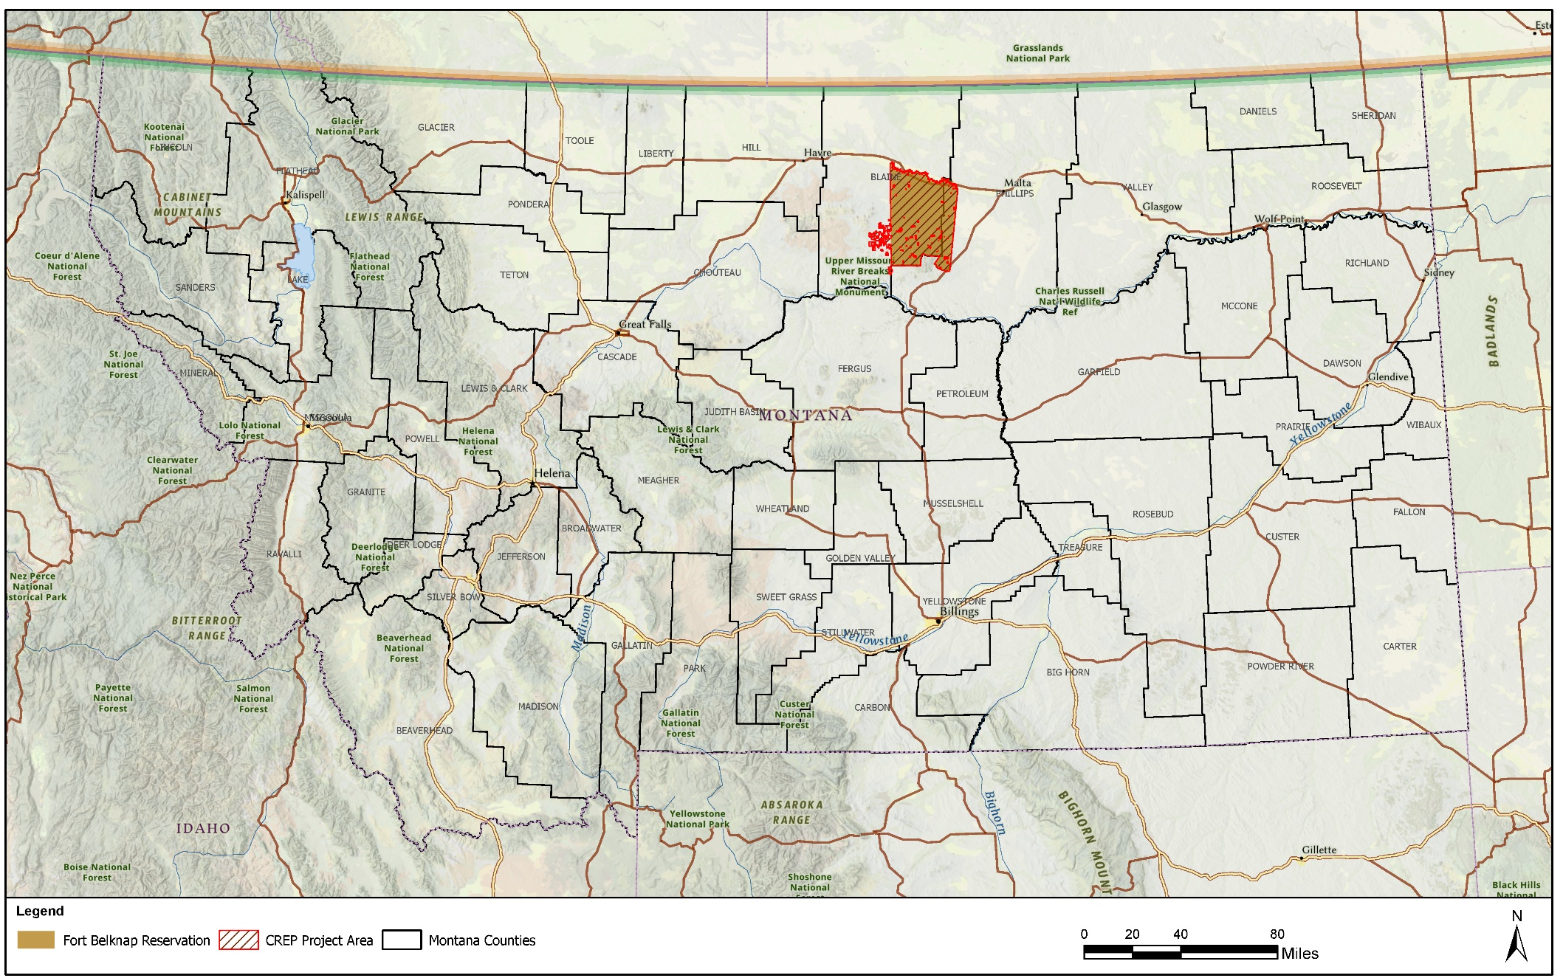
Figure 1-1. Location of the Fort Belknap Reservation and Project Area within Montana
The purpose of the CREP Agreement is to allow, where deemed desirable and appropriate by the CCC and FBIC, certain acreage physically located within the Project Area to be enrolled or re-enrolled, as applicable, in CRP through CREP. The CREP would reduce agricultural environmental impacts within the Project Area. The FSA, on behalf of CCC, would administer the CREP within Montana. CREP is just one option under CRP that farmers and ranchers may select to enhance their land. Eligible producers not participating in CREP may still enroll land in CRP through general, grassland, or continuous CRP signup.

REGULATORY COMPLIANCE
This PEA has been prepared to satisfy the requirements of the National Environmental Policy Act (NEPA) (Public Law 91-190, 42 United States Code 4321 et seq.); Council on Environmental Quality (CEQ) Regulations for Implementing the Procedural Provisions of NEPA (40 CFR §§ 1500–1508); 7 CFR Part 799, FSA NEPA Implementing Regulations; the FSA’s handbook 1-EQ (Rev. 3) Environmental Quality Programs, and FSA’s handbook for the Conservation Reserve Program, 2-CRP (Rev. 6), Agricultural Resource Conservation Program.
NEPA is a law that requires federal agencies to consider the potential environmental consequences of Proposed Actions and alternatives to Proposed Actions. The law’s intent is to protect, restore, or enhance the environment through well-informed federal decisions. The CEQ was established under NEPA for the purpose of implementing and overseeing federal policies as they relate to this process. In 1978, the CEQ issued Regulations for Implementing the Procedural Provisions of the National Environmental Policy Act (40 CFR Parts 1500 through 1508 [CEQ 1978]). On September 14, 2020, CEQ updated the NEPA regulations (85 Federal Register 43357 through 43376), and the Phase 1 final rule went into effect on May 20, 2022, which are being followed for this PEA. CEQ regulations specify that an Environmental Assessment (EA) be prepared to:
- briefly provide sufficient analysis and evidence for determining whether to prepare an Environmental Impact Statement (EIS) or a Finding of No Significant Impact (FONSI);
- aid in an agency’s compliance with NEPA when no EIS is necessary; and
- facilitate preparation of an EIS when one is necessary.
A variety of other laws, regulations, and Executive Orders (EO) apply to actions undertaken by federal agencies. These form the basis of the analyses and are summarized in the PEA where applicable. These include but are not limited to:
- Endangered Species Act (ESA)
- National Historic Preservation Act (NHPA)
- Clean Water Act (CWA)
- EO 11988, Floodplain Management
- EO 11990, Protection of Wetlands
- EO 12898, Federal Actions to Address Environmental Justice in Minority Populations and Low-Income Populations

PURPOSE AND NEED FOR THE PROPOSED ACTION
The purpose of the Proposed Action is to implement the CREP Agreement. The need for the Proposed Action is to reduce agricultural environmental impacts on the reservation through maintenance or improvement of grassland productivity and reduction in soil erosion within the Project Area.
The objectives of the CREP are to:
- Enroll up to 625,000 acres of tribally owned land with the intent of implementing conservation-minded management systems.
- Effect an overall increase in range and grassland health and sustainability.
- Promote Natural Resource Education through partners and using practical and experimental agriculture methods.

The eligible practice for the proposed CREP agreement is Grassland Initiative CP88 – Permanent Grasses and Legumes. The purpose of the CRP Grassland Initiative is to provide assistance to landowners and operators to protect grazing uses and related conservation values on eligible private pasture and rangelands.

ORGANIZATION OF THE PEA
This PEA assesses the potential impacts of the Proposed Action and alternatives on potentially affected environmental and socioeconomic resources. This section, Section 1.0, provides background information relevant to the Proposed Action and discusses its purpose and need. Section 2.0 describes the Proposed Action and alternatives. Section 3.0 describes the baseline conditions for each of the potentially affected resources and describes potential environmental consequences on these resources, including cumulative impacts. Section 4.0 contains a listing of the references cited in this PEA. Various appendices are also included to support the analysis in the PEA.

This page intentionally left blank

DESCRIPTION OF THE PROPOSED ACTION AND ALTERNATIVES

PROPOSED ACTION
On behalf of the CCC, the FSA proposes to implement the CREP Agreement by allowing enrollment of up to 625,000 acres of Tribal land within the CREP Project Area. The FBIC encompasses 675,147 acres of land in north central Montana (See Figures 1-1 and 2-1). Due to the voluntary nature of this program, the exact locations and sizes of specific parcels that would be enrolled are not known at this time. Participating producers would receive support for the costs of installing permanent fencing and livestock watering facilities needed to facilitate livestock grazing, as well as annual rental payments for those specific lands enrolled in the program. Table 1 summarizes the components of the CREP.
The proposed CREP requires the use of CP88, Permanent Grasses and Legumes, which purpose is to maintain existing vegetative cover of either introduced or native grasses and legumes on eligible CRP grassland. The purpose of Grassland CRP is to provide assistance to landowners and operators to protect grazing uses and related conservation values on eligible private pasture and rangelands. Grassland CRP emphasize support of grazing operations, maintaining and improving plant and animal biodiversity, and protecting grasslands and shrublands from the threat of conversion to uses other than grazing.
Table 1. Components of the Aaniih and Nakoda Conservation Reserve Enhancement Program Agreement
Acreage | Up to 625,000 acres
CREP Duration | 15 years
Funding | Federal funds would be used for rental payments. Participants would be provided annual rental payments comprised of a per acre grassland rental rate equal to $15/acre for all eligible grassland acreage offered.
Geographic Area | Fort Belknap Indian Community
Counties | 2
Conservation Practices | CP88, Permanent Grasses and Legumes
Contract Duration | 10 to 15 years
Cost Share | USDA would provide cost-share payments to eligible participants for up to 50% of the eligible reimbursable costs incurred for establishing permanent fencing and livestock watering facilities needed to facilitate livestock grazing. The total of all cost-share payments from all sources shall not exceed 100 percent of the cost of the practice
CREP=Conservation Reserve Enhancement Program

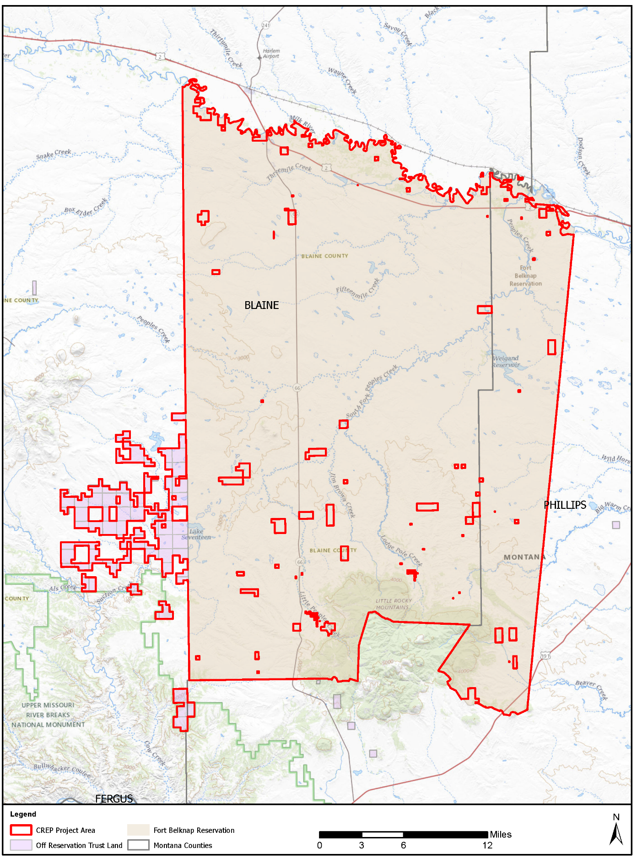
Figure 2-1. Fort Belknap Reservation and Surrounding Areas

Eligible Lands
The FBIC is in northern Montana with the majority of the land lying in Blaine County and the western portion lying in Philips County. The land must have an existing grass cover at the time it is offered for enrollment and meet all the eligibility criteria to be enrolled in CRP as grassland, in accordance with FSA National CRP Directives. Only tribal land is eligible for enrollment under this CREP. “Tribal land” is defined as land either owned by the FBIC or owned by a member of the FBIC. To be eligible to be enrolled or re-enrolled, 100 percent of the land per CRP contract must be physically located within the CREP Project Area (see Figures 1 and 2), as determined by CCC. All approved conservation plans for land enrolled or re-enrolled through this CREP shall be consistent with CRP regulations at 7 CFR Part 1410, FSA National CRP Directives, Natural Resources Conservation Service’s (NRCS) Field Office Technical Guide (FOTG). All conservation practices installed must meet the minimum specifications and criteria in FSA National CRP Directives, NRCS FOTG.
According to FSA’s handbook for CRP (2-CRP [Rev-6]), land eligible for enrollment in Grassland CRP is land on a tract, or a portion of a tract, that:
- Contains forbs or shrubland (including improved rangeland and improved pastureland) for which grazing is the predominant use with less than 5 percent tree canopy interspersed throughout the offered acreage.
- Is located in an area historically dominated by grasslands.
- Provides habitat for animal and plant populations of significant ecological value if the land is retained in its current use or restored to a natural condition.
- Is expiring CRP lands without tree practices.
Once eligible lands are identified, a site-specific environmental review (Environmental Evaluation [EE]) would be completed prior to executing a contract and a Conservation Plan would be developed that details the installation and maintenance of CP88 to ensure that no adverse impacts are anticipated and that the goals of CREP are met throughout the life of the contract. The conservation plan would contain provisions for common grazing or forage management practices and related activities consistent with achieving CRP purposes and maintaining the health and viability of grassland resources.
The EE is completed by the Natural Resources Conservation Service (NRCS) or an approved Technical Service Provider (TSP) during the conservation planning process. NRCS or a TSP is responsible for the site-specific EE, technical leadership, and technical concurrence on Conservation Plans and any revisions. Similarly, they are responsible for collecting the data needed for FSA to ensure compliance with NEPA, NHPA, ESA, and other related laws, regulations, and EOs. The site-specific EE process is consistent with FSA’s Environmental Quality and Related Environmental Concerns – Compliance with NEPA (7 CFR Part 799) and FSA’s Handbook on Environmental Quality Programs (1-EQ [Rev. 3]). FSA reviews and completes sections of the site-specific EE to document that FSA has completed any required consultation with regulatory agencies. The site-specific EE, previous programmatic NEPA documentation, and this PEA together would complete regulatory compliance for each contract enrolled under this CREP agreement.

Install and Maintain Conservation Practices
The practice proposed under the Aaniih and Nakoda CREP Agreement is specific to conditions known to exist within the Project Area. The purpose of practice CP88, Permanent Grasses and Legumes, is to maintain existing vegetative cover of either introduced or native grasses and legumes on eligible CRP grassland. More information on CP88 can be found in Appendix A. Grassland CRP allow for livestock grazing operations.
Installation and maintenance for CP88 may include:
- Installation of interior fencing needed to facilitate a livestock grazing system;
- Installation of access control devices, such as gates, for the purpose of controlling access to an area to maintain the quantity and quality of natural resources, or seasonal or permanent livestock exclusion;
- Development of ponds, wells, spring developments, pipelines, and water facilities to provide a water source for livestock;
- Construction of fuel breaks to control and reduce the risk of the spread of fire by treating, removing, or modifying vegetation, debris, and detritus;
- Development of trails and walkways to provide or improve access to forage, water, working/handling facilities, and/or shelter, to improve grazing efficiency and distribution, and to protect ecologically sensitive, erosive, and/or potentially erosive sites;
- Prescribed burning to improve plant production quantity and/or quality by managing fuel loads to achieve desired conditions. Prescribed fires would be performed under an approved burn plan and outside the primary nesting season (PNS) of May 15 through July 15;
- Common grazing practices, including maintenance and necessary cultural practices in a manner that is consistent with maintaining the viability of grassland, forb, and shrub species appropriate to the locality;
- Haying, mowing, or harvesting for seed production that is subject to appropriate restrictions for species identified by NRCS State Technical Committee focus areas; and
- Control of noxious weeds and other undesirable plants, insects, and pests as necessary to avoid an adverse impact on surrounding land. Chemicals used in performing the practice must be federally, state, and locally registered and applied according to authorized registered uses, directions on the label, and other federal or state policies and requirements.
An approved Conservation Plan is required prior to CRP contract approval and implementation. A Conservation Plan identifies conservation objectives and assesses the natural resource issues that are site-specific to the Project Area and the proposed CP. Conservation Plans are required to meet the NRCS Field Office Technical Guide (FOTG) planning criteria for each natural resource and must address economic and social considerations. The plan describes the schedule of operations and activities required to solve identified natural resource concerns. The approved plan is developed by the local NRCS representative or authorized TSP in cooperation with the participant. The approved Conservation Plan must:
- Contain all the practices necessary to successfully maintain the vegetative cover and install eligible components to facilitate a livestock grazing system.
- Be technically adequate to meet the objectives of CRP.
- Incorporate all federal, state, and local permit requirements for use of agricultural chemicals such as fertilizer and herbicides.
- Be reviewed and approved by the conservation district.
- Ensure the conservation cover is not disturbed (i.e., haying and/or grazing) during PNS dates.
- Incorporate and adhere to county specific guidance from the NRCS CP Standards, identified in the FOTG, and in state or county specific technical notes.
A Draft Five-year Conservation Plan (October 1, 2021 – September 30, 2026), in compliance with these requirements, was completed for the Fort Belknap Indian Community and available on their website.

Provide Financial Support
Agricultural producers enrolled in the CREP would enter into federal contracts for a minimum of 10 and a maximum of 15 years that require the implementation of CP88 to receive financial and technical assistance. Producers would be eligible for annual rental payments for the duration of the contract, and USDA would provide cost-share payments to eligible participants for up to 50 percent of the eligible reimbursable costs incurred for installing permanent fencing and livestock watering facilities needed to facilitate livestock grazing.
The annual rental payments provided would be comprised of a per acre grassland rental rate equal to $15 per acre for all eligible grassland acreage offered. The rental rate is potentially subject to change with future amendments to the CREP agreement. The yearly project cost from rental rates would be over $9 million if 625,000 acres were enrolled at $15 per acre. The cost of the program would be shared between the federal government and the FBIC. The FBIC would contribute a certain percentage of the overall annual program costs of the CREP through direct payments or in-kind contributions to eligible participants. This percentage has not yet been determined. The FBIC would also pay all costs associated with monitoring activities under the CREP and could, at its discretion, pay to enhance the cover on land enrolled in CRP through the CREP.

SCOPING
Scoping is an early and open process for developing the breadth of issues to be addressed in an EA and for identifying significant concerns related to an action. Per the requirements of EO 12372, Intergovernmental Review of Federal Programs, as amended by EO 12416, federal, state, and local agencies with jurisdiction that could potentially be affected by the Proposed Action or alternatives were notified during the development of this PEA. Pursuant to Section 106 of the NHPA and its implementing regulations in 36 CFR Part 800 “Protection of Historic Properties”, potentially affected Tribal governments were also contacted to help in identifying historic properties, cultural resources, and sites of religious or cultural significance that might be affected by the Proposed Action. The list of agencies contacted, copies of notification letters sent, and responses received are included in Appendix B.
The FBIC would implement a broad, continuous outreach and promotion campaign of education regarding the CREP. Producers may be advised through meetings, direct mail, or other methods. Several organizations have been, and continue to be, involved in developing the CREP. These include:
- Fort Belknap Indian Community
- USDA Farm Service Agency (FSA)
- Bureau of Indian Affairs (BIA)
- U.S. Fish and Wildlife Service (USFWS)

PUBLIC INVOLVEMENT
The FSA is providing a public review and comment period for the Draft PEA from February 28, 2024, to March 29, 2024. A summary of the responses received during the comment period will be included in Appendix B.7.

ALTERNATIVES SELECTED FOR ANALYSIS

Proposed Action Alternative (Preferred Alternative)
Under the Proposed Action Alternative, the CREP Agreement would be fully implemented as described above. This would allow up to 625,000 acres of eligible lands to be managed as permanent grasslands to support grazing operations, maintain and improve plant and animal biodiversity, and protect grasslands and shrublands from the threat of conversion to other uses. CP88 would be maintained on eligible lands and producers would receive one-time cost share payments for installing permanent interior fencing and livestock watering facilities needed to facilitate livestock grazing, as well as annual rental payments. The total yearly cost of the program from rental payments would be up to $9,375,000, at a $15 per acre rental rate.

No Action Alternative
Under the No Action Alternative, the CREP Agreement would not be implemented. No land would be enrolled in CREP and the goals of CREP would not be met. Though eligible lands could be enrolled in CRP or other conservation programs, the benefits of the proposed CREP would not be realized. This alternative does not satisfy the purpose and need but is carried forward in the analysis to serve as a baseline against which the impacts of the Proposed Action Alternative can be assessed.

COMPARISON OF POTENTIAL ENVIRONMENTAL CONSEQUENCES
The potential impacts associated with the Proposed Action Alternative and No Action Alternative are summarized in Table 2. The summary is based on information discussed in detail in Section 3.0 and includes a concise definition of the issues addressed and the potential environmental impacts associated with each alternative.

Table 2. Comparison of Potential Environmental Consequences of the Alternatives by Resource
Resource | Proposed Action Alternative | No Action Alternative
Biological Resources | There would be long-term beneficial impacts to vegetation, wildlife, and threatened and endangered species. Approved management practices such as access control, water facilities, fuel breaks, and prescribed burning are not expected to adversely affect any threatened or endangered species with the implementation of site-specific Environmental Evaluations (EE). Known threatened or endangered species population areas, such as black-footed ferret and piping plover colonies, would be identified during the EE and appropriate avoidance or conservation measures would be applied. | Under the No Action Alternative, the proposed CREP Agreement would not be implemented and lands that would have been eligible for enrollment would remain unprotected. The potential conversion of grassland to another type of agricultural production or development would reduce vegetative diversity, increasing susceptibility to invasion by exotic species. The benefits of protection and improvement of grassland productivity, reduction in soil erosion, and enhancement of wildlife habitat would not be realized. Conversion to another use would adversely affect threatened, endangered, and sensitive species currently inhabiting these grasslands by reducing or degrading available habitat.
Cultural Resources | Actions in this PEA may have potential direct, indirect, and cumulative effects on cultural resources. Actions that would disturb previously undisturbed areas may result in impacts to known or unknown historic properties and Traditional Cultural Properties. Evaluation of cultural resources impacts for specific lands to be enrolled in CREP, including the identification of previously undisturbed land, is performed through site-specific EEs. If specific areas of concern are identified, per Section 106 of the NHPA, they would be reviewed in consultation with the Montana State Historic Preservation Office, Tribes, and participating state and federal agencies during the planning and implementation phases. | Under the No Action Alternative, the proposed CREP would not be implemented and all adverse effects to cultural resources from conversion of existing grasslands on the reservation would remain unknown and unreviewed.
Water Resources | Implementation of the proposed CREP Agreement would have long-term beneficial impacts on surface water, wetlands, and floodplains. Some installation and maintenance activities may require small-scale construction and land disturbance and the use of agricultural chemicals. The use of Best Management Practices (BMPs) would reduce impacts from land disturbance and would contain sediment within the site. These potential impacts would be short-term, localized, and temporary. Additionally, application of agricultural chemicals in accordance with label requirements would minimize pollutants in runoff. | Under the No Action Alternative, the CREP would not be implemented, and current agricultural practices would continue. There would be no impacts to water resources from implementation of the No Action Alternative. The beneficial impacts to surface water, wetlands, floodplains, and groundwater from installing CP88 would not be realized.
Air Quality | Implementation of the proposed CREP Agreement would maintain or improve existing vegetative cover and may generally have a long-term beneficial effect on air quality by preserving soil from erosion. Some installation and maintenance activities may produce dust and exhaust emissions that could have a negligible to minor temporary adverse effect on air quality in localized areas. Prescribed burning could have temporary impacts on localized air quality. | Under the No Action Alternative, the proposed CREP would not be implemented. Eligible lands would not be enrolled in the proposed CREP and potential benefits to vegetation would not occur. The beneficial impacts associated with the expected reduction in erosion would not occur and soil degradation would continue.
Soils and Topography | Long-term beneficial impacts are expected to occur from stabilization of soils and topography. Short-term disturbances to soils could result from the installation of various structures to implement rotational grazing. These ground disturbing activities may result in temporary minor increases in soil erosion; however, they would be reduced by implementing erosion control BMPs. | Under the No Action Alternative, the proposed CREP would not be implemented. Eligible lands would not be enrolled in the proposed CREP and potential benefits to soils and topography would not occur. The beneficial impacts associated with the expected reduction in erosion would not occur and soil degradation would continue.
Socioeconomics | Implementation of the Proposed Action Alternative would result in long-term beneficial impacts to socioeconomics for agricultural producers. Individual producers would benefit financially from rental rates but would also benefit financially from increased grassland productivity and carrying capacity. Additionally, implementation of the Proposed Action Alternative would result in long-term beneficial impacts to regional socioeconomics. The CREP would result in enhanced wildlife habitat, which would contribute positively to recreational expenditures related to wildlife viewing, hunting, and fishing. The Proposed Action is unlikely to produce significant changes in general population characteristics. | Under the No Action Alternative, the CREP would not be implemented, and current agricultural practices would continue. This alternative would not produce any measurable changes to the general population characteristics of the region as there would be no changes to the sales or spending patterns of the agricultural producers. However, there would be the lost benefits associated with implementing CP88 that include improvements in water quality, soil retention, grassland productivity, carrying capacity, and wildlife habitat. Any regional economic benefits from increased hunting, fishing, and wildlife-watching expenditures would not be realized.
Environmental Justice | The majority of the environmental impacts would be beneficial to the region and the producers enrolling land into the CREP. There would be no environmental justice issues from implementation of the Proposed Action Alternative. The Proposed Action Alternative would not substantially affect populations covered by EO 12898 by excluding persons, denying persons benefits, or subjecting persons to discrimination or disproportionate environmental or human health risks. | Under the No Action Alternative, there would be no changes to the existing agricultural lands in the FBIC, therefore, implementation of this alternative would not result in disproportionate adverse environmental or health effects on low-income or minority populations. The No Action Alternative would not substantially affect populations covered by EO 12898 by excluding persons, denying persons benefits, or subjecting persons to discrimination or disproportionate environmental or human health risks.
CREP = Conservation Reserve Enhancement Program; PEA = Programmatic Environmental Assessment; NHPA = National Historic Preservation Act; EE = Environmental Evaluation, EO = Executive Order.

AFFECTED ENVIRONMENT AND ENVIRONMENTAL CONSEQUENCES
This section analyzes the potential impacts on existing environmental conditions associated with the Proposed Action on the CREP Project Area. The analysis considers the current, baseline conditions of the affected environment and compares those to the conditions that might occur should FSA implement the Proposed Action Alternative or the No Action Alternative.
A justification for those resources eliminated from analysis is provided in this section. Then, each resource included in the analysis is defined and its evaluation criteria are outlined. Lastly, a description of the existing conditions and a discussion of potential direct, indirect, and cumulative impacts is provided.

RESOURCE AREAS ELIMINATED FROM ANALYSIS
Several resources were considered relative to the Proposed Action but were not carried forward for detailed analysis. They include resources whose baseline conditions lacked a relationship to, and any potential to be altered by, implementation of the Proposed Action.

Prime and Unique Farmland
The Farmland Protection Policy Act was passed by Congress as part of the Agriculture and Food Act of 1981. The Act is intended to minimize the impact federal programs have on the unnecessary and irreversible conversion of farmland to nonagricultural uses. Grassland CRP is a working lands program that helps farmers enhance the sustainability of their operations while keeping land in agricultural production. CP88 continues to allow agricultural use through haying and grazing provisions and livestock operations. For these reasons, the Proposed Action Alternative is not expected to have adverse effects on Prime and Unique Farmland.

Noise
Implementing the Proposed Action Alternative would not permanently increase ambient noise levels at or adjacent to the Project Area. Noise from heavy equipment is common on agricultural lands and farmlands that could be enrolled in the CREP. The potential for increased noise levels associated with implementing CP88 would be minor, temporary, localized, and would cease once implementation of CP88 is complete.

Coastal Zone Management and Coastal Barriers
The proposed CREP for the Fort Belknap Indian Community is located in northern Montana and is not within or near a designated Coastal Zone Management Area. Therefore, the Coastal Zone Management Act of 1972 does not apply. Similarly, the proposed CREP does not include development on coastal barriers, so the Coastal Barrier Resources Act of 1982 does not apply.

Sole Source Aquifers
Sole source aquifers are protected under the Safe Drinking Water Act. Special care must be taken to protect aquifers which the U.S. Environmental Protection Agency (USEPA) has designated as sole source aquifers, which are aquifers that supply at least 50 percent of the drinking water consumed in the area overlying the aquifer. There are no designated sole source aquifers in the Project Area or in north-central Montana (US EPA, 2023).

Other Protected Resources
Other protected resources are lands preserved and managed by state or federal governments for the purpose of conservation, recreation, or research. This includes, but is not limited to, National Historic Landmarks, Wetland Management Districts, National Wildlife Refuges, Wild and Scenic Rivers, National Parks, and National Forests. No protected lands were found in the Project Area, so this resource was dismissed from the analysis.

ANALYZED RESOURCES AND EVALUATION CRITERIA
The following is provided in this section: a description of general evaluation criteria and impact levels, the list of analyzed resources, and a description of the area of potential effects (APE) of potential consequences for the resources analyzed.
The APE for the resources analyzed in this PEA is the land within the CREP Project Area. The specific criteria for evaluating impacts and assumptions for the analyses are presented under each resource area. Evaluation criteria for most potential impacts were obtained from standard criteria; federal, state, or local agency guidelines and requirements; and legislative criteria.
Impacts are defined in general terms and are qualified as adverse or beneficial, and as short- or long-term. For the purposes of this PEA, short-term impacts are generally considered those impacts that would have temporary effects. Long-term impacts are generally considered those impacts that would result in permanent effects. Adverse impacts are defined as:
- negligible, the impact is localized and not measurable or at the lowest level of detection;
- minor, the impact is localized and slight but detectable;
- moderate, the impact is readily apparent and appreciable; or
- major, the impact is severely adverse or highly noticeable and considered to be significant.
Major impacts are considered significant and receive the greatest attention in the decision-making process. The significance of an impact is assessed based on the relationship between context and intensity. Major impacts require application of a mitigation measure to achieve a less than significant impact. Moderate impacts may not meet the criteria to be classified as significant, but the degree of change is noticeable and has the potential to become significant if not effectively mitigated. Minor impacts have little to no effect on the environment and are not easily detected; impacts defined as negligible are the lowest level of detection and generally not measurable. Beneficial impacts provide desirable situations or outcomes.
Impacts and their significance are discussed for each resource, including any BMPs, as applicable for reducing potential adverse environmental impacts. Resource areas that are evaluated include: biological resources, cultural resources, water resources, air quality, soils and topography, other protected resources, socioeconomics, and environmental justice. Reasonably foreseeable future actions that could result in increased impacts to these environmental resources in conjunction with the Proposed Action are discussed in Section 3.10.

BIOLOGICAL RESOURCES

Definition of Resource
Biological resources include all plant and animal species and the habitats in which they occur. For this analysis, biological resources are divided into the following categories: vegetation, wildlife, and threatened or endangered species and critical habitat. Vegetation and wildlife refer to the plant and animal species, both native and introduced, which characterize an area. For this analysis, noxious weeds are not discussed since CREP contracts require conservation plans that include control of such species. Threatened or endangered species are those federally listed and protected by the ESA. The USFWS designates critical habitat as essential for the recovery of species specifically listed as threatened or endangered, and, like those species, critical habitat is protected under the ESA.
Ecoregions are areas of relatively homogenous soils, vegetation, climate, and geology, each with associated wildlife adapted to that region. Montana consists of two Commission for Environmental Cooperation (CEC) Level I ecoregions, namely the Great Plains and Northwestern Forested Mountains. The Fort Belknap Indian Community is within the Great Plains ecoregion and consists dominantly of mixed-grass prairie lands. Further subdivisions of ecoregions (Level IV) within the CREP Project Area are identified and described in Table 3 below.
Table 3. Level IV Ecoregions within the CREP Project Area
Ecoregion | % Area | Description
Glaciated Northern Grasslands (42j) | 79.5% | The Glaciated Dark Brown Prairie ecoregion is primarily a treeless rolling till plain punctuated by scattered low-relief gravel benches. The ecoregion is characterized by dark brown till-derived soils, a potential natural vegetation of wheatgrass - needlegrass, and a land use mosaic of cropland and rangeland. To the west in the Glaciated Northern Grasslands (42j), drier conditions create lighter colored soils and, correspondingly, different natural vegetation. The Glaciated Dark Brown Prairie (42i) extends into North Dakota.
Foothill Grasslands (42r) | 12.3% | The Non-calcareous Foothill Grassland ecoregion lies east of the Continental Divide where it slopes down from the lower mountain treeline to the plains. Its hills and scattered buttes are dissected by shrub- and tree-covered, mountain-fed streams. Ecoregion 42r is physiographically different from the mountains of Ecoregions 17 and 41, the plains of ecoregions 42 and 43, and the Rocky Mountain Front Foothill Potholes (42q). Potential natural vegetation is mostly foothills prairie. A variety of mostly non-carbonate rocks underlie Ecoregion 42r; lithology, stream quality, and aquatic biota are different than in the Limy Foothill Grassland (43u). Ecoregion 42r typically receives more precipitation than the plains below and less than the mountains above. It can be affected by chinooks. Ranching is common. Ecoregion 42r extends into Canada.
Scattered Eastern Igneous-Core Mountains (17r) | 4.9% | The rather dry, mostly wooded Scattered Eastern Igneous-Core Mountains ecoregion lies east of the Rocky Mountain Front and is characteristically underlain by Tertiary volcanic and intrusive rocks. It is lithologically distinct from the Big Snowy-Little Belt Carbonate Mountains (17q), and related stream quality, surficial water availability, aquatic biota, and soils are also different. Average annual precipitation ranges from 16 to just over 30 inches. The climax vegetation is often Douglas-fir forest; ponderosa pine occurs at 4,000 to 6,000 feet elevation, subalpine fir at 6,500 to 7,000 feet, and forest-grassland complex is found in the Sweetgrass Hills.
Montana Central Grasslands (43n) | 2.3% | The Central Grassland ecoregion is an unglaciated plain that is dissected by many small, ephemeral or intermittent streams. It is largely underlain by noncarbonate, fine-grained sedimentary rock of the Tertiary Fort Union Formation which become less widespread in the neighboring, but less dissected, Ecoregion 43e. Clayey frigid soils derived from residuum are common and have a ustic-aridic moisture regime; they contrast with the mesic soils of Ecoregion 43q and the less aridic soils of Ecoregion 43a. Potential natural vegetation is grama needlegrass-wheatgrass and is distinct from that of the Sagebrush Steppe (43e) and Pine Scoria Hills (43p). Ecoregion 43n is mostly rangeland but irrigated and unirrigated farms occur in the Yellowstone Valley. Overall, farmland is less common than in the Judith Basin Grassland  (43m).
Missouri Breaks Woodland-Scrubland (43l) | 1.0% | The Missouri Breaks Woodland-Scrubland ecoregion has very highly dissected  topography and erodible clayey soils derived from Cretaceous sedimentary rock. Steep, rugged terrain with a climax vegetation of ponderosa pine and Rocky Mountain juniper woodland, grassland, and scrubland are characteristic and distinguish the ecoregion from the River Breaks (43c), Glaciated Northern Grasslands (42j), Judith Basin Grassland (43m), and Montana Central Grasslands (43n). Ecoregion 43l is lightly and locally grazed, since stock watering facilities are rare. Some farmland is irrigated especially near the Missouri River. The dissected topography, wooded slopes and draws, and uncultivated areas of Ecoregion 43l are havens for wildlife.
Sources: Woods et al, 2002.

Affected Environment

Vegetation
The Montana Natural Heritage Program (MTNHP) website was utilized to gather descriptions on land cover across the Reservation. Vegetation classes were drawn from the Ecological System Classification developed by NatureServe (Comer et al. 2003). Additional description information was gathered from there as well as the FBIC Agricultural Resource Management Plan (2018). The Fort Belknap Indian Community is located in north central Montana and contains more than 40 types of land cover types. Great Plaines Mixed Grass Prairie, Cultivated Crops, Big Sagebrush Steppe, Great Plaines Riparian, and Rockey Mountain Lodgepole Pine Forest constitute the dominant ecological systems found in the Project Area.
Great Plains Mixed-grass Prairie is the most dominant ecological system in the Project Area and comprises approximately 49% of the Reservation. This system covers much of the eastern two-thirds of Montana and is interspersed with wetland/riparian areas and sand prairies. This system is characterized by high herbaceous canopy cover, with western wheatgrass (Pascopyrum smithii) as the dominant species. Other common species include thickspike wheatgrass (Elymus lanceolatus), green needlegrass (Nassella viridula), blue grama (Bouteloua gracilis), and needle and thread (Hesperostipa comata). The primary ecological drivers of this system include fire and grazing; however, drought can also impact it by favoring shortgrass species over mid-height grasses, resulting in shifts in relative cover by these two general grass types. When mixed-grass prairie is intensely grazed, cool season exotic species such as Kentucky bluegrass (Poa pratensis), smooth brome (Bromus inermis), and field brome increase in cover, thereby reducing both native species cover and potentially diversity. Moderate grazing tends to increase cover and abundance of forb species (MTNHP 2023).
Cultivated Crops comprises approximately 18% of the Reservation. This system includes areas that are used for the production of crops on an annual cycle, such as alfalfa, hay, small grains, seed crops, and vegetables. Agricultural plant cover is variable depending on season and type of farming and may be dry-farmed or irrigated (MTNHP 2023).
The widespread big Sagebrush Steppe, making up 14% of the Reservation, is an ecological system that occurs throughout much of central Montana and the western fringe of the Great Plains. Overall shrub cover can range from 10% to 25%, but this system is always co-dominated by perennial grasses and forbs with greater than 25% cover. Most of this system (50-90%) is dominated by two species - Wyoming big sagebrush (Artemisia tridentata wyomingensis) and western wheatgrass (Pascopyrum smithii). When this system is disturbed, field brome and cheatgrass (Bromus tectorum) can invade and increase in cover. Periodic fire (the natural fire regime) results in a patchy mosaic of shrubs across the landscape; however, fire suppression and/or heavy grazing may result in an increase in shrub cover (MTNHP 2023).
Great Plains Riparian system, which is associated with perennial to intermittent or ephemeral streams throughout the northwestern Great Plains and in Montana, occurs within approximately 20,356 acres of the FBIC, along smaller tributaries of the Yellowstone and Missouri rivers and along tributaries to the large floodplain rivers that feed them (e.g., the Milk, Marias, Musselshell, Powder, Clark’s Fork Yellowstone, and Tongue rivers, etc.). This system is found on alluvial soils in various settings, including confined, deep cut ravines to wide, braided streambeds. The key process influencing this system is flooding, which creates suitable sites for seed dispersal and seedling establishment, and controls vegetation succession. Riparian forests, shrublands, tallgrass wet meadows, and gravel/sand flats are various communities that are included in this system. The dominant species include narrowleaf cottonwood (Populus angustifolia) and Plains cottonwood (Populus deltoides); in wetter systems, the understory is typically willow (Salix spp.) and red-osier dogwood (Cornus stolonifera). Western wheatgrass dominates the grasses, and the dominant forb is American licorice (Glycyrrhiza lepidota). The understory may be dominated by big sagebrush (Artemisia tridentata) or silver sagebrush (Artemisia cana) in areas where the channel is incised. Like floodplain systems, riparian systems are often exposed to overgrazing and/or converted for agricultural use and can be heavily degraded without native woody vegetation and periodic recruitment and regrowth of these species. Under these conditions, salt cedar and Russian olive (Eleagnus angustifolia) can invade and replace the native species. Groundwater depletion and lack of fire have also resulted in species changes (MTNHP 2023).
The Rocky Mountain Lodgepole Pine Forest ecosystem constitutes approximately 3% of the Reservation. This forested system is widespread from the Montana Rocky Mountains and east into island ranges of north-central Montana and the Bighorn and Beartooth ranges of south-central Montana. This system is dominated by lodgepole pine (Pinus contorta), which is a species that relies on fire. After fires in lodgepole pine stands, this species will rapidly re-colonize and develop into dense, even-aged stands. This system in Montana is found at elevations ranging from 3,200-9,000 feet and occurs on flats and slopes of all degrees and aspect, as well as valley bottoms (MTNHP 2023).

Wildlife
Information on this section was derived from the FBIC Agricultural Resource Management Plan (2018), the FBIC Conservation Plan (2021), and the MTNHP. The Fort Belknap Indian Community is inhabited by numerous wildlife species and many of these species are relatively common throughout Montana. Large carnivores and omnivores expected to occur frequently in the Project Area include coyote (Canis latrans), red fox (Vulpes vulpes), bobcat (Lynx rufus), raccoon (Procyon lotor), American badger (Taxidea taxus), striped skunk (Mephitis mephitis), and weasels (Mustela spp.). Black bear (Ursus americanus) are also becoming more prevalent in the Project Area (FBIC 2021). Medium-size omnivores and herbivores that could occur in the Project Area include mountain cottontail (Sylvilagus nutalli), white-tailed jackrabbit (Lepus townsedii), and northern pocket gopher (Thomomys talpoides). Known occurrences of small mammals within the vicinity of the Project Area include the deer mouse (Peromyscus maniculatus), northern grasshopper mouse (Onychomys leucogaster), mink (Mustela vison), western jumping mouse (Zapus princeps), Richardson's ground squirrel (Urocitellus richardsonii), prairie vole (Microtus ochrogaster), meadow vole (Microtus pennsylvanicus), long-tailed vole (Microtus longicaudus), and masked shrew (Sorex cinereus). Bat species identified within the vicinity of the Project Area include the following: the silver-haired bat (Lasionycteris noctivagans) and the little brown myotis (Myotis lucifugus), a species of concern within the state of Montana (FBIC 2018).
The Tribes manage two bison herds: a 500-600 head buffalo herd in the Snake Butte area and 125-150 head of genetically pure Yellowstone bison in a separate pasture east of Hwy 66 (FBIC 2021).
The primary big game species in and around the Project Area include elk (Cervus canadensis), mule deer (Odocoileus hemionus), white-tailed deer (O. virginianus), moose (Alces alces), pronghorn antelope (Antilocapra americana), and mountain lion (Puma concolor) (MTNHP 2023; MFWP 2016). Upland game species present and hunted in the Project Area include ring-necked pheasant (Phasianus colchicus), gray partridge (Perdix perdix), wild turkey (Meleagris gallopavo), and sharp-tailed grouse (Tympannuchus phasianellus) (FBIC 2021).
Surface water features within and adjacent to the Project Area that may support fisheries include freshwater ponds, reservoirs, and perennial streams (e.g., Weigand Reservoir, Seventeen-mile Reservoir, etc.) (MTNHP 2023). Fish species observed in the Seventeen-mile Reservoir (located near the southwestern boundary of the Project Area) include golden shiner (Notemigonus crysoleucas), longnose Dace (Rhinichthys cataractae), brook trout (Salvelinus fontinalis), bluegill (Lepomis macrochirus), and largemouth bass (Micropterus salmoides) (FBIC 2018).
Migratory birds are protected by the Migratory Bird Treaty Act of 1918 (MBTA). The MBTA was developed in the early 20th century in response to the precipitous decline in populations of many bird species from over harvest for commercial operations. Under the MBTA, taking, killing, or possessing migratory birds is unlawful. Unless permitted by regulations, the MBTA provides that is it unlawful to pursue, hunt, take, capture, or kill; attempt to take, capture or kill; possess, offer to or sell, barter, purchase, deliver or cause to be shipped, exported, imported, transported, carried, or received any migratory bird, part, nest, egg or product, manufactured or not (USFWS 2023).
Large numbers of waterfowl and shorebirds are drawn to this Montana region, particularly during the breeding season, given the proximity of the nearby Snake Butte Reservoir, Bigby Lake, Lake 17, Weigand Reservoir, and the Milk River and the associated emergent marsh and riparian wetland habitats within the Project Area. For example, some common waterfowl and shorebirds that have occurred within the vicinity of the Project Area include Canada goose (Branta canadensis), mallard (Anas platyrhynchos), American coot (Fulica americana), pied-billed grebe (Podilymbus podi), California gull (Larus californicus), solitary sandpiper (Tringa solitaria), willet (Tringa semipalmata), greater yellowlegs (Tringa melanoleuca), killdeer (Charadrius vociferus), and black tern (Chlidonias niger) (FBIC 2018).
Birds of prey are also common in the Project Area, given the diversity of cover types and the abundance of small mammal prey. Such species that have been identified within the vicinity of the Project Area include northern harrier (Circus cyaneus), red-tailed hawk (Buteo jamaicensis), and western screech-owl (Megascops kennicottii) (FBIC 2018). Golden eagles (Aquila chrysaetos) and bald eagles (Haliaeetus leucocephalus) have been observed in the Project Area (MTNHP 2023).
Under the Bald and Golden Eagle Protection Act of 1940 (16 U.S.C. 668-668d) the taking, killing, possession or commerce of bald and golden eagles (including their eggs, nests, or parts) is prohibited unless allowed by permit.

Threatened and Endangered Species and Critical Habitat
Three species of federally threatened, endangered or candidate species are known to occur in the vicinity of the FBIC (USFWS 2023). Table 4 lists the species that could occur in the Project Area and the federal listing status. The listed and candidate species include one mammal, one bird, and one insect.
Table 4. List of Threatened and Endangered Species and Critical Habitat on the Fort Belknap Reservation
Species | Federal Status | Critical Habitat on the Reservation?
Black-footed Ferret  (Mustela nigripes) | Experimental Population,  Non-Essential | No
Piping Plover  (Charadrius melodus) | Threatened | No
Monarch Butterfly  (Danaus plexippus) | Candidate | No
Source: USFWS 2023
Black-Footed Ferret
The black-footed ferret (Mustela nigripes) is listed as endangered, nonessential experimental population under the ESA. The black-footed ferret is a slender, medium-sized member of the weasel family with black feet, a black-tipped tail, and a distinctive black face mask. Historically, the range of this species extended throughout western North America’s prairie grasslands and coincided with the range of the black-tailed prairie dog (Cynomys ludovicianus), Gunnison’s prairie dog (C. gunnisoni), and the white-tailed prairie dog (C. leucurus) (USFWS 2023). Prairie dogs are the primary prey of the black-footed ferret, and prairie dog complexes provide habitat for the species. Black-footed ferret habitat is limited to grasslands containing large prairie dog complexes, of which the black-footed ferret uses the burrows for shelter and dens (USFWS 2023).
The USFWS black-footed ferret program has annually released ferrets into the wild at a number of different reintroduction sites across the West (USFWS 2023). Black-footed ferrets were reintroduced into the wild on the Reservation for the first time in 1997 but their population was decimated in 1999 by the sylvatic plague. Since that time, additional ferrets have been released on the Reservation and the population has been steadily growing (WWF 2016). The FBIC Tribal Wildlife Biologist, Tevin Messerly, provided 2023 black-footed ferret survey information for the Reservation.
“Black-footed ferret kit surveys and trapping efforts were conducted in the Snake Butte Conservation Area on the Ft. Belknap Reservation from 7/31-8/11/23, 8/30-9/9/2023, and 10/2-10/9/23 via spotlighting/trapping/vaccinations.
Black-footed ferrets are entirely dependent on prairie dogs and their colonies for food and shelter and reside on colonies their whole lifetime. A total of 28 (14 adults and 14 kits) individual ferrets were trapped on prairie dog colonies in the Snake Butte Conservation Area on the Ft. Belknap Reservation during the trapping efforts in September and October as previously mentioned above. Ferrets may travel to neighboring colonies as well.”
In 2019, the USFWS identified the four primary stressors to black-footed ferrets as disease, drought, declining genetic fitness, and prairie dog poisoning and shooting. The sylvatic plague is the main disease concern and canine distemper has also historically affected populations. (USFWS 2023).
Piping Plover
The piping-plover (Charadrius melodus) is listed as threated under the ESA. The Northern Great Plains population of the piping plover was listed as threatened under the provision of the Endangered Species Act on January 10, 1986 (USFWS 1985). The breeding population of the Northern Great Plains piping plover extends from Nebraska north along the Missouri River through South Dakota, North Dakota, and eastern Montana, and on alkaline (salty) lakes along the Missouri River Coteau (a large plateau extending north and east of the Missouri River) in North Dakota, Montana, and extending into Canada. The majority of piping plovers from Prairie Canada winter along the south Texas coast, while breeding piping plovers from the United States are more widely distributed along the Gulf Coast from Florida to Texas, with a small percentage of the population wintering along the Atlantic Coast and in the Bahamas (USFWS 2023). Recovery of this species will require restoration of ecosystem functions on both the breeding and wintering grounds so that the population can persist into the foreseeable future without extensive human intervention (USFWS 2016).
Tevin Messerly, FBIC Tribal Wildlife Biologist, provided input on piping plover habitat or individual presence on the Reservation. He stated that no piping plover habitat assessments or surveys have been completed on the Reservation.
“Hypothetically, it's possible that some could use some of the larger water bodies or prairie potholes such as Lake 17 in non-drought conditions However, it would be a rare sighting/extend the known breeding range for the species about 45 kilometers west.”
Monarch Butterfly
The monarch butterfly is a candidate species and not yet listed or proposed for listing. The monarch is a species of butterfly globally distributed throughout 90 countries, islands, and island groups. These butterflies are well known for their phenomenal long-distance migration in the North American populations. Descendants of these migratory monarch populations expanded from North America to other areas of the world where milkweed (their larval host plant) was already present or introduced. With the year-round presence of milkweed and suitable temperatures, many of these global monarch populations no longer migrate. The primary drivers affecting the health of the two North American migratory populations are primarily: loss and degradation of habitat (from conversion of grasslands to agriculture, widespread use of herbicides, logging/thinning at overwintering sites in Mexico, senescence and incompatible management of overwintering sites in California, urban development, and drought), continued exposure to insecticides, and effects of climate change (USFWS 2020).
State and Tribal Sensitive Species
Although the State of Montana does not have any regulatory authority within the Project Area, there are species identified by the State of Montana as being “sensitive” that could potentially occur within the Project Area. Recent occurrence information for the State of Montana “state species of concern” was obtained by means of a search of the MTNHP database (MTNHP 2023). State-sensitive species queried and identified by the MTNHP database include 6 mammal species, 22 species of birds, and 4 fish species. As identified in the FBIC Conservation Plan, FBIC have established goals focused on improving habitat and viability of the greater sage grouse, black-footed ferret, and swift fox.
The greater sage grouse (Centrocercus urophasianus) was previously a candidate species for federal listing, but it was determined that the primary threats to populations had been reduced by conservation efforts implemented by federal, state, and private landowners. Sixteen leks have been identified throughout the Project Area, and one of the Core Areas identified in the state Executive Order No. 12-2015 (State of Montana 2015) overlaps the Project Area. Core Areas are those areas designated as prime nesting and breeding habitat for greater sage grouse. Core Areas have stipulations which limit activities that may threaten resident populations. The BIA acknowledges, but does not adopt, the Montana State Executive Orders concerning sage grouse conservation on state and private lands. The lek and core area habitat designations may be utilized for management purposes, but the Tribes are not obligated to adhere to the state executive orders on federal Indian trust lands. However, the Tribes currently manage sage grouse on the Reservation with various mitigation measures (e.g., fence markers, monitoring, etc.) (FBIC 2021).
Primary threats to the greater sage grouse include habitat loss, fragmentation and alteration due to altered wildfire cycles and human activities such as energy development, transmission lines, and rural subdivisions (USFWS 2023).
The swift fox (Vulpes velox) is North America’s smallest native canid and they inhabit open prairie and arid plains, including areas intermixed with winter wheat fields in north-central Montana. A habitat survey conducted by MT FWP in 1994 noted a total of eight million acres of suitable habitat in Montana (MTNHP 2023). On the FBIC, predation by coyotes is a primary threat to the swift fox, as well as vehicle collisions, canine distemper and parvo. Drought, climate change, and lack of sufficient size and habitat are underlying threats to the swift fox on the Reservation (FBIC 2021).

Environmental Consequences Evaluation Criteria
Impacts to biological resources would be considered significant if implementation of the Proposed Action resulted in reducing wildlife populations to a level of concern, removing land with unique vegetation characteristics, or an incidental or otherwise take of a protected species or critical habitat. “Take” is defined as, "to harass, harm, pursue, hunt, shoot, wound, kill, trap, capture, or collect, or to attempt to engage in any such conduct."

Environmental Consequences – Proposed Action Alternative
The assessment of impacts in the following sections is general in nature because the location, size, and number of tracts that would be enrolled in CREP is currently unknown. This information would be determined by individual contracts. Once eligible lands are identified, a site-specific EE would be completed prior to executing a contract. The EE is completed by NRCS or an approved TSP during the conservation planning process and approved by FSA. The site-specific evaluation process includes collecting and documenting the data, consultation, and permitting needed for FSA to ensure compliance with the ESA and other related laws, regulations, and EOs. It includes identifying the presence of migratory birds, invasive species, and endangered or threatened species. FSA reviews the EE for compliance with a myriad of environmental laws and mandates and completes any required consultations needed for site specific actions. Upon completion of consultations, FSA will sign the EE as complete.

Vegetation
Implementing the Proposed Action is expected to result in beneficial long-term impacts to vegetation. Implementation of Conservation Practice CP88, Permanent Grasses and Legumes, would maintain existing vegetative cover of either introduced or native grasses and legumes for 10 to 15 years. Components of CP88 may include interior fencing, access control, water facilities, fuel breaks, trails, and prescribed burning. These practices would result in a reduction in soil erosion and enhancement of vegetation quality and quantity on the enrolled lands.

Wildlife
The Proposed Action would create beneficial and lasting impacts for wildlife through improvements to grassland productivity and reduced erosion. While this is not a direct goal for the CREP agreement, federal term set-aside programs, such as CRP, have shown to provide important nesting habitat for grassland birds, despite their lack of species diversity (Allen and Vandever, 2012; Shaffer and DeLong, 2019). Several declining grassland bird species occur in CRP fields during the breeding season, such as dickcissel (Spiza americana), lark bunting (Calamospiza melanocorys), Baird’s sparrow, grasshopper sparrow (Ammodramus savannarum), clay colored sparrow (Spizella pallida), and bobolink (Johnson and Schwartz, 1993; Johnson and Igl, 1995; Herkert, 1998). Ryan et al. (1998) reviewed literature on bird use of CRP fields and determined that more than 90 species have been reported using CRP fields during the breeding season and at least 42 species have nested in these habitats. Approved BMPs that can have an affect on birds that use CRP lands would be performed outside of the PNS dates to minimize impact. The objectives of the CREP Agreement to maintain, improve, and protect grassland productivity and reduce erosion in riparian areas, would benefit all wildlife.

Threatened and Endangered Species and Critical Habitat
Impacts to threatened or endangered species and state sensitive species would be beneficial and long-term. Prior to enrollment in the program, site-specific EEs would identify the potential for protected species to be present and any required conditions for implementing CP88 to ensure that the Proposed Action would not have negative impacts on these species.
Similar to vegetation and wildlife, some threatened and endangered species (both federal and state listed) are expected to experience long-term benefits from the maintenance of grassland productivity and reduction in soil erosion. It is unlikely that there would be any long-term adverse effects on threatened and endangered species from the Proposed Action since none of these species benefits from the conversion of grassland habitat to other agricultural uses, such as cropland, or development uses. Approved ongoing management practices such as access control, water facilities, fuel breaks, prescribed burning, and trails are not expected to adversely affect any threatened or endangered species.
The black-footed ferret depends almost exclusively on prairie dogs for food and on prairie dog burrows for shelter (USFWS 2023). Prairie dogs are vital to the prosperity of the black-footed ferret, and the addition of grasslands through the CREP Agreement will help support these populations. The proposed project is expected to have No Effect on black-footed ferrets and their habitat.
The Proposed Action will have No Effect on piping plovers since they primarily rely on large salty lakes in their migratory path. CREP management practices will benefit smaller water features and grasslands but would have no measurable impact on the habitat that piping plovers utilize.
Monarch butterflies may benefit from CP88 practices due to improved grassland conditions. Milkweed and other forb species utilized by monarchs may become more prevalent in some areas and provide improved monarch habitat. However, these potential benefits would be difficult to quantify, and the project is not likely to jeopardize the continued existence of this species.
For the purposes of signing the agreement, a no effect determination has been made. FSA will conduct a site-specific survey with USFWS when needed. See exhibit B.4 for related information and species-specific effect determinations made in accordance with Section 7 of the Endangered Species Act.

Environmental Consequences – No Action Alternative

Vegetation
Under the No Action Alternative, the proposed CREP Agreement would not be implemented. Lands that would have been eligible for enrollment would remain unprotected. The potential conversion of grassland to another type of agricultural production or development would reduce vegetative diversity, increasing susceptibility to invasion by noxious species.

Wildlife
Under the No Action Alternative, the CREP Agreement would not be implemented. Eligible lands would not be enrolled in the CREP. The benefits of protection and improvement of grassland productivity, reduction in soil erosion, and enhancement of wildlife habitat would not be realized.

Threatened and Endangered Species and Critical Habitat
Under the No Action Alternative, the proposed CREP Agreement would not be implemented. Lands that would have been eligible for enrollment would remain vulnerable to conversion to other uses. Conversion to another use would adversely affect threatened, endangered, and sensitive species currently inhabiting these grasslands by reducing or degrading available habitat.

CULTURAL RESOUCES

Definition of Resource
Cultural resources are any prehistoric or historic district, site, building, structure, or object considered important to a culture or community for scientific, traditional, religious, or other purposes. These resources are protected and identified under several federal laws and EOs.
Cultural Resources include the following subcategories:
- Archaeological (i.e., prehistoric or historic sites where human activity has left individual artifacts or structures as physical evidence of that activity);
- Architectural (i.e., individual or groups of buildings or structures, or designed landscapes that are of historic or aesthetic significance); and
- Traditional Cultural Properties (TCP) (resources or landscapes associated with cultural practices, traditions, beliefs, lifeways, arts, crafts, or social institutions that have traditional, religious, or cultural significance to living Native American Tribes or traditional communities).
Significant cultural resources are called historic properties and are listed on the National Register of Historic Places (NRHP) or have been determined to be eligible for listing. To be eligible for the NRHP, historic properties must be 50 years old and have national, state, or local significance in American history, architecture, archaeology, engineering, or culture. They must possess sufficient integrity of location, design, setting, materials, workmanship, feeling, and association to convey their historical significance and meet at least one of four criteria (National Park Service [NPS], 1997):
- Associated with events that have made a significant contribution to the broad patterns of our history (Criterion A);
- Associated with the lives of persons significant in our past (Criterion B);
- Embody distinctive characteristics of a type, period, or method of construction, or represent the work of a master, or possess high artistic values, or represent a significant and distinguishable entity whose components may lack individual distinction (Criterion C); and/or
- Have yielded or be likely to yield information important in prehistory or history (Criterion D).
Properties that are less than 50 years old can be considered eligible for the NRHP under Criterion Consideration G if they possess exceptional historical importance. Those properties must also retain historic integrity and meet at least one of the four NRHP Criteria for Evaluation (Criterion A, B, C, or D). The term “Historic Property” refers to National Historic Landmarks, NRHP-listed, and NRHP-eligible cultural resources. If cultural resources have not been evaluated and determined eligible, it is assumed they are eligible (until proven otherwise) and treated as such.
Federal laws protecting cultural resources include the Archaeological and Historic Preservation Act of 1960 as amended, the American Indian Religious Freedom Act of 1978, the Archaeological Resources Protection Act of 1979, the Native American Graves Protection and Repatriation Act of 1990, and the NHPA, as amended through 2016, and associated regulations (36 CFR Part 800). The NHPA requires federal agencies to consider effects of federal undertakings on historic properties prior to making a decision or taking an action and integrate historic preservation values into their decision-making process. Federal agencies fulfill this requirement by completing the Section 106 consultation process, as set forth in 36 CFR Part 800. Section 106 of the NHPA also requires agencies to consult with federally recognized American Indian Tribes with a vested interest in the area where the project is occurring.
Section 106 of the NHPA requires all federal agencies to seek to avoid, minimize, or mitigate adverse effects on historic properties (36 CFR § 800.1[a]). For cultural resource analysis, APE is defined as the “geographic area or areas within which an undertaking may directly or indirectly cause alterations in the character or use of historic properties, if any such properties exist,” (36 CFR § 800.16[d]) and thereby diminish their historic integrity. The APE defined to analyze direct and indirect effects for this PEA covers the entirety of the Fort Belknap Indian Community, encompassing approximately 625,000 acres in central Montana (see Figure 2-1).
The FBIC THPO requires cultural surveys be completed prior to surface disturbance on any previously unbroken ground and/or when any surface disturbance will be deeper than the plow zone (i.e., 24 inches).

Affected Environment
The FSA notified all potentially interested tribes, pursuant to Section 106 of the National Historic Preservation Act and its implementing regulations in 36 CFR Part 800, Protection of Historic Properties. The following is a list of all tribes contacted by letter on September 20, 2023.
- Apache Tribe of Oklahoma
- Assiniboine and Sioux Tribes of the Fort Peck Indian Reservation
- Blackfeet Nation
- Cheyenne River Sioux Tribe of the Cheyenne River Reservation
- Chippewa Cree Indians of the Rocky Boy’s Reservation
- Coeur D’Alene Tribe
- Confederated Salish and Kootenai Tribes of the Flathead Reservation
- Crow Tribe
- Kalispel Indian Community of the Kalispel Reservation
- Little Shell Tribe of Chippewa Indians of Montana
- Lower Brule Sioux Tribe of the Lower Brule Reservation
- Nez Perce Tribe
- Northern Cheyenne Tribe of the Northern Cheyenne Indian Reservation
- Rosebud Sioux Tribe of the Rosebud Indian Reservation
- Santee Sioux Nation
- Shoshone Tribe of the Wind River Reservation
- Shoshone-Bannock Tribes of the Fort Hall Reservation
- Standing Rock Sioux Tribe
- Three Affiliated Tribes of the Fort Berthold Reservation
A copy of tribal correspondence letters is provided in Appendix B. No responses were received from any of the above-listed tribes.
Mr. Michael Black Wolf, FBIC THPO, was contacted for cultural information within the Project Area. In his response received on January 23, 2024, Mr. Black Wolf stated known cultural resources in the Project Area include historic battle sites, burial sites, fasting areas, and specific plant species. Traditional Cultural Properties are known to exist on the Reservation. The THPO has information regarding some TCPs as a result of cultural resource investigations, but a systematic inventory of TCPs has not been completed. The full response from Mr. Black Wolf is provided in Appendix B.

Environmental Consequences Evaluation Criteria
Adverse effects on cultural resources might include physically altering, damaging, or destroying all or part of a resource or altering characteristics of the resource that make it eligible for listing in the NRHP. Those effects can include introducing visual or audible elements that are out of character with the property or its setting; neglecting the resource to the extent that it deteriorates or is destroyed; or the sale, transfer, or lease of the property out of agency ownership (or control) without adequate enforceable restrictions or conditions to ensure preservation of the property’s historic significance. For this PEA, an effect is considered adverse if it alters the integrity of a NRHP-listed or eligible resource or if it has the potential to adversely affect TCPs and the practices associated with the property.

Environmental Consequences – Proposed Action Alternative
The intent of this PEA is to analyze the potential environmental impacts from implementing the CREP within a geographical area of 625,000 acres. Given the purpose, need, scope and scale of the Proposed Action, a meaningful inventory of historic properties and determination of effects cannot be provided. There is a high potential, however, for recorded and unidentified significant archaeological sites to exist within the CREP lands, especially those near water sources (rivers and streams, springs, marshes), areas of known habitation or other cultural activities, certain topographic or geologic features, and prehistoric and historic trails. There is also the potential for significant architectural resources and TCPs.
Should the Proposed Action Alternative be implemented, up to 625,000 acres of eligible land would be enrolled in CP88 to protect existing grasslands from conversion to other uses. The Proposed Action would mainly include maintenance of grassland and rotational grazing. However, some infrequent actions like digging to bury water pipelines, could disturb previously undisturbed areas and may result in impacts to known or unknown historic properties and TCPs. Evaluation of cultural resources impacts for specific lands to be enrolled in the CREP, including the identification of previously undisturbed land, is performed through site-specific agreements. If specific areas of concern are identified, per Section 106 of the NHPA, FSA will review the areas of concern in consultation with the THPO, Montana State Historic Preservation Office (SHPO), Tribes with associated interest, and other participating state and federal agencies during the planning and implementation phases. This includes definition of specific APEs, development of historic properties inventories, determination of effects to historic properties, and plans for mitigation of adverse effects (as appropriate). This work would also require a Class I literature search to determine if previous cultural resource inventories have been conducted on these properties and if any further investigations are warranted. If further investigation is warranted, THPO will provide guidance if a Class II or Class III Survey is required.
Furthermore, after a full Cultural Resource Survey, THPO may require a Tribal Cultural Specialist (TCS) to be present for “ground disturbing” activities to ensure known, and potentially unknown, cultural resources are protected.
Cultural Resource Surveys consist of:
- Class I: Literature Search/Existing Inventory
- Class II: Probabilistic Field Survey
- Class III: Intensive Field Survey
To summarize, the cultural resources analysis in this PEA concludes that the Proposed Action Alternative may have direct, indirect, and cumulative effects on cultural resources. Site-specific agreements would evaluate the potential for an individual contract to impact cultural resources. The following would apply to individual contracts:
- All future work initiated under the CREP and associated contracts would meet required federal and state historic preservation statutes, regulations, and guidelines. Any permitting or ground-disturbing actions would be preceded by consultation with THPO, Montana SHPO, other THPOs or Tribal representatives and followed by archival and field investigations as warranted.
- Potential indirect, direct, and cumulative adverse effects on significant cultural resources would be determined and mitigation plans developed for the protection of historic properties, the treatment of TCPs, and unanticipated discoveries.
- Some locations would carry a higher potential for cultural resources. Installation of CP88 may require participation by, and consultation with, multiple public and private agencies.

Environmental Consequences – No Action Alternative
Under the No Action Alternative, the proposed CREP would not be implemented and all adverse effects to cultural resources from conversion of existing grasslands on the reservation would remain unknown, undocumented, and unreviewed.

WATER RESOURCES

Definition of Resource
Water resources are natural and man-made sources of water that are available for use by, and for the benefit of, humans and the environment. Water resources relevant to the Proposed Action include surface water, wetlands, floodplains, and groundwater. Evaluation of water resources examines the quantity and quality of the resource and its demand for various purposes and ensures compliance with the CWA of 1972 (33 [US] Code [U.S.C.] § 1251 et seq.). Each sub-section below first defines the resource and then describes the existing conditions and potential environmental consequences for that resource.

Affected Environment

Surface Water and Wetlands
Surface water includes natural, modified, and man-made water confinement and conveyance features above groundwater that may or may not have a defined channel and discernable water flow. These features are generally classified as streams, springs, wetlands, natural and artificial impoundments (e.g., ponds, lakes), and constructed drainage canals and ditches.
The CWA regulates discharges of pollutants into surface waters of the United States. Jurisdictional waters, including surface water resources as defined in 33 Code of Federal Regulations § 328.3, are regulated under § 401 and § 404 of the CWA and § 10 of the Rivers and Harbors Act. Man-made features not directly associated with a natural drainage, such as upland stock ponds and irrigation canals constructed in uplands, are generally not considered jurisdictional waters. The CWA establishes federal limits, through the National Pollutant Discharge Elimination System (NPDES) permit process, for regulating point (end of pipe) and nonpoint (e.g., stormwater) discharges of pollutants into the waters of the United States and quality standards for surface waters. The term “waters of the United States” has a broad meaning under the CWA and incorporates deep water aquatic habitats and special aquatic habitats (including wetlands).
The following information is from the FBIC Agricultural Resource Management Plan (2018). The Reservation is located within the Milk River Valley and is bordered to the north by the Milk River and to the south by the Little Rocky Mountains. Generally, the Milk River Valley consists primarily of irrigated agricultural lands surrounded by low bluffs that rise to glaciated plains (Goodwin and Longknife 2013). The Milk River, which eventually drains into the Missouri River Basin (FBIC 2013), is supplied by four principal tributaries (Goodwin and Longknife 2013): Three Mile Creek, White Bear Creek, Peoples Creek, and Beaver Creek. Peoples Creek accounts for the majority of the drainage on the Reservation (Alverson 1965) and includes the following perennial and intermittent streams, all of which are located on the Reservation: Duck Creek, South Fork of Peoples Creek, Little Peoples Creek, Jim Brown Creek, Lodge Pole Creek, Lone Tree Coulee, and Mud Creek. Beaver Creek Basin (located in the eastern portion of the Reservation) includes the Big Warm Creek and the Little Warm Creek (FBIC 2013). Surface water resources in the submarginal lands also include Rattlesnake Creek, Suction Creek, and Little Suction Creek.
In addition to the rivers and creeks listed above, surface water resources in the Project Area also include several major lakes and reservoirs. The major surface water bodies in the Project Area include Snake Butte Reservoir (5 acres), Bigby Lake (145 acres), Lake 17 (415 acres), and Weigand Reservoir (1,000 acres) (FBIC 2013). Strike Reservoir, which is a public recreation area, is also within the Project Area (FBIC 2017c). Numerous other water impoundments for livestock, irrigation, wildlife habitat, and recreational purposes are also present within the Project Area (Goodwin and Longknife 2013). Figure 3-1 shows major waterways and wetland complexes in the Project Area (NWI 2023).
The FBIC negotiated their water rights claims with the U.S. government, which were adopted by the Montana state legislature and ratified in 2001 in the Water Rights Compact Entered into by the State of Montana, the Fort Belknap Indian Community of the Fort Belknap Reservation, and the United States of America. The Water Rights Compact quantifies specific amounts of water that can be used for different purposes (i.e., domestic, agricultural, and for emergency uses). Note that the Water Rights Compact is not effective until it is approved by the FBIC, the State of Montana, and Congress. The FBIC has been actively working with federal, state and stakeholder representatives since 2018 to have federal legislation introduced in an effort to obtain congressional ratification of the Compact. The State supports the federal legislation introduced by Senator Daines and Senator Tester in June of 2023 (DNRC 2023).
According to the FBIC ARMP (2018), FBIC and EPA conduct water quality assessments on the Reservation. Surface waters within the Reservation generally tend to have a high mineral content and are designated as alkaline waters with high concentrations of calcium and magnesium. This designation is due to the surrounding geological features of glacial till and limestone bedrocks (Alverson 1965). The operation of the former Zortman and Landusky gold mines adjacent to the south side of the Project Area have historically contaminated surface water and groundwater resources with high levels of cyanide and acid rock drainage (Indian Law Resource Center 2016b). Although the mines are no longer operational, the surface and groundwater leaving the mine sites continue to be threatened by contamination and water treatment is recommended.
According to the U.S. Fish and Wildlife Service (USFWS) National Wetlands Inventory database, wetland resources in the Project Area consist of the following wetland types (shown on Figure 3-1): freshwater (or palustrine) emergent wetlands, freshwater forested/shrub wetlands, freshwater ponds, lake (lacustrine), and riverine (USFWS 2023). Additionally, wetland and riparian systems identified in the MTNHP environmental summary report are characterized as Great Plains Riparian. Communities within this system range from riparian forests and shrublands to tallgrass wet meadows and gravel/sand flats (MTNHP 2023).
The FBIC Environmental Department has a Wetland Management Program, which included administrative, programmatic, legal, and a regulatory framework that allowed for wetlands in the Project Area to be assessed, monitored, controlled, and protected as a community resource (FBIC 2018). Lake 17 Wetland is also protected under a cooperative agreement, under the USDA NRCS Wetlands Reserve Program (WRP), which serves to preserve, protect, and enhance wetland ecosystems throughout the nation. In 2013, Lake 17 was enrolled into a 30-year WRP contract with the USDA NRCS, with the intent to restore the wetland to its original, undisturbed conditions, and prevent future degradation, primarily from livestock use (USDA NRCS 2013). Restoration of Lake 17, as outlined by the USDA NRCS, includes the implementation of fencing to exclude livestock, and the management of both upland and wetland habitats.
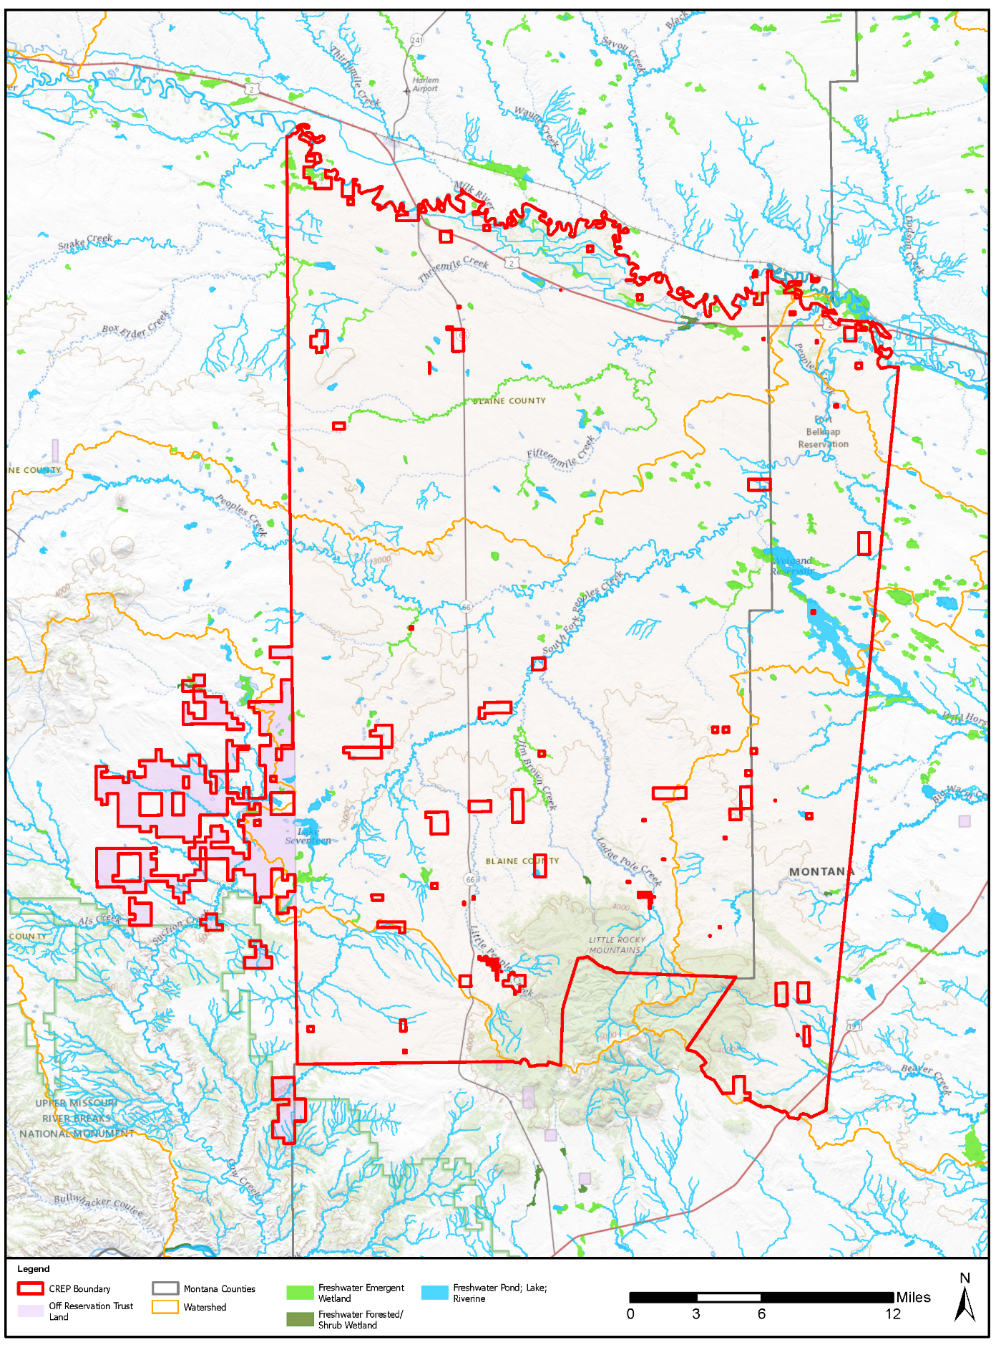
Figure 3-1. Surface Water on the Fort Belknap Reservation

Floodplains
Floodplains are areas of low, level ground present along rivers, stream channels, or coastal waters that are subject to periodic or infrequent inundation due to rain or melting snow. Floodplain ecosystem functions include natural moderation of floods, flood storage and conveyance, groundwater recharge, nutrient cycling, water quality maintenance, and provision of habitat for a diversity of plants and animals. Flood potential is evaluated by the Federal Emergency Management Agency, which defines the 100-year floodplain as an area within which there is a 1 percent chance of inundation by a flood event in a given year, or a flood event in the area once every 100 years. The risk of flooding is influenced by local topography, the frequency of precipitation events, the size of the watershed above the floodplain, and upstream development. EO 11988, Floodplain Management (42 FR 26951, 1979), requires that federal agencies: “…take action to reduce the risk of flood loss, to minimize the impact of floods on human safety, health and welfare, and to restore and preserve the natural and beneficial values served by floodplains...”
Federal agencies are required to avoid, to the extent possible, adverse impacts associated with the occupancy and modification of floodplains and to avoid direct and indirect support of floodplain development. Additionally, all earthmoving, grading, and construction in a Special Flood Hazard Area (as defined by the Federal Emergency Management Agency) would require a Floodplain Development Permit to ensure compliance with the National Flood Insurance Program regulations.
The Project Area lies within many FEMA Flood Insurance Rate Maps (FIRM), most of which are unmapped areas on the Fort Belknap Reservation. The only mapped 100-year floodplain and floodways occur at the north end of the Project Area along the Milk River (FEMA 2023).
A search of the National Oceanic and Atmospheric Administration’s Storm Events Database indicates that there have been 19 floods/flash flood events in Blaine County since 1996 (NOAA, 2023).

Groundwater
Groundwater exists in the saturated zone below the ground surface that collects and flows through permeable zones in aquifers. Groundwater is an essential resource that discharges to surface water supplying baseflow and is used for drinking, irrigation, and industrial purposes. Groundwater typically can be described in terms of depth from the surface, aquifer or well capacity, water quality, recharge rate, and surrounding geologic formations.
Groundwater quality and quantity are regulated under several federal and state programs. Groundwater resources are regulated on the federal level by the USEPA under the Safe Drinking Water Act (SDWA), 42 U.S.C. § 300f et seq. The federal Underground Injection Control regulations, authorized under the SDWA, require a permit for the discharge or disposal of fluids into a well.
The following information is from the FBIC Agricultural Resource Management Plan (2018). Potential groundwater sources and groundwater quality on the Reservation have been characterized by the U.S. Geological Survey (USGS) and Douglas C. Alverson (1965). Upper deposits of alluvium, glacial, and terrace rocks on the Reservation have shown small to moderate quantities of fair to good quality groundwater at rates that are sufficient to support domestic and livestock uses (Alverson 1965). The deeper aquifers under the Reservation yield none to small quantities of poor to fair quality water. The Judith River Formation, along the northwest flank of the Little Rocky Mountains on the Reservation, yields moderate to large quantities of poor to good water from many locations with some under artesian pressure (Alverson 1965). Deep aquifers within the Madison group and Ellis group may supply small to large quantities of good water (Alverson 1965), but it is unknown as to whether there are any water wells within those aquifers. The surface water recharge rates to groundwater in the Project Area likely follow seasonal fluctuations, with highest water levels during the spring and summer.
Groundwater quality within the area is generally composed of fair to good quality slightly alkaline water (Alverson 1965). Additional analysis administered through the FBIC Environmental Department with a source water protection grant found that contaminants from identified sources have had little effect on the groundwater; however, continued monitoring was recommended (FBIC n.d.a). As mentioned previously, the former Zortman and Landusky mines have been identified as a potential contaminant source to groundwater with groundwater in the area showing impacts from acid rock drainage (Indian Law Resource Center 2016a and 2016b). Other nonpoint pollution sources may have the potential to impact groundwater such as wastewater and agricultural runoff (FBIC n.d.a); however, those impacts have not been identified or quantified.

Environmental Consequences Evaluation Criteria
Evaluation criteria for potential impacts on water resources are based on water availability, quality, and use; existence of floodplains; and associated regulations. Adverse impacts to water resources would occur if the proposed or alternative actions:
- Reduce water availability or supply to existing users;
- Overdraft groundwater basins;
- Adversely affect groundwater recharge;
- Exceed safe annual yield of water supply sources;
- Adversely affect water quality;
- Threaten or damage unique hydrologic characteristics;
- Endanger public health by creating or worsening health hazard conditions; or
- Violate established laws or regulations adopted to protect water resources.

Environmental Consequences – Proposed Action Alternative
Implementation of the proposed CREP Agreement would have long-term beneficial impacts on surface water and wetlands. Implementation of rotational grazing practices and designated water facilities would result in increased vegetative cover along riparian areas. This increased cover would stabilize streambanks, reduce erosion, and intercept pollutants carried by runoff. Additionally, these practices can help keep animal wastes from contaminating waterways and wetlands.
Installation and maintenance of CP88 may include the clearing of vegetation for fire breaks, prescribed burning, and some soil disturbance from activities such as fence installation or installation of pipelines or other infrastructure for water conveyance. These activities may result in increased levels of sediment runoff, resulting in short-term negligible adverse impacts to surface water quality and wetlands. The use of erosion control BMPs would reduce impacts and contain sediment within the site. These potential impacts would be short-term and localized and would cease once land preparation activities were completed and vegetation was reestablished.
Herbicides could be used for the control of noxious weeds or other undesirable plants. All herbicides used would be registered with the USEPA and applied according to label requirements. CP88 implementation requiring the use of herbicides, fertilizers, lime, or any other such applications, as well as the timing of implementation, must be pre-approved through a Conservation Plan developed with the NRCS. There would be short-term negligible adverse impacts to surface water from potential runoff of these chemicals. Application in accordance with label requirements would minimize pollutants in runoff.
The Milk River is the only regulated floodplain on the Reservation. However, for the purpose of evaluating impacts from the proposed action in this document, all perennial or intermittent streams will be considered as having floodplains (non-regulated). Impacts to floodplains are expected to be long-term and beneficial as cover enhancement along riparian areas can help stabilize the floodplain. Rotational grazing results in reduced soil compaction and increased infiltration rates which ultimately reduce stormwater runoff.
Impacts to groundwater would be negligible and difficult to quantify. However, the proposed action is not expected to have negative impacts to groundwater, as impacts to surface water are expected to be long-term and beneficial. Overall, rotational grazing practices and establishment of additional water sources should reduce the concentration of nitrates from cattle and reduce chances of groundwater contamination from overgrazing practices.

Environmental Consequences – No Action Alternative
Under the No Action Alternative, the CREP would not be implemented, and current agricultural practices would continue. There would be no impacts to water resources from implementation of the No Action Alternative. The beneficial impacts to surface water, wetlands, floodplains, and groundwater from installing CP88 would not be realized.

AIR QUALITY

Definition of Resource
Air quality is affected by air pollutants emitted by numerous sources, including natural and man-made sources. Weather conditions and topography of the area further influence the amounts and types of pollutants that are present in the ambient air.
To manage pollutant emission levels in ambient air, the USEPA was mandated under the federal Clean Air Act to set standards for select pollutants that are known to affect human health and the environment. These standards, known as National Ambient Air Quality Standards (NAAQS), are currently established for six criteria air pollutants: ozone (O3), carbon monoxide (CO), nitrogen dioxide (NO2), sulfur dioxide (SO2), respirable particulate matter (including particulates equal to or less than 10 microns in diameter (PM10) and particulates equal to or less than 2.5 microns in diameter (PM2.5), and lead (Pb).
To evaluate compliance with NAAQS, USEPA has divided the country into geographical regions with regulatory areas that are designated as an attainment area or nonattainment area for each of the criteria pollutants depending on whether it meets or exceeds the NAAQS. Attainment areas that were reclassified from a previous nonattainment status to attainment are called maintenance areas. For areas designated as nonattainment or maintenance for one or more criteria pollutants, the state must prepare a State Implementation Plan (SIP) or a Maintenance Plan to show how the area will meet or maintain the NAAQS within a specified timeframe.
Federal actions in NAAQS nonattainment and maintenance areas are also required to comply with USEPA’s General Conformity Rule (40 CFR 93). Federal actions are evaluated to determine if project emissions are below de minimis levels for each of the pollutants as specified in 40 CFR § 93.153. If project emissions are below de minimis levels (or are minimal), no further evaluation is required. If project emissions are exceeded for any of the pollutants, detailed analysis is necessary.
Greenhouse gases (GHGs) are gases, occurring from natural processes and human activities, that trap heat in the atmosphere. The accumulation of GHGs in the atmosphere helps regulate the earth’s temperature and are believed to contribute to global climate change. The USEPA regulates GHG emissions via permitting and reporting requirements that are applicable mainly to large stationary sources of emissions. Agricultural activities contribute directly to emissions of GHGs including carbon dioxide (CO2), methane (CH4), and nitrous oxide (N2O). These emissions result through a variety of activities such as the use of diesel-fueled farm equipment, enteric fermentation, agricultural soil and manure management, crop and field burning.
The air quality analysis for this PEA covers the CREP Project Area, which includes the Fort Belknap Reservation in Blaine and Phillips Counties, Montana. The long-term air quality impacts from CP88 implementation are considered in this section. Also considered are effects of short-term activities, such as site preparation and construction, which would lead to increases in emissions. The following discussion provides a general picture of air quality in the CREP Project Area where the proposed project would be located.

Affected Environment
Air quality standards are set by the USEPA as the primary enforcer of the Clean Air Act (CAA) that was originally passed in 1955 as the Air Pollution Control Act. In accordance with U.S.C. Title 42, Chapter 85, §7601(d)(2)(B), the USEPA is given authority to treat tribes as states for purposes of developing, administering, and enforcing air quality regulations within reservation boundaries, irrespective of land ownership. The Tribal Authority Rule implements the provisions of Section 301(d) of the CAA authorizing eligible tribes to implement their own tribal air programs. If a tribe is eligible per the criteria, the rule provides that the tribe will be treated in the same manner as states for virtually all CAA programs.
The following information is from the FBIC Agricultural Resource Management Plan (2018). In 2000, the FBIC assessed air quality conditions with the goal of continuing to maintain a clean airshed. The Project Area is rural in nature and air quality in the Project Area is not located in a non-attainment area (USEPA 2023c). Additionally, an air emissions inventory of the Reservation was also completed in 2000. The air emissions inventory included the transfer stations (gas pipeline) just west of the Reservation, potential impacts from Canada, and a 1-year saturation (i.e., particulate matter 10 micrometers or less in diameter [PM10] and particulate matter 2.5 micrometers or less in diameter [PM2.5]) study to investigate the concentration of PM10 on the southern and the northern ends of the Reservation. As a result of this study, the FBIC Environmental Protection Department indicated the PM air quality on the Reservation should be designated as unclassifiable (FBIC n.d.a; Doney 2008).
Concentrations of total suspended particulates (dust) could occur occasionally during springtime due primarily to wind erosion of tilled land. Additionally, local traffic also likely produces road dust during periods of dry weather. Other emission sources affecting air quality in the area likely include agricultural equipment and trains. Sparse human development in the area has likely resulted in a dispersal of the number of emission sources, which subsequently have a minimal effect on air quality.

Environmental Consequences Evaluation Criteria
The counties within which the CREP Project Area is located, meet the federal standards for emissions of criteria pollutants and are in attainment of the NAAQS for all specified pollutants (40 CFR 17 Part 81.342). In general, air quality impacts in these attainment areas would be considered significant if air emissions associated with the Proposed Action could potentially violate the NAAQS. Impacts would also be considered significant if pollutant emission concentrations associated with the Proposed Action have a potential to impact sensitive receptors (e.g., schools, hospitals, etc.) or have the potential to violate any SIP provisions, including visibility.
For this analysis, the potential impact to air quality is evaluated generally in a qualitative manner, because the location and sizes of specific parcels that would be enrolled are unknown.

Environmental Consequences – Proposed Action Alternative
Installation of practice CP88, Permanent Grasses and Legumes, would maintain existing vegetative cover of either introduced or native grasses and legumes on eligible CRP grassland through rotational grazing. This action would generally yield GHG mitigation benefits and would result in long-term beneficial air quality impacts.
According to a study by Conant et al, (2001), management of grazing land can influence emissions of CO2, CH4 and N2O and can also influence soil organic carbon (SOC) storage by modifying carbon inputs to the soil, including net primary production, root turnover, and carbon allocation between root and shoots. The same study also found that, on average, across climates and regions, the introduction of legumes and improved grass species led to increases in net soil carbon storage. Additionally, Conant et al. (2001, 2017) and other similar studies have found that, in general, planting nitrogen-fixing legumes can promote carbon sequestration in grassland soils and may provide an alternative to nitrogen fertilization with a lower overall GHG footprint. Although the recovery of soil carbon is a slow process and could take several decades, air quality is likely to benefit in the long-term from implementation of the proposed CREP Agreement due to increased storage of organic carbon. The potential for carbon sequestration and reduction in pollutant emissions would likely have an overall positive effect on air quality resulting in a mitigating effect on GHG emissions.
Installation and maintenance for CP88 may include installation of fencing and gates, water sources for livestock, and construction of fuel breaks. Activities such as digging and debris removal can produce dust or release particulate matter into the air. These emissions would be primarily fugitive in nature and temporary. Watering exposed soil during, and after, such ground-disturbing activities would reduce dust emissions. Use of diesel vehicles and heavy-duty equipment would emit air pollutants into the air as exhaust emissions from combustion of fuel. Routine and proper maintenance of equipment and vehicles would keep these pollutant emissions in check. These emissions are not likely to impact air quality significantly as they would be localized and temporary.
Debris removal activities may take place in combination with prescribed burning of vegetative material. The exact location and extent of burning that would take place for this Proposed Action is not known at this time. Burning could release PM10, PM2.5, CO and NO2 into the air. The type and quantity of these pollutants would be determined by the type of vegetation being burned and the weather conditions. Depending on where the burn takes place, there could be restrictions to burning in the area. Consultation with Tribal, state, and local permitting agencies, as applicable, is recommended to determine the open burning regulations for the affected county given that these regulations can change each season.
Construction of structures, such as firebreaks, hydrological barriers, and other access control devices could be performed with various types of equipment, such as backhoes, front-end loaders, tractors and skid-steer loaders. Diesel vehicles and heavy-duty diesel equipment used for such operations would emit pollutants such as CO, VOCs, NOx and PM, but these emissions would be localized, temporary and minor. Routine and proper maintenance of equipment and vehicles and use of BMPs for construction activities would reduce pollutant emissions. Fugitive emissions from construction activities would be mitigated using dust suppression practices, as needed.
Overall, there is potential for air quality to benefit in the long-term due to the potential for carbon sequestration. Implementation of the Proposed Action could potentially improve air quality in the region.

Environmental Consequences – No Action Alternative
Under the No Action Alternative, the CREP would not be implemented, existing grassland practices would continue. Implementation of No Action Alternative would not change existing air quality conditions.

SOILS AND TOPOGRAPHY

Definition of Resource
Soils are the unconsolidated materials overlying bedrock or other parent material. Soils typically are described in terms of their complex type, slope, and physical characteristics. Differences among soil types in terms of structure, elasticity, strength, shrink-swell potential, and erosion potential affect the ability of a given area to support certain applications or uses. In certain cases, soil properties must be assessed for their compatibility with particular construction activities or types of land use. Topography and physiography pertain to the general shape and arrangement of the land surface, including the height and position of natural and man-made features.

Affected Environment
Topography plays a significant role in the location and type of soils found across the Project Area. Topography in the northern portion of the Project Area generally consists of glacial plains and alluvial river valley lands, which give way to rolling grasslands, river breaks, and eventually the Little Rocky Mountains that are found in the southern portion of the Project Area (FBIC 2018). Elevations in the Project Area range from approximately 2,300 feet to 5,000 feet (Klauk 2017). The health of the soil in the Project Area is critical for agricultural activities, and farm/pasture lease rates and AUMs for range units are generally partly determined by soil classification and health (FBIC 2018).
Soil series were developed by the USDA NRCS as part of a soil classification system for the U.S. The Reservation lies within the Blaine County and Part of Phillips County Area, Montana soil survey area. The Reservation consists of 175 soil map units. Therefore, for the purpose of this document, soil map units have been grouped into their respective soil series, which are based on similarities. The approximate acreage and percentages of the soil map units that encompass greater than 1% of the Reservation are shown in Table 5.
Table 5. Soil Associations in the Project Area
Unit | Map Unit Soil Name | Percentage of Reservation | Soil Series
200 | Farland-Cherry silt loams, 2 to 8 percent slopes | 11 | Farland
317 | Phillips-Elloam complex, 0 to 4 percent slopes | 8 | Phillips
109 | Phillips loam, 0 to 4 percent slopes | 1
63 | Phillips-Elloam complex, 4 to 8 percent slopes | 1
218 | Telstad loam, 0 to 4 percent slopes | 5 | Telstad
157 | Telstad-Joplin loams, 2 to 8 percent slopes | 3
46 | Telstad loam, 2 to 8 percent slopes | 1
255 | Thoeny-Elloam complex, 0 to 4 percent slopes | 6 | Thoeny
48 | Thoeny-Kevin-Elloam complex, 4 to 8 percent slopes | 1
230 | Zahill-Vida clay loams, 15 to 35 percent slopes | 3 | Zahill
99 | Zahill clay loam, 25 to 45 percent slopes | 2
59 | Cabba-Cambert-Cherry silt loams, 8 to 15 percent slopes | 3 | Cabba
30 | Cabba-Cambert silt loams, 15 to 45 percent slopes | 1
232 | Nishon clay loam, 0 to 2 percent slopes | 3 | Nishon
27 | Vanda-Nobe clays, 0 to 2 percent slopes | 2 | Vanda
52 | Vanda clay, 0 to 2 percent slopes | 1
141 | Dooley sandy loam, 0 to 4 percent slopes | 2 | Dooley
116 | Dimmick silty clay | 2 | Dimmick
18 | Whitecow association, steep | 1 | Whitecow
31 | Whitecow-Warneke gravelly loams, 25 to 60 percent slopes | 1
47 | Havrelon loam, 0 to 2 percent slopes | 2 | Havrelon
58 | Martinsdale clay loam, 0 to 4 percent slopes | 1 | Martinsdale
28 | Martinsdale loam, 1 to 8 percent slopes | 1
28 | Turner-Beaverton complex, 8 to 15 percent slopes | 1 | Turner
97 | Evanston loam, 2 to 8 percent slopes | 1 | Evanston
28 | Harlem silty clay loam, protected, 0 to 2 percent slopes | 1 | Harlem
Source: USDA NRCS 2023, FBIC 2018
Three soil series that comprise 30% of the Reservation (i.e., Farland, Phillips, and Telstad) are very deep, well- drained soils with moderately slow to slow permeability. The Farland soil series is a product of stratified alluvium, which was formed by sediments deposited by running bodies of water (USDA NRCS 1998). The Phillips and Telstad soil series are a product of till parent material, which formed from a direct deposit of glacial sediments. When cultivated, Farland soil is suitable for growing small grains, such as flax, corn, and hay. Irrigated Farland soils have the potential to yield alfalfa, beans, corn, and sugar beets (USDA NRCS 1998). Phillips and Telstad soil series are suitable for rangeland use and dryland farming, such as small grains (e.g., wheat, rye, barley, etc.). Generally, these soils are subject to long, cold winters; and, can experience 90-130 day period of frost-free conditions (USDA NRCS 1998).

Environmental Consequences Evaluation Criteria
Minimization of soil erosion, and the siting of facilities in relation to potential geologic hazards are considered when evaluating potential impacts of the Proposed Action on soils and topography. Generally, impacts can be avoided or minimized if proper construction techniques and erosion control measures are incorporated into project development.
Effects on soils and topography would be adverse if they would alter the lithology, stratigraphy, or geological structures that control groundwater quality or availability. Impacts would also be considered adverse if implementation changes the soil composition, structure, or function of soil within the environment or if implementation permanently increases the potential for erosion.

Environmental Consequences – Proposed Action Alternative
Under the Proposed Action Alternative, long-term beneficial impacts are expected to occur from stabilization of soils and topography. Enhanced vegetative cover would hold the soil in place and lead to lower soil erosion rates. Soil compaction would decrease from rotational grazing, protecting the soil structure of the grasslands.
Short-term disturbances to soils could result from the installation of various structures to implement rotational grazing such as fences and water features. These ground disturbing activities may result in temporary minor increases in soil erosion; however, they would be reduced by implementing erosion control BMPs such as establishing stable grades, applying water to limit airborne dust in windy environments, and installing silt fencing. Under the Proposed Action Alternative, erosion and soil compaction would be properly controlled during CP88 installation resulting in minor impacts to soils.

Environmental Consequences – No Action Alternative
Under the No Action Alternative, the proposed CREP would not be implemented. Eligible lands would not be enrolled in the proposed CREP and potential benefits to soils and topography would not occur. The beneficial impacts associated with the expected reduction in erosion would not occur and soil degradation would continue.

SOCIOECONOMICS

Definition of Resources
Socioeconomic analyses generally include detailed investigations of the prevailing population, income, employment, and housing conditions of a community or region. The socioeconomic conditions of a region could be affected by changes in the rate of population growth, changes in the demographic characteristics of a region, or changes in employment caused by the implementation of a Proposed Action.
The sections below identify the information essential to describe the broad-scale demographic and economic components of the Fort Belknap Indian Community.

Affected Environment

General Population Characteristics
Population
The population (3,382) in the Project Area comprises less than 1% of Montana’s total population (1,122,867) and approximately 4% of the state’s American Indian and Alaska Native population (U.S. Census Bureau 2023). There are an estimated 8,000 enrolled tribal members, half of whom live on the Reservation (US. Census 2023, Mt. Office of the Governor).

Personal Income and Earnings
With respect to low-income populations, the incidence of poverty on the Reservation is higher than the counties located partially within the Reservation and the state as a whole. Table 6 illustrates the median income and poverty rates for the Reservation, the two counties located partially within the Reservation, and the State of Montana. According to 2022 US Census data, the median income for the FBIC ($44,500) was approximately 34% lower than the median income for the State of Montana ($67,631) and approximately 24% lower than the median income for Blaine County ($58,507). Further, the proportion of residents on the Reservation living below the poverty line was over two times as high as those living in poverty statewide.
Table 6. Average Income and Poverty Rates (2022)
Location | Median Income | Poverty Rate¹
Reservation | $44,500 | 30.7%
Blaine County | $58,507 | 20.2%
Phillips County | $61,250 | 6.9%
Montana | $67,631 | 12.1%
Source: U.S. Census Bureau 2023
¹Percentage of people whose income in the past 12 months was below the poverty level.
Table 7 illustrates data from the Bureau of Economic Analysis (BEA) for earnings by place of work between 2019 and 2022 for Blaine County and Phillips County. The BEA defines earnings as the sum of three components of personal income: wage and salary disbursements, supplements to wages and salaries, and proprietors' income. Personal income across both counties rose steadily during that time period. Farm earnings rose dramatically, over 100% in both counties, during that time period.
Table 7: Earning Measures for the Fort Belknap Indian Community
Earnings Measure | 2019 | 2020 | 2021 | 2022 | Percent Change from 2019 to 2022
Personal Income (Blaine County) | 204,535 | 228,466 | 229,114 | 254,170 | 24.3%
Personal Income (Phillips County) | 163,624 | 177,721 | 178,635 | 190,653 | 16.5%
Farm Earnings (Blaine County)¹ | 20,237 | 23,656 | 12,680 | 40,853 | 101.9%
Farm Earnings (Phillips County)¹ | 8,006 | 11,998 | 5,759 | 20,225 | 152.6%
Nonfarm Earnings | 204,535 | 228,466 | 229,114 | 254,170 | 24.3%
Source: BEA, 2023a
Notes: ¹ Farm Earnings are comprised of the net income of sole proprietors, partners, and hired laborers arising directly from the current production of agricultural commodities, either livestock or crops. It includes net farm proprietors' income and the wages and salaries, pay-in-kind, and supplements to wages and salaries of hired farm laborers; but specifically excludes the income of non-family farm corporations.
Employment
The Bureau of Labor Statistics (BLS) compiles current and historic data on the labor force, the number of persons employed, the number of persons unemployed, and the unemployment rate. Montana, between 2019 to 2022, increased the total labor force by approximately 8.7% to 746,194 persons (BEA, 2022b). The annual average unemployment rate was 3.5% in 2019, spiking due to the coronavirus pandemic at 5.8% in 2020, and rebounding to 2.6% by 2022 (BLS, 2022b).
The BEA also tracks employment characteristics at the farm and nonfarm levels. Table 8 illustrates the employment levels between 2019 to 2022 for the state of Montana and the Fort Belknap Reservation. The data for both Montana and the Reservation show overall increases in total employment and farm employment from 2019 to 2022, with considerable annual variation. Total employment numbers dropped lightly in Montana from 2019 to 2020, which can generally be attributed to the coronavirus pandemic. Employment in Blaine and Phillips County decreased slightly from 2019 to 2020. Farm employment in the counties that contain the Reservation is a higher proportion of all jobs when compared to the state.
Table 8. Employment in the State and Fort Belknap Reservation 2015 – 2020
Type of Employment | 2019 | 2020 | 2021 | 2022
State of Montana
Total Employment | 685,999 | 684,052 | 716,176 | 746,194
Farm Employment | 29,429 | 29,221 | 28,637 | 29,362
Percentage Farm Employment | 4.3% | 4.3% | 4.0 | 3.9%
Nonfarm Employment | 656,570 | 654,831 | 687,539 | 716,832
Fort Belknap Indian Community/Blaine County Phillips County
Total Employment | 5081 | 5024 | 5049 | 5151
Farm Employment | 1100 | 1096 | 1073 | 1100
Percentage Farm Employment | 21.7% | 21.8% | 21.3% | 21.4%
Nonfarm Employment | 3979 | 3928 | 3976 | 4051
Source: BEA, 2022b.

General Agricultural Characteristics
The National Agricultural Statistic Service (NASS) estimated that there were approximately 27,048 farms with approximately 58.1 million acres of land in farms in Montana in 2017 (NASS, 2017). The FSA detailed in their December 2021 CRP monthly report that there were 1,868 Montana farms with CRP contracts with 807,703 acres in CRP practices (FSA, 2023).
For the Fort Belknap Indian Community, the best available data at the county level was compiled in the 2017 Agricultural Census and can be found in Table 9. In 2017, Blane County and Phillips County accounted for approximately 5,995,247 acres in Montana (6.4% of the land area of the state) with approximately 3,976,672 acres in farms (NASS, 2017). Cropland accounted for approximately 18% of the total land in Blane and Phillips Counties and harvested cropland accounted for approximately 10% of the total land in the two counties (NASS, 2017). The land use of Blaine and Phillips is estimated at about 48% pasture and rangeland.
Table 9. 2017 Agricultural Land Use in Blaine and Phillips Counties and Montana
Land Use | Blaine and Phillips County | Percent of Reservation County Area | Montana | Percent of Montana Total
Approximate Land Area | 5,995,247 | 100% | 93,149,066 | 100%
Land in Farms | 3,976,672 | 66% | 58,122,878 | 62%
Total Cropland | 1,107,821 | 18% | 16,406,300 | 18%
Harvested Cropland | 605,802 | 10% | 9,901,226 | 11%
Woodland | 25,949 | 0% | 2,540,798 | 11%
Pasture and Rangeland | 2,874,588 | 48% | 38,459,451 | 41%
Source: NASS 2017 Census of Agriculture

Regional Production Expenses, Agricultural Sales, and Other Farm Related Income
Farm production expenses in 2017 for Phillips and Blaine Counties were estimated to exceed $153 million and total agricultural sales exceeded $164 million (NASS, 2017). Other farm related income (i.e., recreation, custom farming, cooperative patronage rebates, cash rents, etc.) contributed an additional $25 million to farm balance sheets in 2017 (NASS, 2017). In 2017, the average production expenses per farm was $166,981 in Blaine County and $161,220 in Phillps County. The average agricultural sales per farm was $350,974, and the average farm related income per farm was $49,890 in Blaine County and $43,841 in Phillips County.
Data from the 2017 Agricultural Census indicates that the average farm production expenses per acre (using the total acres in farms minus land in houses, roads, ponds, etc. within the region) in Blaine County was $40.19 per acre, and Phillips County was $37.05 per acre (NASS, 2017). Farm income from agricultural sales was estimated to have been $44.10 per acre in Blaine County and $38.54 in Phillips County with income from farm related sources adding $7.02 and $5.81 per acre, respectively (NASS, 2017).

Environmental Consequences Evaluation Criteria
A significant impact to socioeconomic conditions can be defined as a change that is outside the normal or anticipated range of those conditions that would flow through the remainder of the economy and community creating substantial adverse effects. For small percentage changes in individual attributes, it would be unlikely that the changes would result in significant impacts at the total level of analysis (i.e., statewide). Changes to the statewide economy of greater than agriculture’s normal contribution could be considered significant, as this could affect the general economic climate of other industries on a much greater scale.
Additional changes in demographic trends (i.e., population movements) would be considered significant if a substantial percentage of the population were to enter or leave a particular area based on the changing economic conditions associated with the alternatives, rather than projected changes or changes generated by economic activities as a whole.

Environmental Consequences – Proposed Action Alternative
Implementation of the Proposed Action would generate $9,375,000 in annual rental payments if 625,000 acres were enrolled. This is a fully implemented scenario that was developed by assuming full enrollment of 625,000 acres for 15 years in year one. A more likely scenario is a gradual conversion up to a certain point of less than full enrollment.
Federal funding would be used to pay the rental rates and additional funding would also be provided for cost sharing to install CP88. Enrollment in the CREP would not preclude producers from haying and grazing, therefore, producers would still be able to generate income from agricultural sales. It is anticipated that a large portion of the lands to be enrolled already have some of the necessary facilities, such as water facilities and fencing. Therefore, the cost to implement CP88 is not expected to be exceedingly high, and the producer would be responsible for only 50% of these installation costs.
For land enrolled under CP88, the Conservation Plan would contain provisions for common grazing or forage management practices and related activities consistent with achieving CRP purposes and maintaining the health and viability of grassland resources. The grassland CRP is a working lands program. Working lands conservation programs help farmers to enhance the sustainability of their operations while keeping land in production. Enhancing the sustainability of the grasslands increases the economic value of grassland through increases in grassland productivity and increases in the carrying capacity of the land enrolled.
The economic impact of implementing the CREP Agreement would be beneficial for producers. The program is voluntary, so if a producer believes that enrolling in the program would not be profitable, they could choose not to enroll. Wu and Weber (2012) reviewed the existing studies on the impacts of CRP and concluded that the economic benefits outweigh the costs to taxpayers. Economic benefits of CRP include the reduction of soil erosion, the improvement of recreation conditions, and the increase in land values (Wu and Weber, 2012). Although, enhanced wildlife habitat is not a goal of this CREP, wildlife would benefit from improved grassland productivity and reduced erosion as described in Section 3.3.4.2. Improved wildlife habitat would contribute positively to recreational activities and expenditures in the region, such as wildlife viewing activities, hunting, and fishing (improved water quality would increase fish populations).
Additionally, part of the evaluation of all lands offered for enrollment in CRP is a site-specific EE, which includes an evaluation of potential negative impacts on the local social and economic conditions. The site- specific EE would ensure that enrollment of specific lands into the CREP would not result in significant adverse impacts to the local economy.
Implementation of the Proposed Action Alternative would result in long-term beneficial impacts to producers and would improve the economic conditions in the region.

General Population Impacts
Implementing the Proposed Action is unlikely to produce significant changes in the general population characteristics of the region in either the short-term or long-term. Recent research supports this conclusion. A study conducted by the USDA’s Economic Research Service showed that declines in agriculture and supporting industries due to enrollment of land in CRP are on average offset by increases in other businesses and industries such as recreation (Sullivan et al. 2004; Brown et. al., 2018). The study also concluded that there was no evidence that CRP contributed to outmigration and population decline in rural counties (Sullivan et al. 2004; Brown et. al., 2018). In the case of the grassland CRP, there could be a small increase in population as the economic benefits of the program may encourage producers to return to previous ranching operations.

Environmental Consequences – No Action Alternative
Under the No Action Alternative, the CREP would not be implemented, and current agricultural practices would continue. Unlike the Proposed Action Alternative, no acreage within the reservation would be enrolled in CP88. This alternative would not produce any measurable changes to the general population characteristics of the region as there would be no changes to the sales or spending patterns of the agricultural producers. However, there would be the lost benefits associated with implementing CP88 that include improvements in water quality, soil retention, grassland productivity, carrying capacity, and improved wildlife habitat. Any regional economic benefits from increased hunting, fishing, and wildlife-watching expenditures would not be realized.

ENVIRONMENTAL JUSTICE

Definition of Resource
Federal agencies, through EOs, are required to address disproportionate environmental and human health effects in minority and low-income communities. For the purposes of this analysis, minority populations are defined as Alaska Natives and American Indians, Asians, Blacks or African Americans, Native Hawaiians, and Pacific Islanders or persons of Hispanic origin (of any race). Low-income populations include persons living below the poverty threshold as determined by the U.S. Census Bureau.
EO 12898, Federal Actions to Address Environmental Justice in Minority Populations and Low-Income Populations, pertains to environmental justice issues and relates to various socioeconomic groups and disproportionate impacts that could be imposed on them. This EO requires that federal agencies’ actions substantially affecting human health or the environment do not exclude persons, deny persons benefits, or subject persons to discrimination because of their race, color, or national origin. EO 12898 was enacted to ensure fair treatment, meaningful involvement, and access to benefits for all people regardless of race, color, national origin, or income with respect to the development, implementation, and enforcement of federal environmental laws, regulations, and policies. Consideration of environmental justice concerns includes race, ethnicity, and the poverty status of populations in the vicinity of a Proposed Action.

Affected Environment
Per CEQ guidance, minority populations are identified where either the minority population of the affected area exceeds 50 percent, or the minority population percentage of the affected area is meaningfully greater than the minority population percentage in the general population or other appropriate unit of geographic analysis. Following the Office of Management and Budget’s Statistical Policy Directive 14, the Census Bureau uses a set of money income thresholds that vary by family size and composition to determine who is in poverty. If a family's total income is less than the family's threshold, then that family and every individual in it is considered in poverty.
In order to determine if minority or low-income populations exist in the Project Area, the Project Area must be compared to a larger regional area that includes the affected area and serves as a Community of Comparison (COC). The state of Montana is the COC under this environmental justice analysis.
Because the CREP would be implemented on a reservation, a minority group, American Indians, exist in the Project Area. On Fort Belknap Indian Reservation in 2022, 93% of the population had a race of Alaska Natives and American Indians, compared to 6% in the state of Montana in 2022 (U.S. Census Bureau, 2023b). Other minority populations found on the reservation accounted for less than 2% of total population. In 2022, the poverty rate for Blaine County was 20.2% and Phillips County is 6.9% (U.S. Census Bureau, 2023b, US Census Bureau, 2023c). The Montana poverty rate of 12.1% and the U.S. poverty rate of 11.4% (U.S. Census Bureau, 2023a). Compared to the COC, the reservation as whole has a significantly higher proportion of minorities and, in the case of Blaine County, a higher proportion of low-income populations.
In 2017, within the Reservation, there were 155 agricultural producers of American Indian or Alaska Native race, representing 9% of the agricultural producers in the reservation. Table 10 displays the number of agricultural producers by each race in 2017. This represents about 9% of the American Indian or Alaska Native race producers (1,764 producers) in the entire state of Montana in 2017 (NASS, 2017).

Table 10: 2017 Agricultural Producers by Race in Blaine and Phillips Counties
Race | Blaine and Phillips Counties | Percent
American Indian or Alaska Native | 155 | 9%
Asian | 0 | 0%
Black or African American | 1 | 0%
Native Hawaiian or Other Pacific Islander | 0 | 0%
White | 1473 | 89%
More than one race reported | 17 | 1%
Total Producers | 1646 | 100%
Source: NASS 2017.

Environmental Consequences Evaluation Criteria
Environmental justice analysis applies to potential disproportionate effects on minority or low-income populations. Environmental justice issues could occur if an adverse environmental or socioeconomic consequence to the human population fell disproportionately upon minority or low-income populations. Environmental justice impacts could also occur if the benefits of a Proposed Action would be disproportionally low for minority or low-income populations.

Environmental Consequences – Proposed Action Alternative
The majority of the environmental impacts described in this PEA would be beneficial to the region and to producers enrolling land into the CREP. The enrollment of lands into the CREP is voluntary and open to any producer with qualifying land. Some negligible and minor adverse impacts have been identified in this PEA. These adverse impacts would be temporary and would not rise to the level of major (significant). Additionally, part of the evaluation of all lands offered for enrollment in CRP is a site-specific EE, which includes an evaluation of potential environmental justice impacts. The site-specific EE would ensure that enrollment of specific lands into the CREP would not result in disproportionately adverse human health or environmental effects to minority or low-income communities. The Proposed Action Alternative would not substantially affect populations covered by EO 12898 by excluding persons, denying persons benefits, or subjecting persons to discrimination or disproportionate environmental or human health risks. Therefore, there would be no environmental justice issues from implementation of the Proposed Action Alternative.

Environmental Consequences – No Action Alternative
Under the No Action Alternative, there would be no changes to the existing agricultural lands in the Fort Belknap Indian Community. Therefore, implementation of this alternative would not result in disproportionate adverse environmental or health effects on low-income or minority populations. The No Action Alternative would not substantially affect populations covered by EO 12898 by excluding persons, denying persons benefits, or subjecting persons to discrimination or disproportionate environmental or human health risks.

CUMULATIVE IMPACTS
Cumulative impacts to environmental resources result from the incremental effects of proposed actions when combined with other past, present, and reasonably foreseeable future projects in the Project Area. Cumulative impacts can result from individually minor, but collectively substantial, actions undertaken over a period of time by various agencies (federal, state, and local) or individuals. Past and present actions are reflected in the Existing Conditions sections for each resource area. A list of reasonably foreseeable actions on the Fort Belknap Indian Community that could result in cumulative impacts with implementation of the Proposed Action are listed below. Future actions that have no potential for cumulative impacts to resources analyzed in this PEA are not listed in the table.
There would be no potential for cumulative impacts from the No Action Alternative. The analysis below is for potential cumulative impacts from implementation of the Proposed Action.
Reasonably Foreseeable Future Actions

Fort Belknap Indian Community Water Rights Settlement Act of 2023
The Fort Belknap Indian Community Water Rights Settlement Act of 2023 (2023 Water Settlement Bill) was passed through the US Senate on July 27, 2023, and must now be brought in front of the US House of Representatives for approval. Although the 2023 Water Settlement Bill has not yet been enacted, if it is implemented it could result in cumulative impacts in combination with the Proposed Action. The following elements of the 2023 Water Settlement Bill, as summarized by the FBIC Council, could overlap with improvements from the CREP.
- $415 million for the BIA to rehabilitate, modernize, and expand the Fort Belknap Indian Irrigation Project on the Milk River, including the Three Mile and White Bear units, construction of a Fort Belknap Reservoir and the Peoples Creek Flood Protection Project. The Bureau of Indian Affairs will retain federal responsibility for the FBIIP.
- $119 million for the FBIC to: restore the Southern Tributary Irrigation Project and Peoples Creek Irrigation Project, including construction of the Upper Peoples Creek Dam and Reservoir, on the southern portion of the Reservation; develop infrastructure for stock-watering across the Reservation; provide on-farm development support; and restore wetlands across the Reservation.
- Congress will ratify the 2001 Fort Belknap-Montana Water Rights Compact affirming the quantification of and sources for the FBIC’s Tribal water rights—providing a judicially enforceable right to use the water. The Water Compact provides sufficient Tribal water rights to irrigate 34,500 acres of Reservation lands, including the existing Milk River unit and the Southern Tributary Irrigation Project.
There are no other reasonably foreseeable future actions that may have cumulative impacts on the Proposed Action.

Biological Resources
Implementation of the Proposed Action would result in long-term beneficial impacts to biological resources. These would be additive to the beneficial impacts from other similar USDA programs and other state and federal conservation programs that aim to protect and restore habitat on the reservation. The 2023 Water Settlement Bill, if implemented, would have beneficial cumulative impacts for water resources and wetland restoration. Although difficult to measure, these improvements should have long term beneficial impacts on biological resources. However, funding would also be used for irrigation infrastructure improvements, which could result in landowners transitioning land to farmland rather than the CREP for grassland improvements.

Cultural Resources
Assuming compliance with Section 106 of the NHPA as outlined in Section 3.4.4, when considered in combination with the other reasonably foreseeable future actions, the Proposed Action is not expected to result in significant cumulative impacts to historic properties. All ground disturbing actions utilizing public funds are anticipated to have separate and complete cultural resources reviews prior to initiating work.

Water Resources
Short-term impacts to surface water may occur during establishment of CP88, but these impacts would be negligible, well controlled with BMPs, and would not impact water quality at the regional level. Any adverse environmental impacts to water resources from the Proposed Action Alternative would be negligible to minor on their own and, when added to the impacts to water resources from other reasonably foreseeable future actions, would not result in a significant impact. The 2023 Water Settlement Bill, if implemented, would have beneficial cumulative impacts for water resources and wetland restoration by providing funding for improvements.

Air Quality
The Proposed Action Alternative to enroll existing grassland into the CREP program would add to land already participating in CREP or other similar conservation programs in Montana. If more land is brought under conservation programs, there would be an additional improvement in air quality in the long-term. Any adverse air quality impacts from the Proposed Action Alternative would be negligible to minor on their own and, when added to the anticipated air quality impacts from reasonable foreseeable future actions, would not result in a significant impact.

Soils and Topography
Short-term, adverse impacts to soils may occur during installation of CP88, but these impacts would be negligible, well controlled with BMPs, and would not impact erosion rates at the regional level. Any adverse environmental impacts to soils and topography from the Proposed Action Alternative would be short term and negligible to minor on their own. The 2023 Water Settlement Bill could result in adverse cumulative impacts on soils if landowners choose to transition land to farmland rather than the CREP for grassland improvements. However, these impacts would be negligible and minor.

Socioeconomics
The Proposed Action along with reasonably foreseeable future actions could result in direct or indirect impacts to the economy of the region. The CREP program would be economically beneficial to agricultural producers and would also provide societal benefits such as reduced soil erosion, improved water quality, and improved wildlife habitat. As with other USDA conservation programs, long-term beneficial impacts to recreation would occur. Recreational opportunities indirectly benefit from other federal and state conservation programs that protect and restore habitat, resulting in cumulative beneficial impacts to wildlife-related recreational opportunities. No significant adverse cumulative impacts to socioeconomics are expected from the Proposed Action when added to the other reasonably foreseeable future actions. The 2023 Water Settlement Bill could result in beneficial economic cumulative impacts for the Reservation by improving irrigation and water resources, adding jobs, and resulting in more profitable farmland and rangeland yields.

Environmental Justice
The Proposed Action, as well as reasonably foreseeable future actions, are not expected to have a disproportionate cumulative impact on minority and low-income populations. Cumulative impacts to environmental justice, if any, would be beneficial for the community by providing additional federal aid to Tribal members for property and farm improvements.

This page intentionally left blank

REFERENCES
Allen, A.W., and Vandever, M.W. 2012. Conservation Reserve Program (CRP) contributions to wildlife habitat, management issues, challenges, and policy choices—An annotated bibliography: U.S. Geological Survey Scientific Investigations Report 2012–5066, 185 p.
Alverson, D. C. 1965. Geology and Hydrology of the Fort Belknap Indian Reservation Montana. Geological Survey Water-Supply Paper. 1576-F. Available from: https://pubs.er.usgs.gov/publication/wsp1576F.
Brown, Jason, Lambert, Dayton M. and Wojan, Timothy R. 2018. The Effect of the Conservation Reserve Program on Rural Economies: Deriving a Statistical Verdict from a Null Finding. Federal Reserve Bank of Kansas City Working Paper No. RWP 18-04, Available at SSRN: <https://ssrn.com/abstract=3236272>.
BEA. 2022a. CAINC5N Personal Income by Major Component and Earnings by NAICS Industry. <https://apps.bea.gov/iTable/iTable.cfm?reqid=70&step=1#reqid=70&step=1>. Accessed on November 20, 2023.
BEA. 2022b. CAEMP25N Total Full-Time and Part-Time Employment by NAICS Industry. <https://apps.bea.gov/iTable/iTable.cfm?reqid=70&step=1#reqid=70&step=1>. Accessed on November 20, 2023.
Bureau of Labor Statistics (BLS). 2020. Labor force data by county, 2020 annual averages. <https://www.bls.gov/lau/>. Accessed on November 21, 2023.
BLS. 2022a. States and selected areas: Employment status of the civilian noninstitutional population, 1976 to 2020 annual averages. <https://www.bls.gov/lau/>. Accessed on November 20, 2023.
BLS. 2022b. Local Area Unemployment Statistics (LAUS), Unemployment Rates for States, Annual Averages. <https://www.bls.gov/lau/>. Accessed on November 20, 2023.
Comer, P., D. Faber-Langendoen, R. Evans, S. Gawler, C. Josse, G. Kittel, S. Menard, M. Pyne, M. Reid, K. Schulz, K. Snow, and J. Teague. 2003. Ecological systems of the United States: A working classification of U.S. terrestrial systems. NatureServe, Arlington, VA.
Conant, R.T., K. Paustian, and E.T. Elliott. 2001. Grassland Management and Conversion into Grassland; Effects on Soil Carbon. Ecological Applications, 11:343–355. <https://www.jstor.org/stable/3060893>.
Conant, R.T., K. Paustian, and B.B. Osborne. 2017. Grassland Management Impacts on Soil Carbon Stocks: A New Synthesis. Ecological Applications, 27(2):662–668.
Congressional Research Service. 2016. Indian Water Rights Settlements Report.
Department of Natural Resources & Conservation (DNRC). 2023. Fort Belknap Indian Reservation Compact. https://dnrc.mt.gov/Water-Resources/Compacts/Fort-Belknap-Indian-Community#:~:text=This%20compact%20quantifies%20water%20rights,by%20the%20United%20States%20Congress. Accessed November 29, 2023.
Farm Service Agency (FSA). 2021. Conservation Reserve Program Monthly Summary – September 2023. <https://www.fsa.usda.gov/Assets/USDA-FSA-Public/usdafiles/Conservation/Others/crp-monthly/Summary-September-2023-CRPMonthly.pdf>. Accessed November 21, 2023.
FBIC. 2013. Gros Ventre and Assiniboine Tribes of the Fort Belknap Indian Community Water Rights Settlement Bill: Executive Summary. August 26, 2013.
FBIC. 2017a. Tribal Fee land. Confirmed via personal communication, Warren Morin, October 2017.
FBIC. 2017b. Fort Belknap Indian Community Environmental Protection Department Comments on Working Draft Agricultural Resource Management Plan and Programmatic Environmental Assessment. Personal communication with Ina Nez Perce via email. November 9, 2017.
FBIC. 2017c. BIA Roads. Confirmed via personal communication, Wes Cochran, November 2017.
FBIC. n.d.a. Comprehensive Economic Development Strategies (CEDS) 2012-2017. Available from: http://www.ftbelknap.org/fbicplanning/documents/FB%20CEDS%20Final%20Report%20%20061213.pdf.
FBIC. n.d.b. Wetlands Program Workplan FY2010-FY2015.
FBIC Council. 2023. Council Summary 2023 Water Settlement Bill. Available at: https://img1.wsimg.com/ blobby/go/d94bfdb9-dd85-49bd-94c2-4822ef04bf3b/downloads/Council%20Summary%202023%20 Water%20Settlement%20Bill.pdf?ver=1703196403219.
Federal Emergency Management Agency (FEMA). 2023. FEMA National Flood Hazard Layer (NFHL) Viewer. https://www.fema.gov/flood-maps/national-flood-hazard-layer. Accessed November 29, 2023.
Fort Belknap Indian Community (FBIC). 2018. Final Agricultural Resource Management Plan and Programmatic Environmental Assessment. January 2018.
Fort Belknap Indian Community (FBIC). 2021. Draft Five-year Conservation Plan October 1, 2021 – September 30, 2026. FBIC Fish and Wildlife Department. Version: August 16, 2021.
Forest Invasive Plants Resource Center. 2016. Autumn olive (Elaeagnus umbellata) and Russian olive (Elaeagnus angustifolia). Available from: http://www.na.fs.fed.us/spfo/invasiveplants/.
Fredericks, T. W., Patterson, J.P., Provencio, E.A., and Reagen, C.J. 2013. Motion for leave to appear amicus curiae and to submit an amicus memorandum in support of the United States’ Motion for order requiring DNRC to examine for post-June 30, 1973 nonuse and motion for water court to adjudicate post-June 30, 1973 abandonment in the Montana adjudication and brief in support. In the water court of the State of Montana Yellowstone division Tongue River below Hanging Woman Creek – Basin 42C. Case 42B-1. Available from https://courts.mt.gov/Portals/113/water/42B1_FortBelknapAmicus.pdf.
Goodwin, K., and Longknife, D. 2013. Fort Belknap Indian Community, Noxious Weed Management Strategic Plan 2013-2018. Bozeman MT: Center for Invasive Species Management, Montana State University.
Herkert, J. R. 1998. Effects of management practices on grassland birds: Henslow’s Sparrow. Northern Prairie Wildlife Research Center, Jamestown, ND. 17 pages. Revised 2002.
Indian Law Resource Center. 2016a. Protecting the Fort Belknap Indian Reservation. Available from http://indianlaw.org/ftbelknap/home.
Indian Law Resource Center. 2016b. Fort Belknap Tribes Still Fighting for Clean Water after Mine Closure. Available from: http://indianlaw.org/en/fortbelknap.
Johnson, Douglas H. and Schwartz, Michael D. 1993. The Conservation Reserve Program: Habitat for Grassland Birds. Great Plains Research: A Journal of Natural and Social Sciences. 128. <https://digitalcommons.unl.edu/greatplainsresearch/128>. Accessed on July 26, 2022.
Johnson, Douglas H., and Lawrence D. Igl. 1995. Dramatic Increase of LeConte’s Sparrow in Conservation Reserve Program Fields in the Northern Great Plains. USGS northern Prairie Wildlife Research Center.170.
Klauk, E. 2017. Integrating Research and Education. Impacts of Resource Development on American Indian Lands. Geology and Physiography of Fort Belknap. Available from: https://serc.carleton.edu/research_education/nativelands/ftbelknap/geology.html.
Massachusetts Institute of Technology. 2012. Mission 2012: Clean Water. Reservation water rights. Available from: http://web.mit.edu/12.000/www.m2012/finalwebsite/problem/waterrights/shtml.
Montana Natural Heritage Program (MTNHP). 2023. Natural Heritage Map Viewer. <https://mtnhp.org/mapviewer/?t=1>. Accessed November 21, 2023.
Montana Natural Heritage Program (MTNHP). 2023. Swift Fox (Vulpes velox). Montana Field Guide. https://fieldguide.mt.gov/speciesDetail.aspx?elcode=AMAJA03030. Accessed November 21, 2023.
National Agricultural Statistics Service (NASS). 2017. 2017 Census of Agriculture. Montana State and CountyData.https://www.nass.usda.gov/Publications/AgCensus/2017/Full_Report/Volume_1,_Chapter_1_State_Level/Montana/ >. Accessed November 22, 2023.
National Oceanic and Atmospheric Administration (NOAA). 2023. Storm Events Database. <https://www.ncdc.noaa.gov/stormevents/>. Accessed on November 18, 2023.
NPS. 1997. National Register Bulletin 15, How to Apply the National Register Criteria for Evaluation. Electronic document. <https://www.nps.gov/subjects/nationalregister/upload/NRB-15_web508.pdf>. Accessed July 2022.
Messerly, Tevin. 2024. FBIC Tribal Wildlife Biologist Personal Communications via email. January 18, 2024.
Montana Office of the Governor of Indian Affairs. Electronic document. https://tribalnations.mt.gov/Directory/FortBelknapIndianCommunity. Accessed November 28, 2023.
Reynolds, R.E., C.R. Loesch, and B. Wangler, et. al. 2007. Waterfowl Respond to the Conservation Reserve Program and Swampbuster Provision in the Prairie Pothole Region, 1992-2004. USFWS Habitat and Population Evaluation Team, Bismarck, ND, and T. L. Shaffer, USGS, Northern Prairie Wildlife Research Center, Jamestown, ND.
Ryan, M. R., Burger, L. W., and Kurzejeski, E. W. 1998. The impact of CRP on wildlife: A review. Journal of Production Agriculture, 11(1), 61-66. <https://doi.org/10.2134/jpa1998.0061>.
Slagle, S. E., and Christensen, P. K. 1993. Reconnaissance of the Hydrology of Sandstone and Limestone Aquifers Along the Northwest Flank of the Little Rocky Mountains, Fort Belknap Indian Reservation, North-central Montana. U.S. Geological Survey, Water-Resources Investigations Report 93-4193.
Shaffer, J.A., and DeLong, J.P. 2019, The effects of management practices on grassland birds—An introduction to North American grasslands and the practices used to manage grasslands and grassland birds, chap. A of Johnson, D.H., Igl, L.D., Shaffer, J.A., and DeLong, J.P., eds., The effects of management practices on grassland birds: U.S. Geological Survey Professional Paper
State of Montana. 2015a. Water Rights Compact Entered into by the State of Montana, the Fort Belknap Indian Community, of the Fort Belknap Reservation, and the United States of America. 85-20-1001. Available from: http://leg.mt.gov/bills/mca/85/20/85-20-1001.htm.
State of Montana. 2015. Executive Order No. 12-2015. Executive Order Amending and Providing for Implementation of the Montana Sage Grouse Conservation Strategy. https://leg.mt.gov/content/Committees/Interim/2015-2016/EQC/Committee-Topics/sage-grouse-2015-gov-executive-order.pdf. Accessed November 21, 2023.
Sullivan, P., D. Hellerstein, L. Hansen, R. Johansson, S. Koenig, R. Lubowski, W. Mcbride, D. McGranahan, M. Roberts, S. Vogel, and S. Bucholtz, 2014. The Conservation Reserve Program: Economic Implications for Rural America. Agricultural Economic Report, 834, Economic Research Service, Washington, D.C.
Undersander, D., B. Albert, D. Cosgrove, D. Johnson, and P. Peterson. 2002. Pastures for Profit: A Guide to Rotational Grazing. Madison, WI: Cooperative Extension Publications, University of Wisconsin-Extension, Publication A3529.
U.S. Census Bureau. 2023a. QuickFacts Montana; United States; <https://www.census.gov/quickfacts/fact/table>. Accessed November 28, 2023.
U.S. Census Bureau. 2023b. QuickFacts Blaine County, Montana. Retrieved from <https://www.census.gov/quickfacts/fact/table >. Accessed on November 28, 2023.
U.S. Census Bureau. 2023c. QuickFacts Phillips County, Montana. Retrieved from <https://www.census.gov/quickfacts/fact/table >. Accessed on November 28, 2023.
U.S. Census Bureau. 2023d. Fort Belknap Reservation and Off-Reservation Trust Land, MT. https://data.census.gov/profile?q=Fort%20Belknap%20Reservation%20and%20Off-Reservation%20Trust%20Land,%20MT. Accessed December 4, 2023.
United States Department of Agriculture (USDA) Natural Resource Conservation Service (NRCS). 1998. Official Soil Series Descriptions for the Farland Series, Phillips Series, and Telstad Series. Available from: https://soilseries.sc.egov.usda.gov/osdlist.aspx.
USDA NRCS. 2008. Plant guide: Cheatgrass (Bromus tectorum L.). October 1, 2008. Available from: http://plants.usda.gov/plantguide/pdf/pg_brte.pdf.
USDA NRCS. 2013. Conservation Pathways. Spring 2013. Available from: https://www.nrcs.usda.gov/Internet/FSE_DOCUMENTS/nrcs144p2_052365.pdf.
USDA NRCS. 2023. Web Soil Survey. Soil Survey for Blaine County and Part of Philips County Area, Montana. https://websoilsurvey.nrcs.usda.gov/app/WebSoilSurvey.aspx. Accessed November 22, 2023.
USDA NRCS. 2016. Grazing Management and Soil Health. Keys to Better Soil, Plant, Animal, and Financial Health.February 2016.
USEPA. 2020. DRAFT Inventory of U.S. Greenhouse Gas Emissions and Sinks: 1990–2020. <https://www.epa.gov/system/files/documents/2022-04/us-ghg-inventory-2022-chapter-5-agriculture.pdf>. Accessed November 26, 2023.
United States Environmental Protection Agency (US EPA). 2023a. Map of Sole Source Aquifer Locations. https://epa.maps.arcgis.com/apps/webappviewer/index.html?id=9ebb047ba3ec41ada1877155fe31356b. Accessed November 2023.
United States Environmental Protection Agency (US EPA). 2023b. Water quality data query from STORET. Available from: http://www.waterqualitydata.us/portal/ (Blaine County with FTBLKNAP designation). Downloaded November 28, 2023.
United States Environmental Protection Agency (US EPA). 2023c. Montana Nonattainment/Maintenance Status for Each County by Years for All Criteria Pollutants. https://www3.epa.gov/airquality/ greenbook/anayo_mt.html. Accessed November 22, 2023.
United State Fish and Wildlife Service (USFWS). 1985. Determination of Endangered and Threatened Species for Piping Plover, 50 FR 50726-50734.
United States Fish and Wildlife Service (USFWS). 2023. Black-Footed Ferret. https://www.fws.gov/species/black-footed-ferret-mustela-nigripes. Accessed November 21, 2023.
United States Fish and Wildlife Service (USFWS). 2023. Migratory Bird Treaty Act of 1918. https://www.fws.gov/law/migratory-bird-treaty-act-1918. Accessed November 21, 2023.
United States Fish and Wildlife Service (USFWS). 2023. Piping Plover. https://www.fws.gov/species/piping-plover-charadrius-melodus. Accessed November 21, 2023.
United States Fish and Wildlife Service (USFWS). 2023. Monarch. https://www.fws.gov/species/monarch-danaus-plexippus. Accessed November 21, 2023.
United States Fish and Wildlife Service (USFWS). 2023. Greater Sage Grouse. https://www.fws.gov/species/greater-sage-grouse-centrocercus-urophasianus. Accessed November 21, 2023.
United States Fish and Wildlife Service (USFWS). 2020. Monarch (Danaus plexippus) Species Status Assessment Report, version 2.1. https://ecos.fws.gov/ServCat/DownloadFile/191345. Accessed November 21, 2023.
United States Fish and Wildlife Service (USFWS). 2016. Draft Revised Recovery Plan for the Piping Plover. 81 FR 14121 14122, 81 FR 3450. Published March 16, 2016.
United States Fish and Wildlife Service (USFWS). 2016b. National wetlands inventory. U.S. Fish and Wildlife Service, Division of Habitat and Resource Conservation. Available from: http://www.fws.gov/wetlands/.
Woods, Alan J., Omernik, James, M., Nesser, John A., Shelden, J., Comstock, J.A., Azevedo, Sandra H., 2002, Ecoregions of Montana, 2nd edition
World Wildlife Fund (WWF). 2016. Returning black-footed ferrets to the wilds of the Northern Great Plains. https://www.worldwildlife.org/magazine/issues/spring-2016/articles/returning-black-footed-ferrets-to-the-wilds-of-the-northern-great-plains. Spring 2016 issue.
Wu, J., and B. Weber, 2012. Implications of a Reduced Conservation Reserve Program. The Conservation Crossroads in Agriculture: Insight from Leading Economists.

This page intentionally left blank
APPENDICES
TABLE OF CONTENTS
Appendix A: Conservation Practice Description………………………………………………A-1
Appendix B: Agency, Tribal, and Public Coordination……………………………………….B-1
B.1 Introduction……………………………………………………………………………….B-3
B.1.1 Government-Government Consultation…………………………………….B-3
B.1.2 Agency Consultations………………………………………………………...B-3
B.2 Public Review of Programmatic Environmental Assessment……………………….B-3
B.3 Tribal Consultation Mailing List…………………………………………………………B-4
B.4 U.S. Fish and Wildlife Service Correspondence……………………………………...B-5
B.5 Sample Other Interested Parties Letter………………………………………………..B-6
B.6 Other Interested Parties Mailing List………………………………………………….B-17
B.7 Summary of Responses Received……………………………………………………B-29
Appendix C: List of Preparers and Contributors………………………………………………C-1

LIST OF TABLES
Table B-1. Summary of Responses Received………………………………………………………B-8
Table C-1. List of Government Contributors…………………………………………………………C-4
This page intentionally left blank
APPENDIX A
CONSERVATION PRACTICE DESCRIPTION

This page intentionally left blank
The below pages are excerpts from FSA’s handbook for the Conservation Reserve Program, 2-CRP, Agricultural Resource Conservation Program. Only CP88 would be authorized under the CREP Agreement.
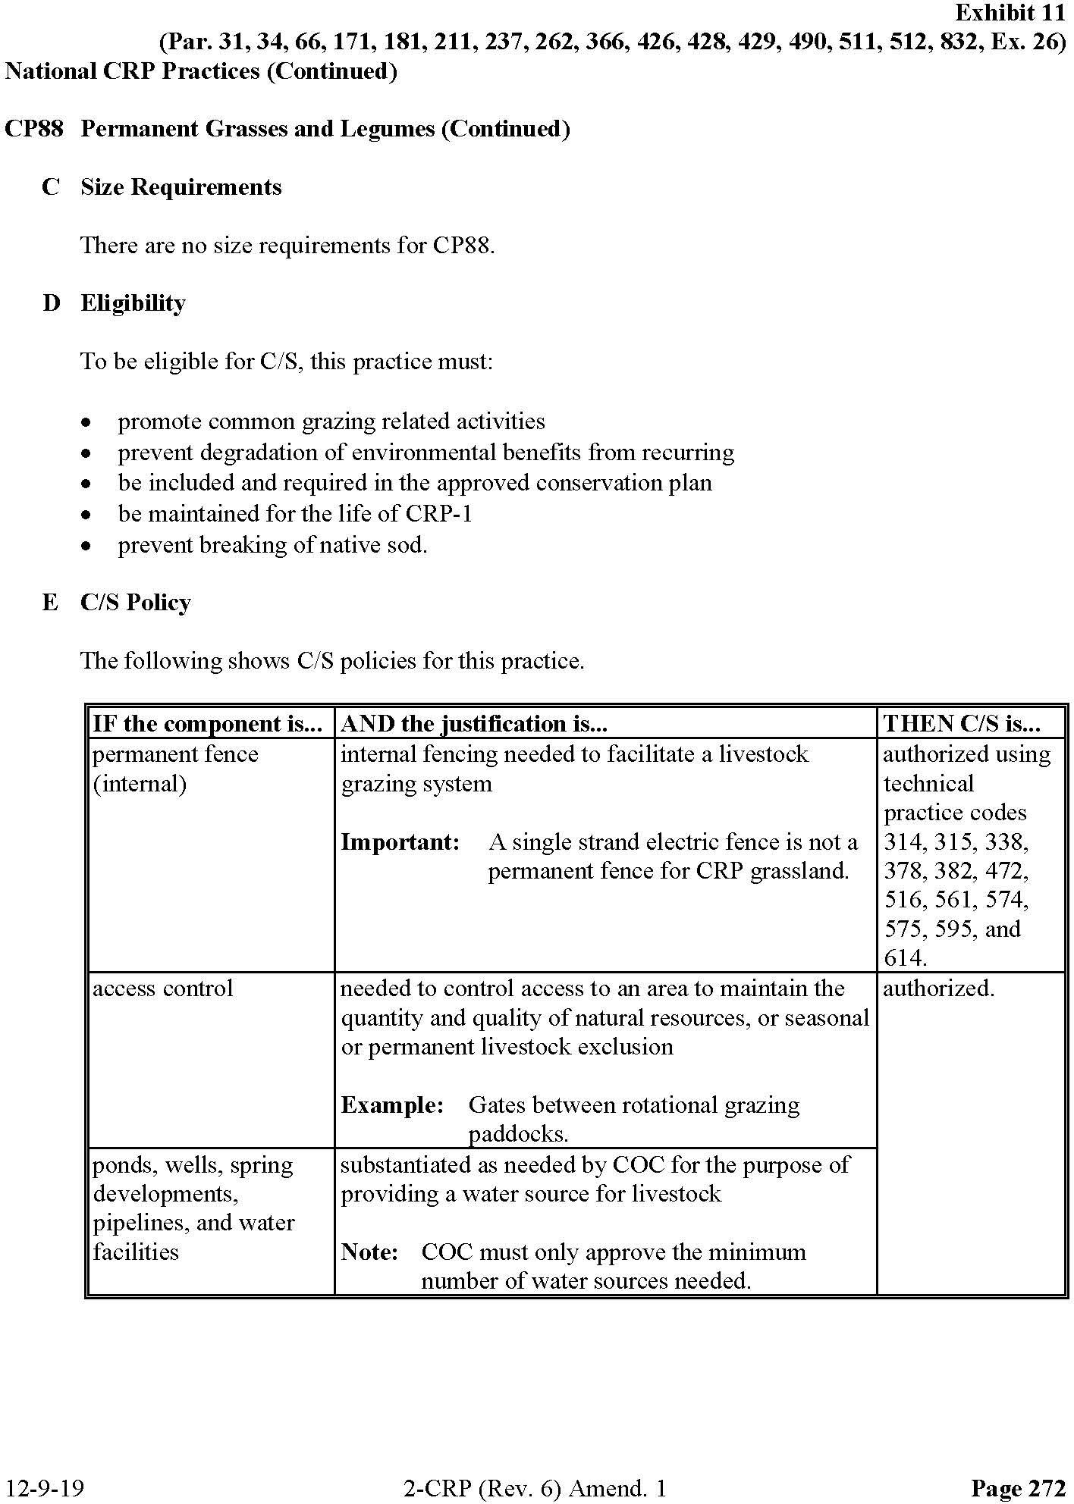
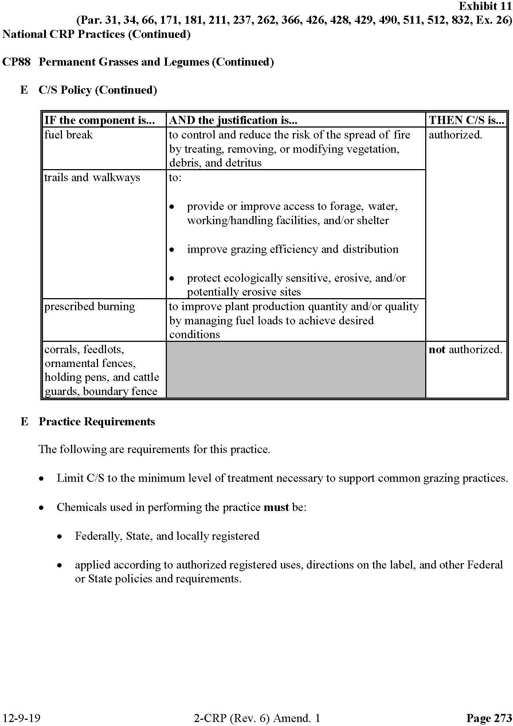

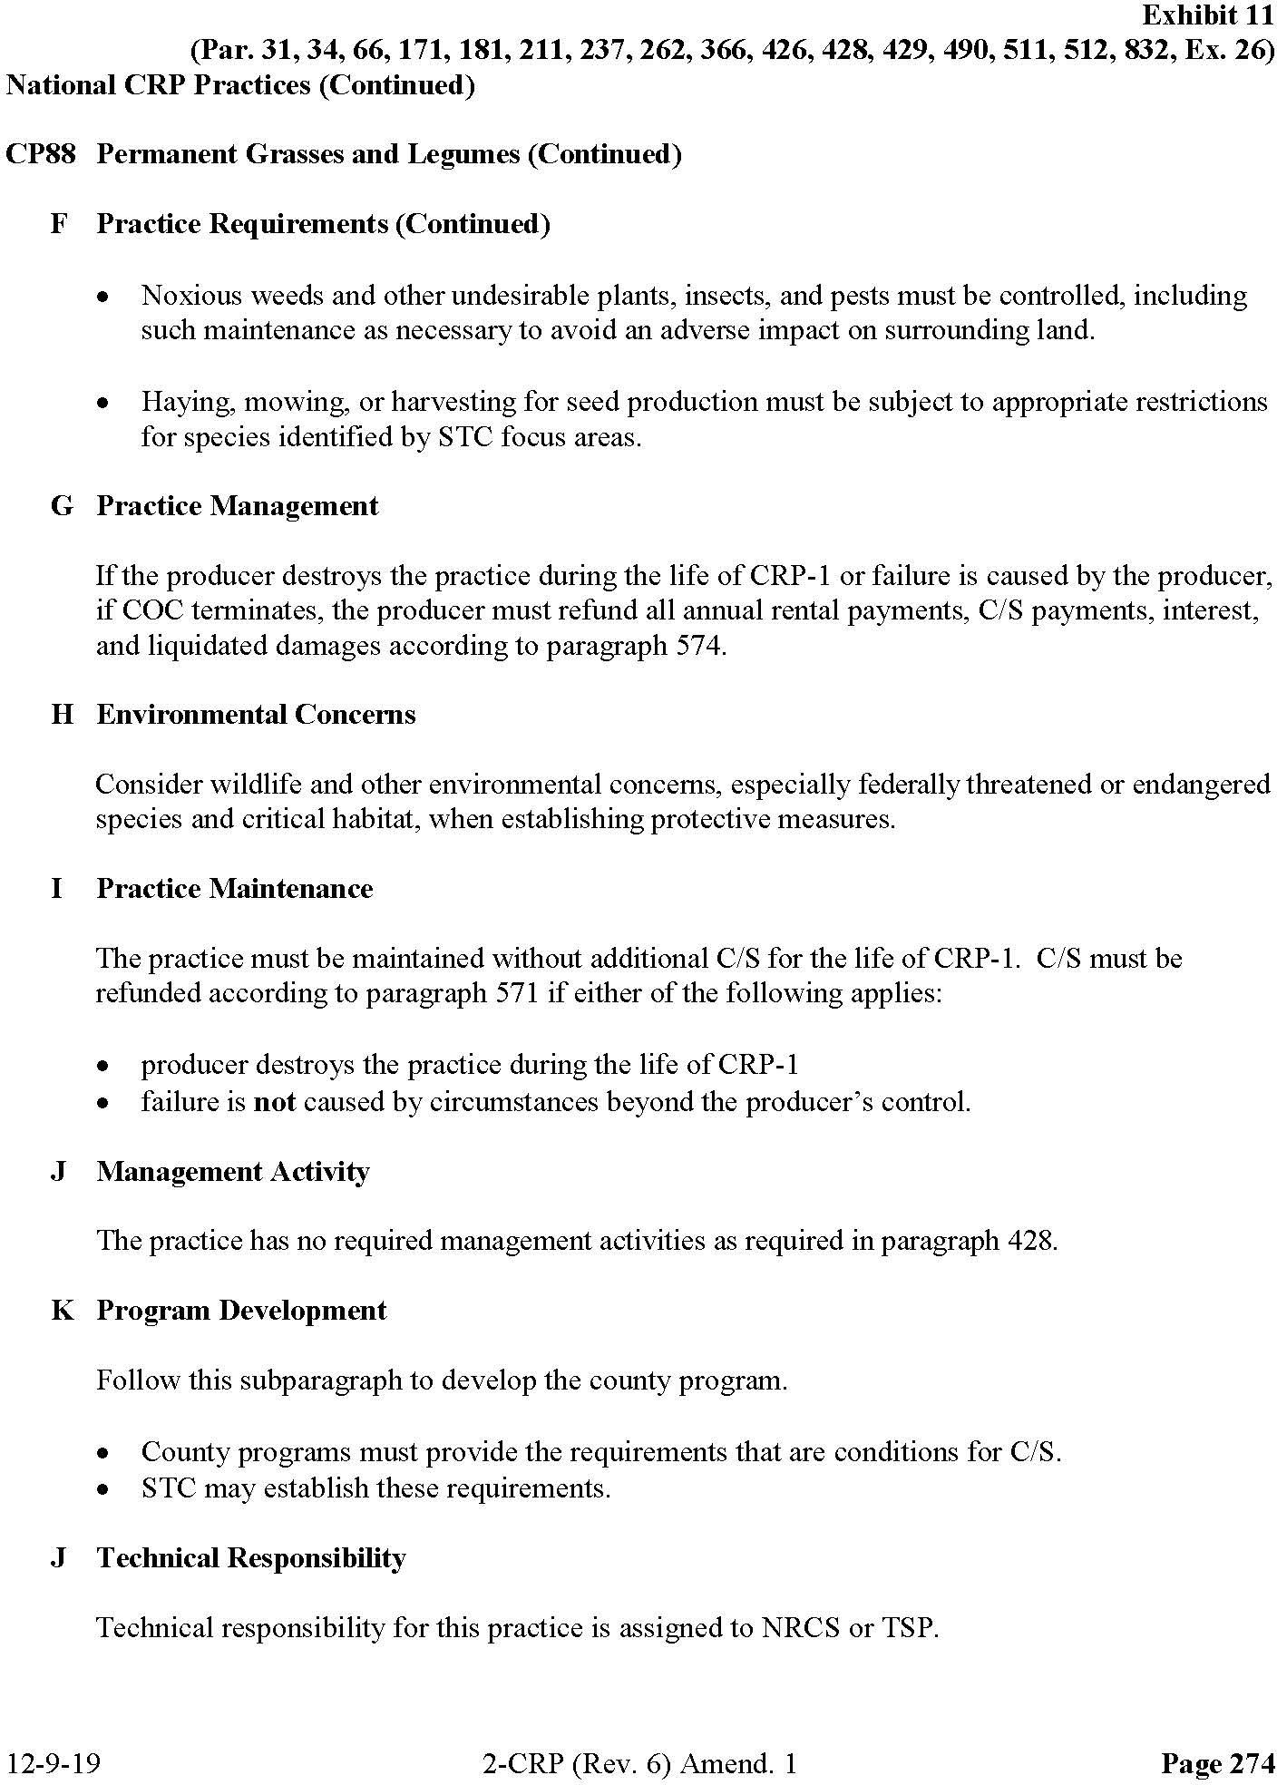

APPENDIX B
AGENCY, TRIBAL, AND PUBLIC COORDINATION

This page intentionally left blank
B.1 INTRODUCTION
Scoping is an early and open process for developing the breadth of issues to be addressed in an Environmental Assessment (EA) and for identifying significant concerns related to an action. Per the requirements of Executive Order (EO) 12372, Intergovernmental Review of Federal Programs, as amended by EO 12416, federal, state, and local agencies with jurisdiction that could potentially be affected by the Proposed Action or alternatives were notified during the development of this PEA.
The Intergovernmental Coordination Act and EO 12372 require federal agencies to cooperate with and consider state and local views in implementing a federal proposal. Through the coordination process, the Farm Service Agency contacted potentially interested and affected government agencies, government representatives, elected officials, and interested parties potentially affected by the Proposed Action. The agency and intergovernmental coordination process is summarized in this Appendix.
B.1.1 Government-to-Government Consultation
The National Historic Preservation Act (NHPA) and its regulations in 36 CFR Part 800 direct federal agencies to consult with federally recognized Indian tribes when a proposed or alternative action has the potential to affect tribal lands or properties of religious and cultural significance to a tribe. Consistent with the NHPA, federally recognized tribes that are historically affiliated with lands in the vicinity of the Proposed Action have been invited to consult on all proposed undertakings that have a potential to affect properties of cultural, historical, or religious significance to the tribes. Interested Tribes were sent two letters – the notification letter requested feedback on the Area of Potential Effects (APE) and the consultation letter requested review and comments on the Draft PEA. The Tribal Consultation Mailing List can be found in Section B.3. Any responses received from Tribes are summarized in Section B.7.
B.1.2 Agency Consultations
Development of the PEA involved coordination with several organizations and agencies. Correspondence sent to the U.S. Fish and Wildlife Service can be found in Section B.4. The sample letter for Other Interested Parties can be found in Section B.5. The Other Interested Parties mailing list can be found in Section B.6.
B.2 PUBLIC REVIEW OF PROGRAMMATIC ENVIRONMENTAL ASSESSMENT
A Notice of Availability of the Draft PEA will be published in the Blaine County Journal and the Phillips County Newsinviting the public to review and comment on the Draft PEA during a 30-day review period.
The Draft PEA is available for review on the FSA website at www.fsa.usda.gov/mt and in person at the Montana State FSA Office at 10 E Babcock Street, Bozeman, MT 59715 from February 28, 2024, to March 29, 2024. Copies are also available in the Phillips and Blaine County FSA Offices. A summary of the responses received during the comment period will be provided in in Section B.7.
B.3 TRIBAL CONSULTATION MAILING LIST
Apache Tribe of Oklahoma
Cheyenne and Arapaho Tribes, Oklahoma Cheyenne River Sioux Tribe
Crow Creek Sioux Tribe
Fort Belknap Indian Community of the Fort Belknap Reservation of Montana Lower Brule Sioux Tribe
Oglala Sioux Tribe Rosebud Sioux Tribe
Santee Sioux Nation, Nebraska
Standing Rock Sioux Tribe of North & South Dakota

B.4 U.S. FISH AND WILDLIFE SERVCE CORRESPONDENCE
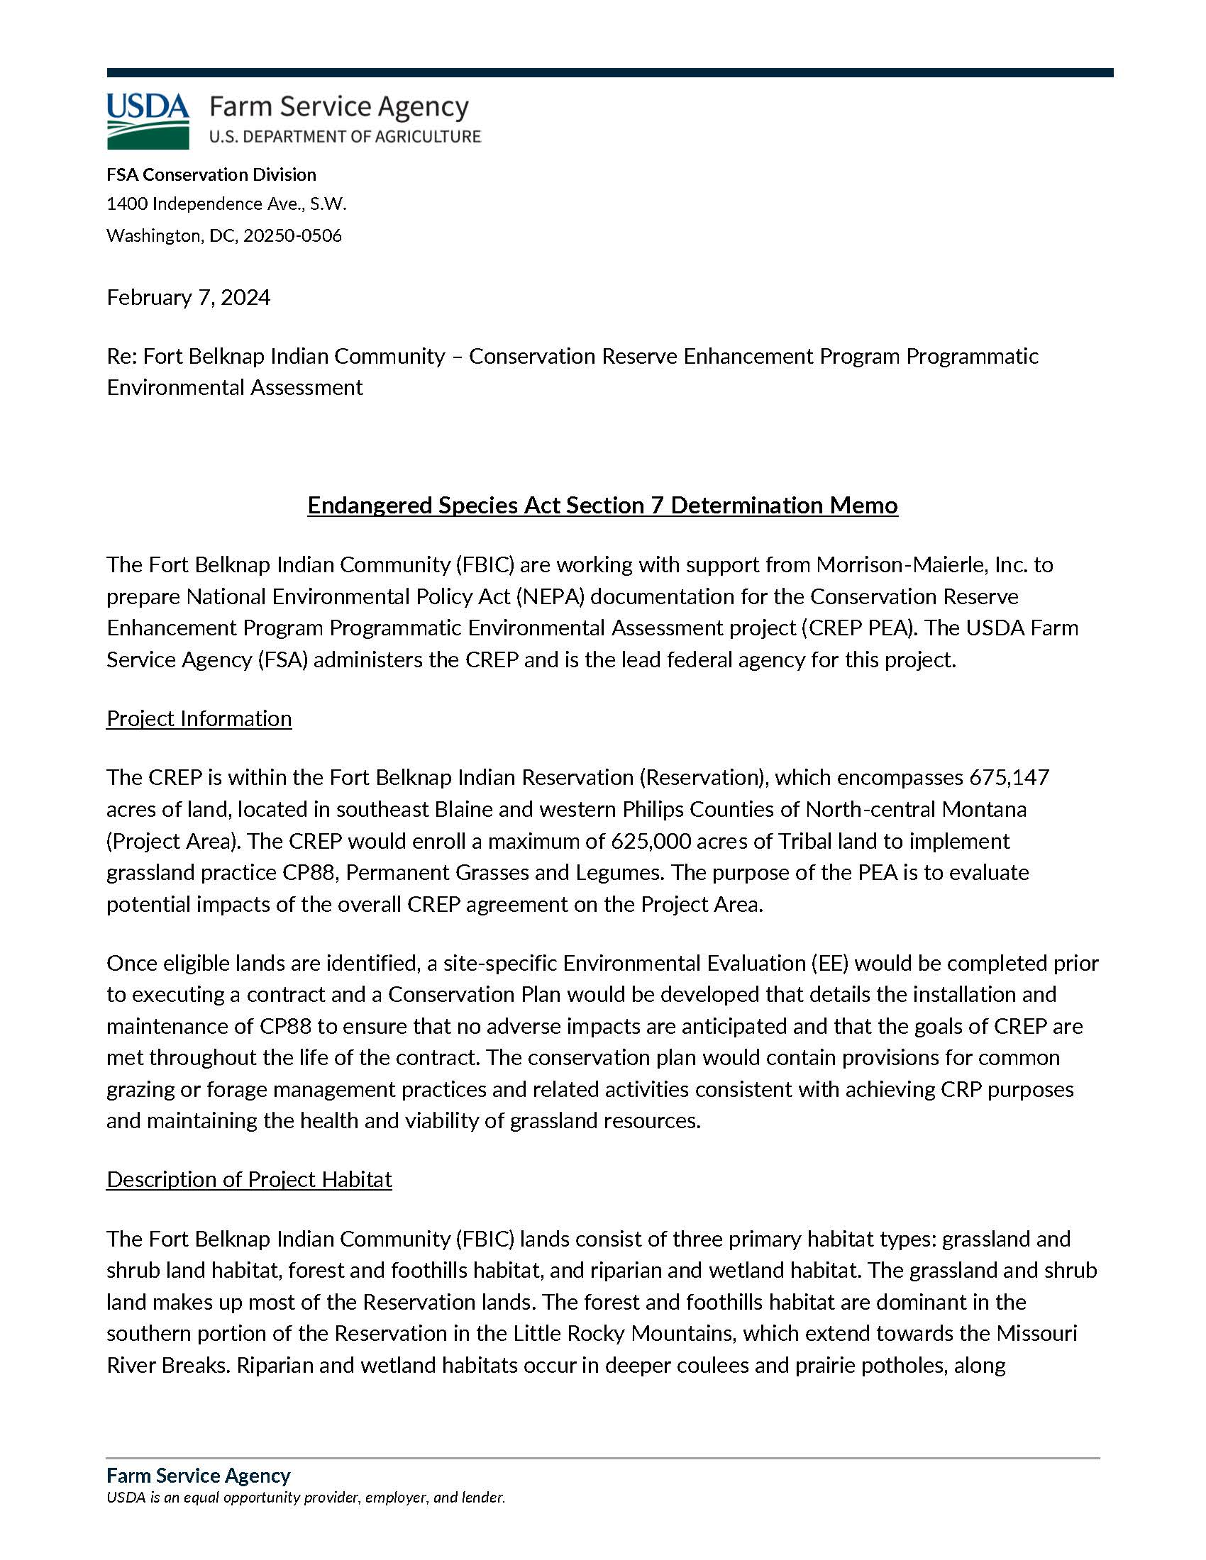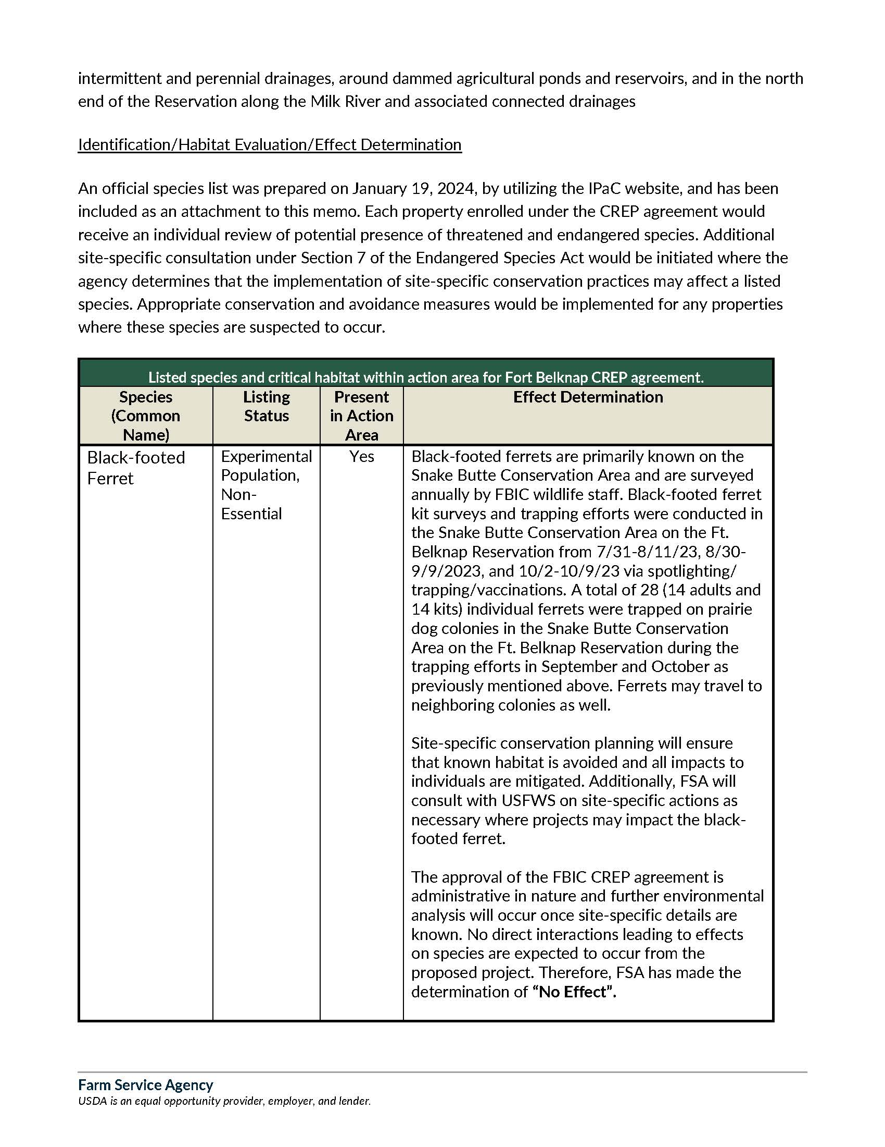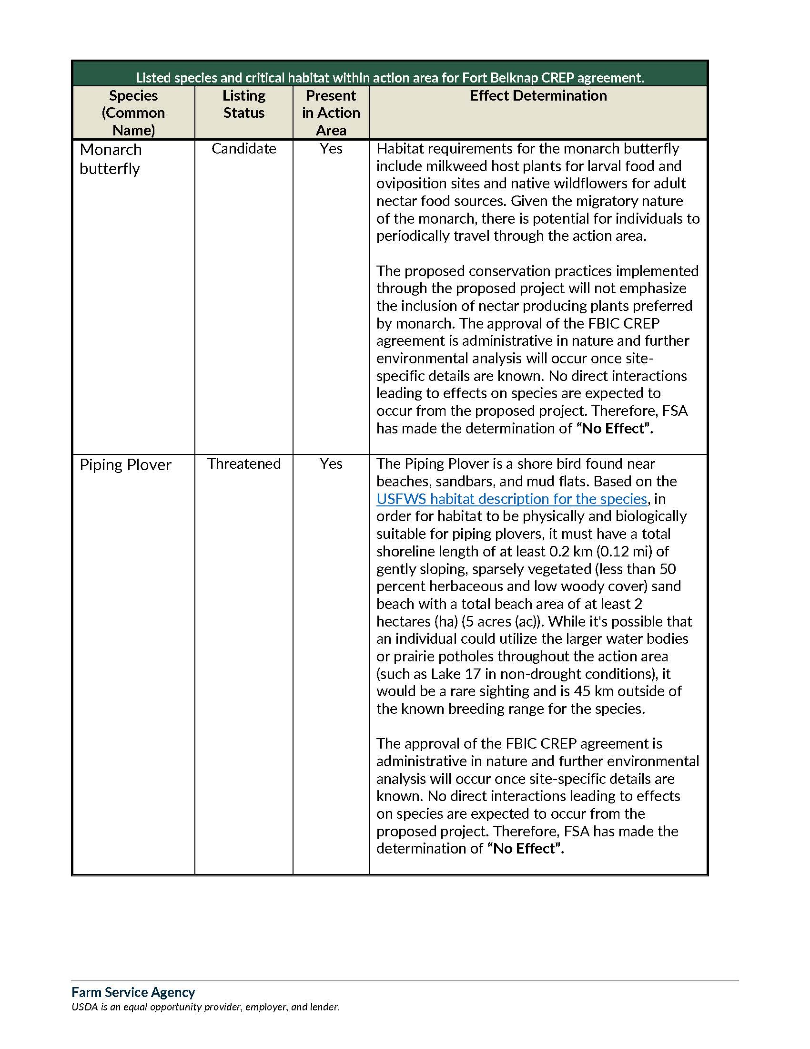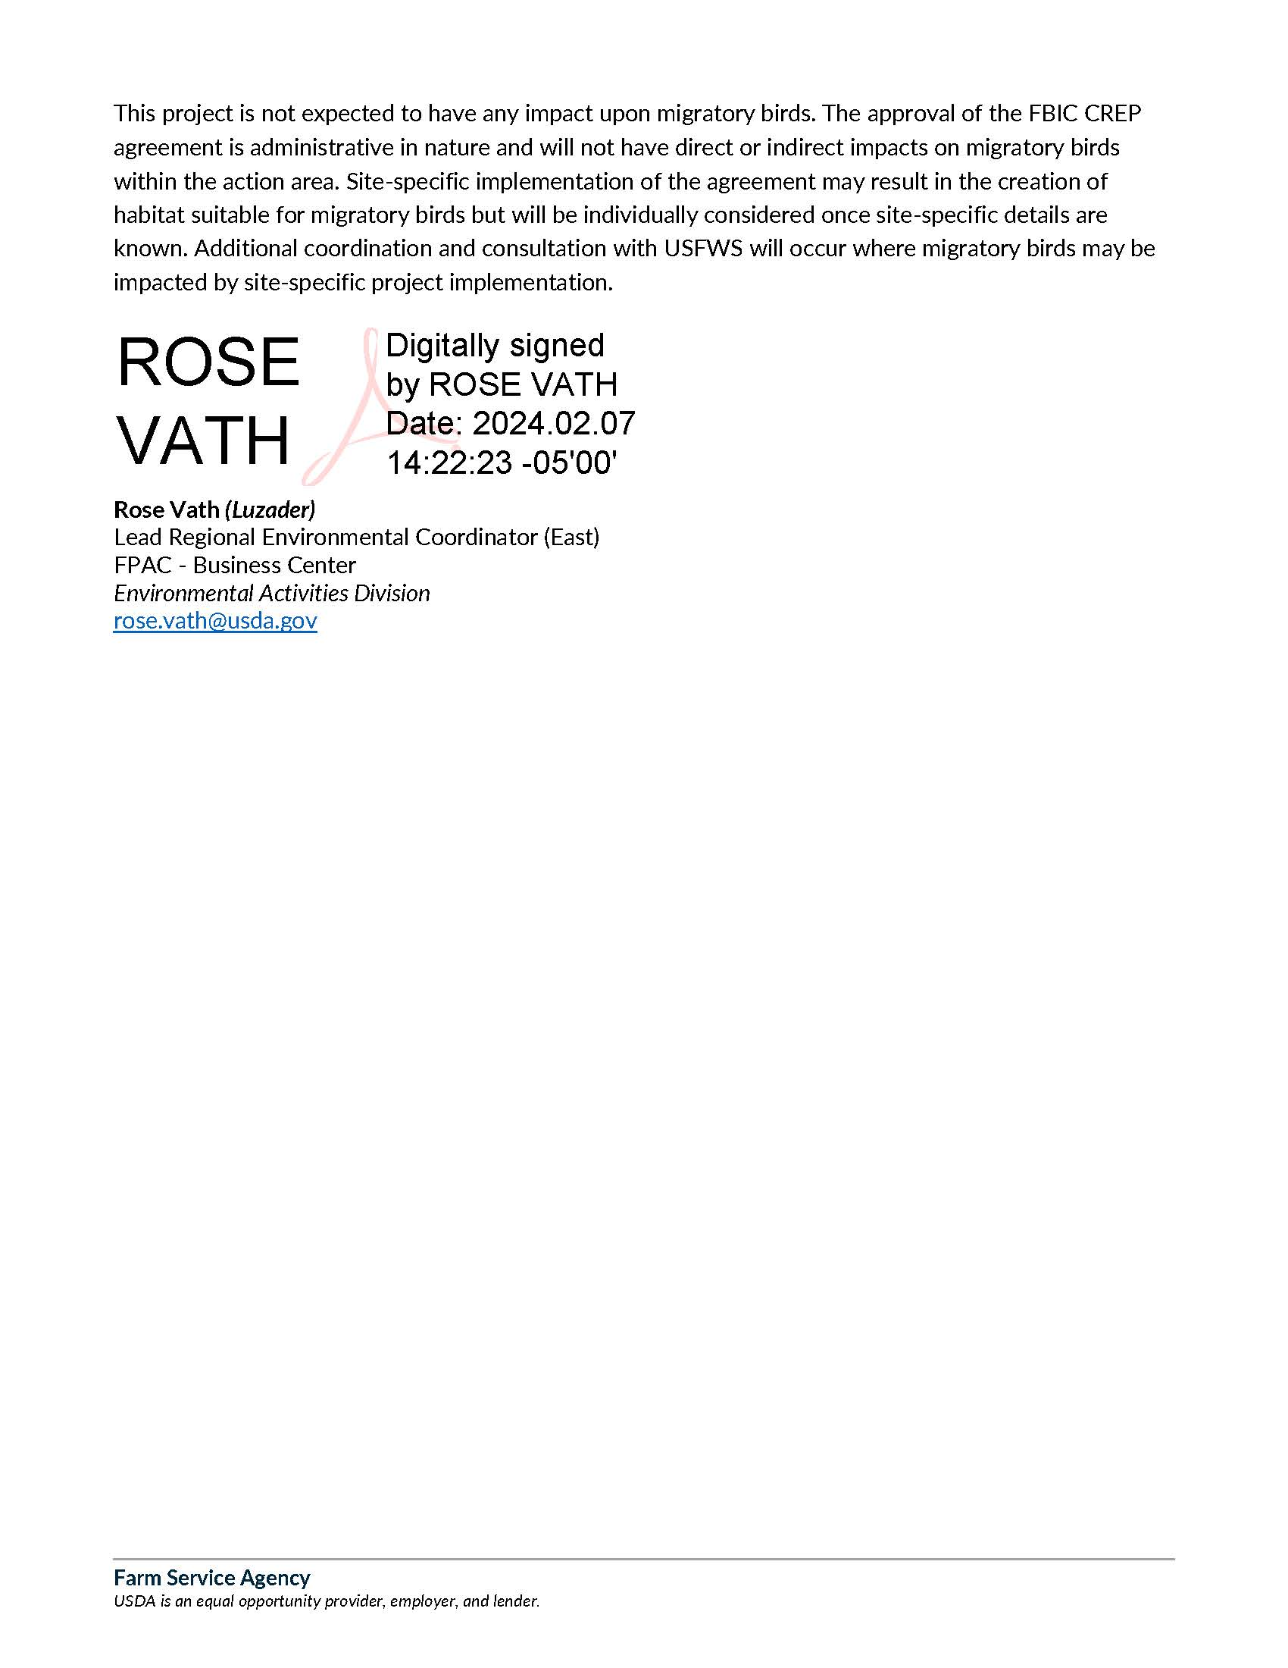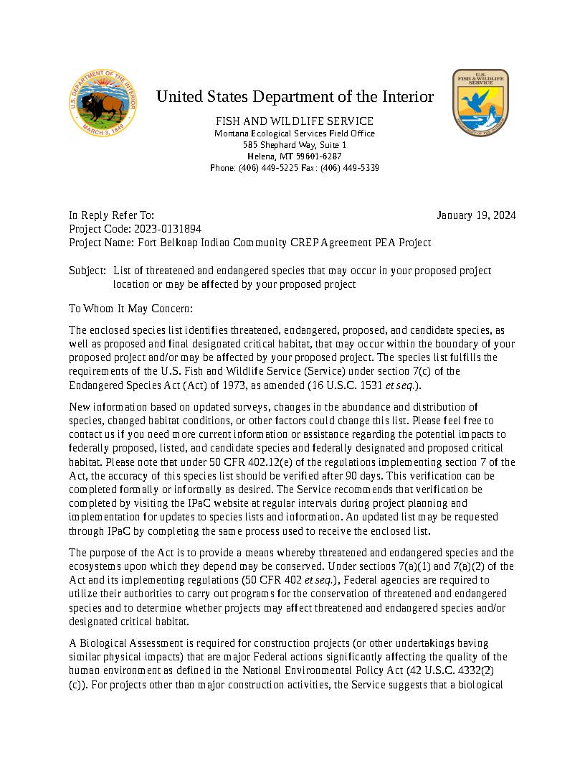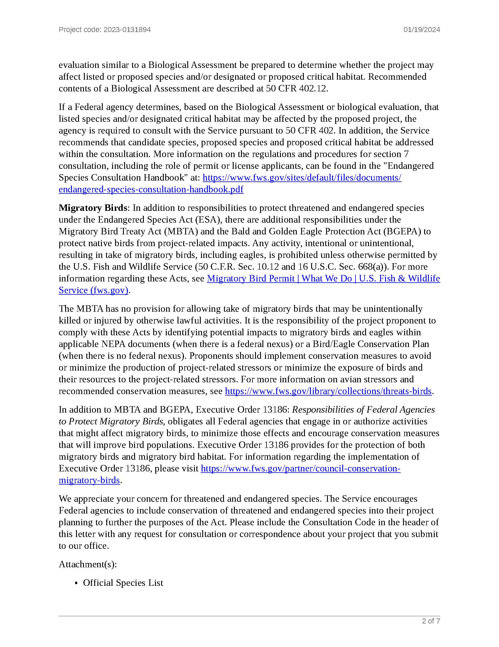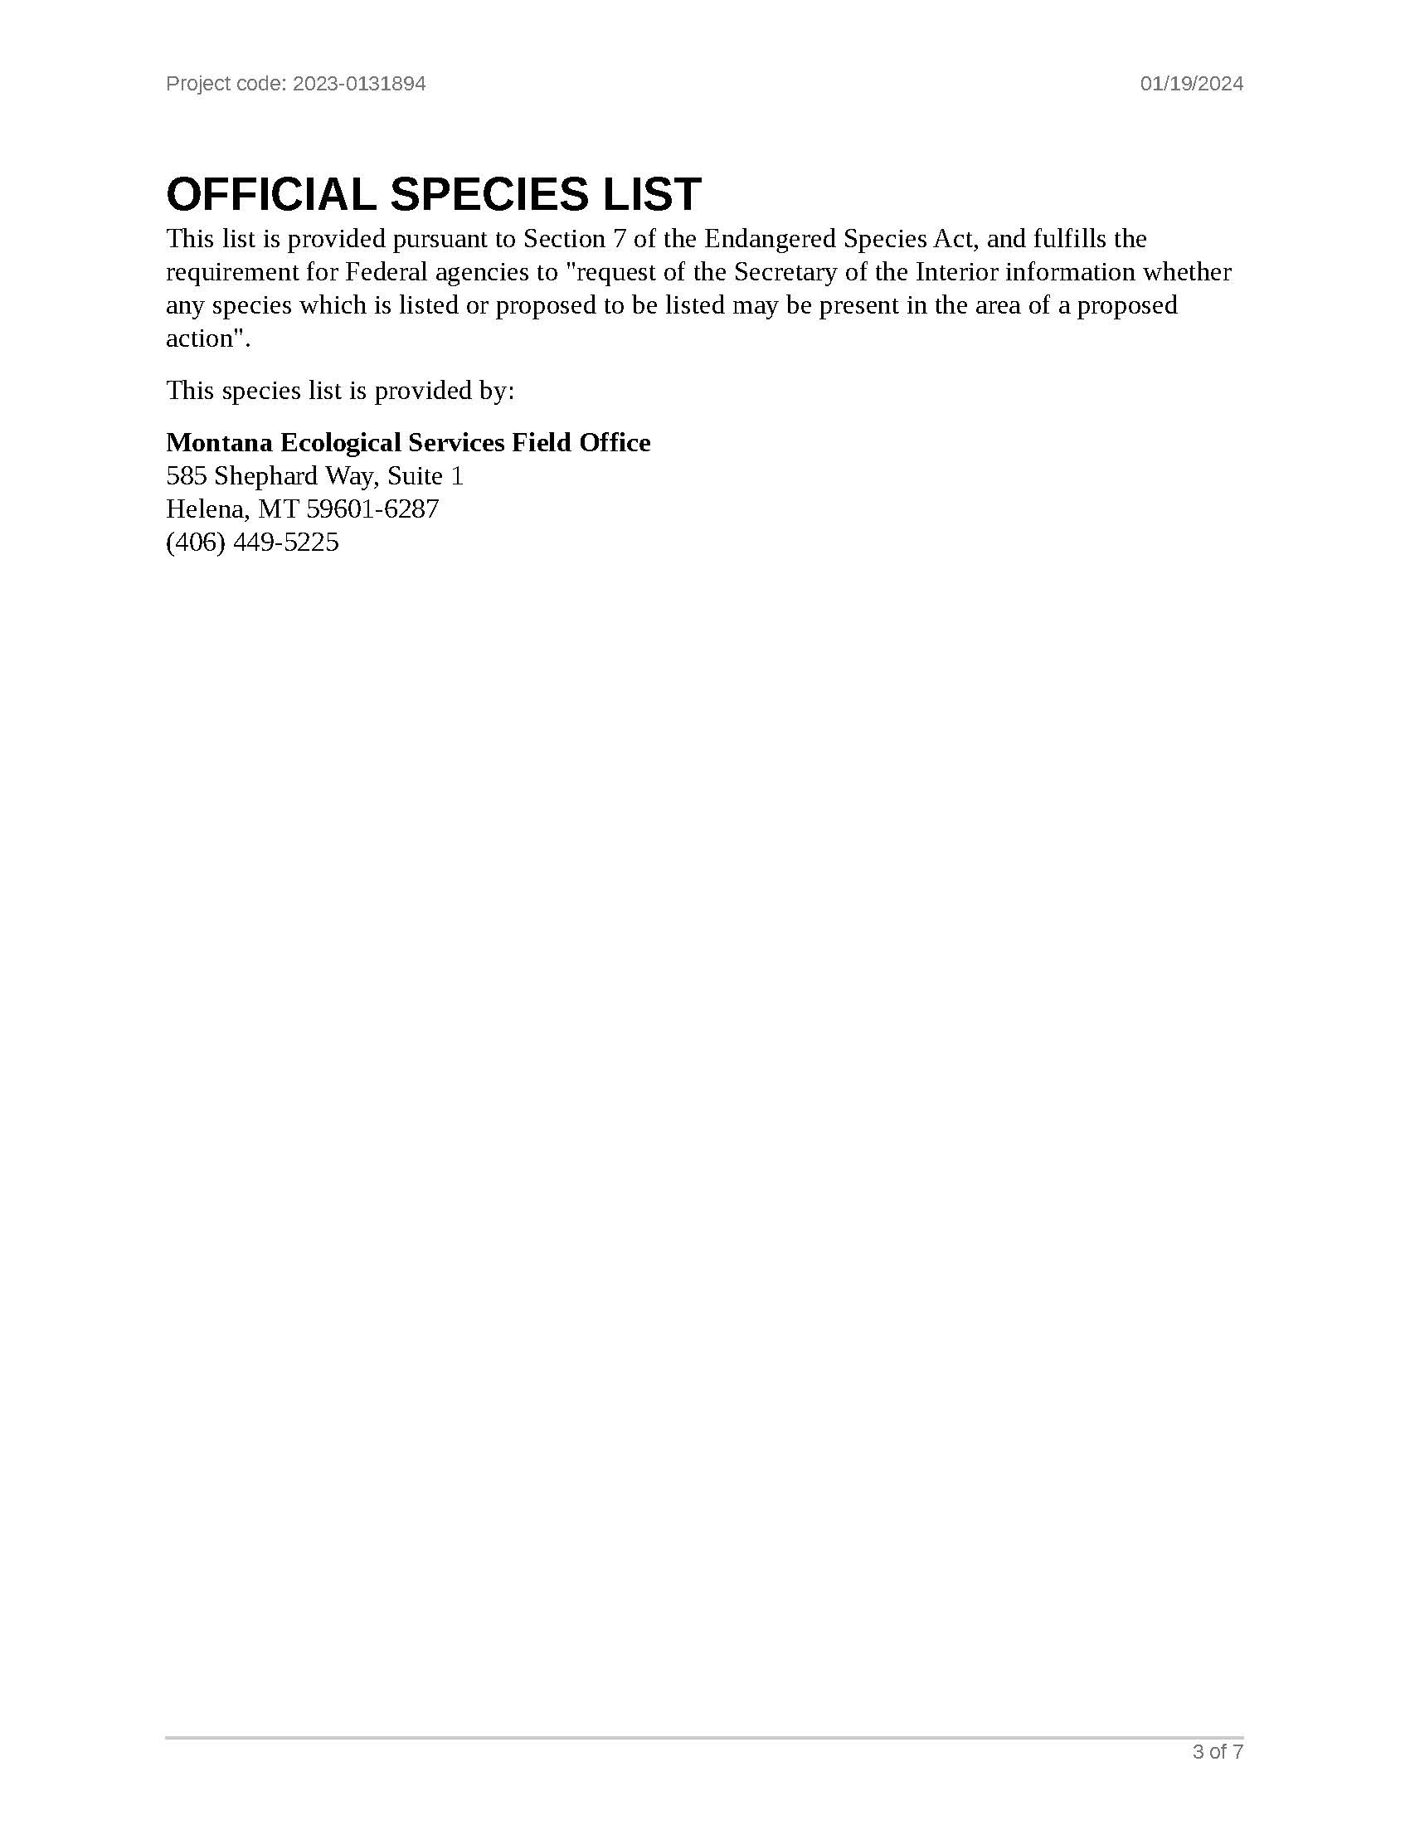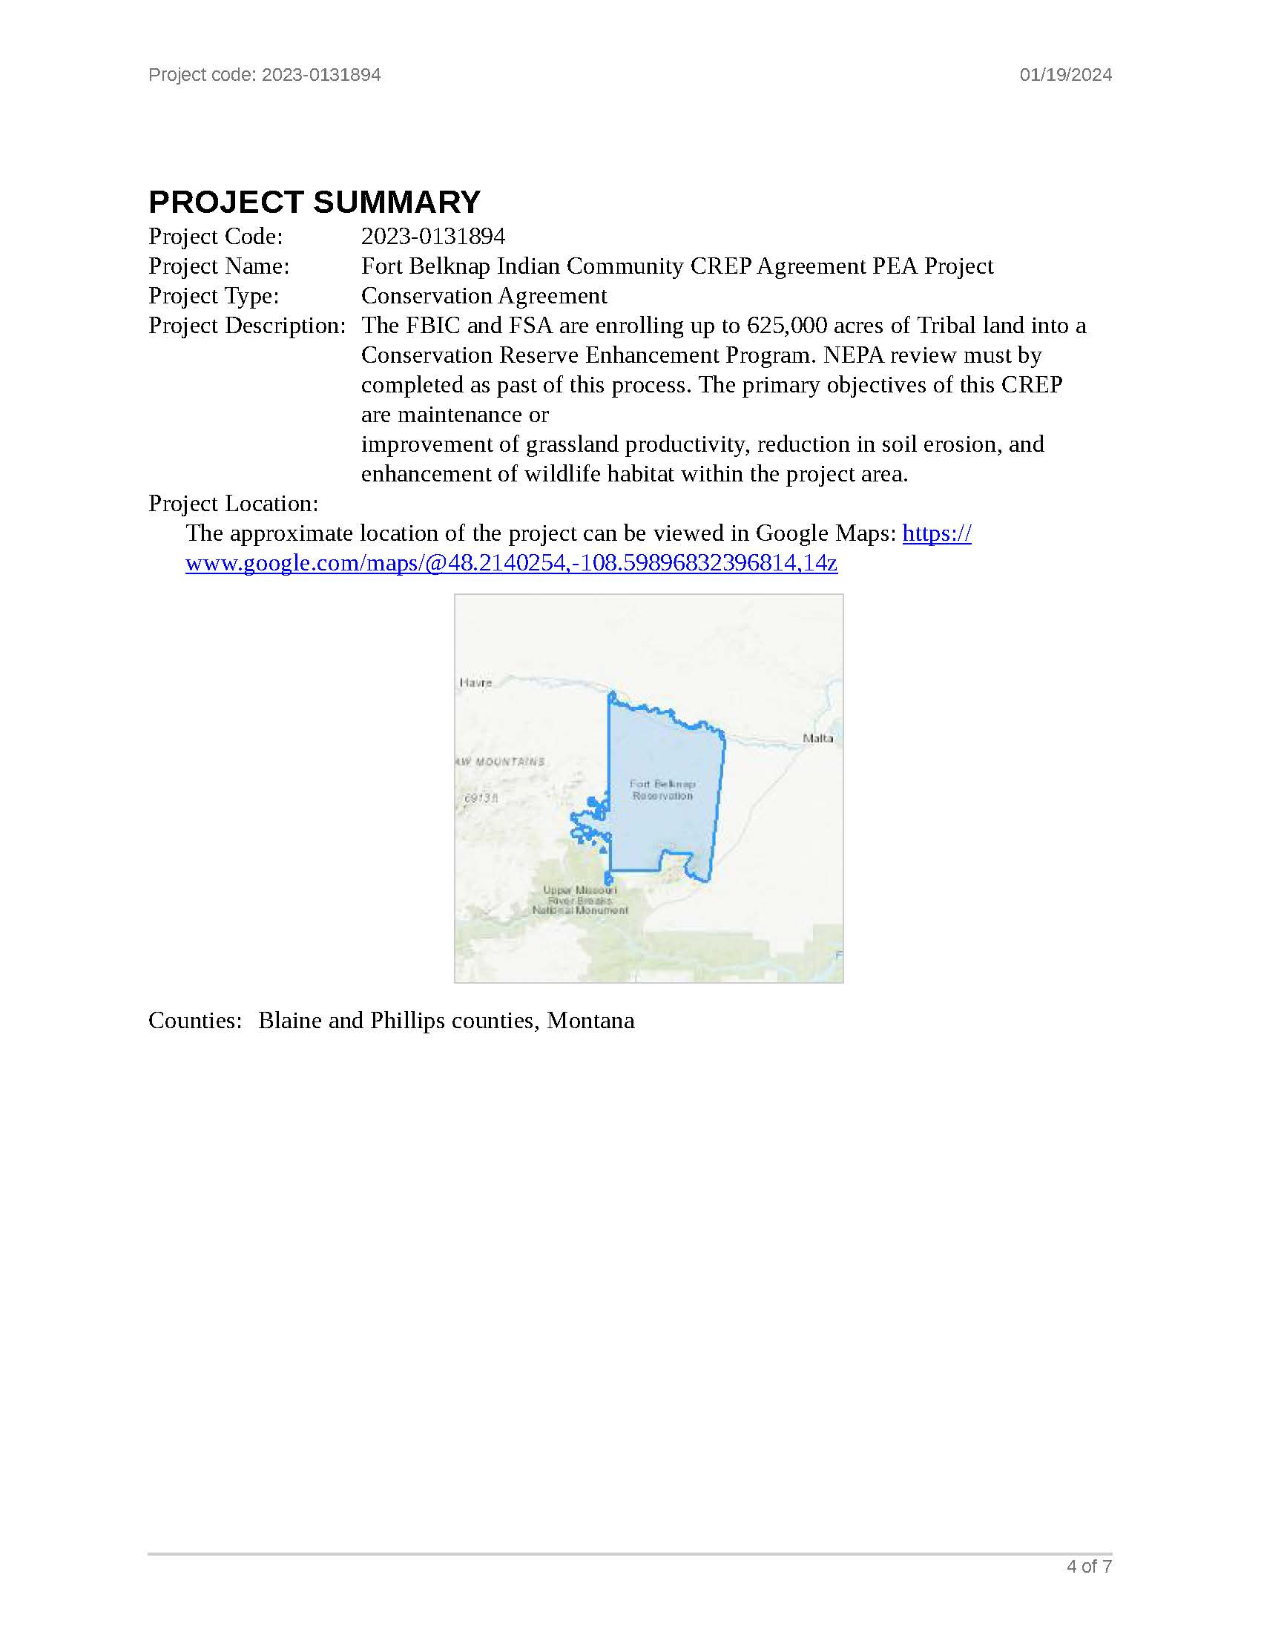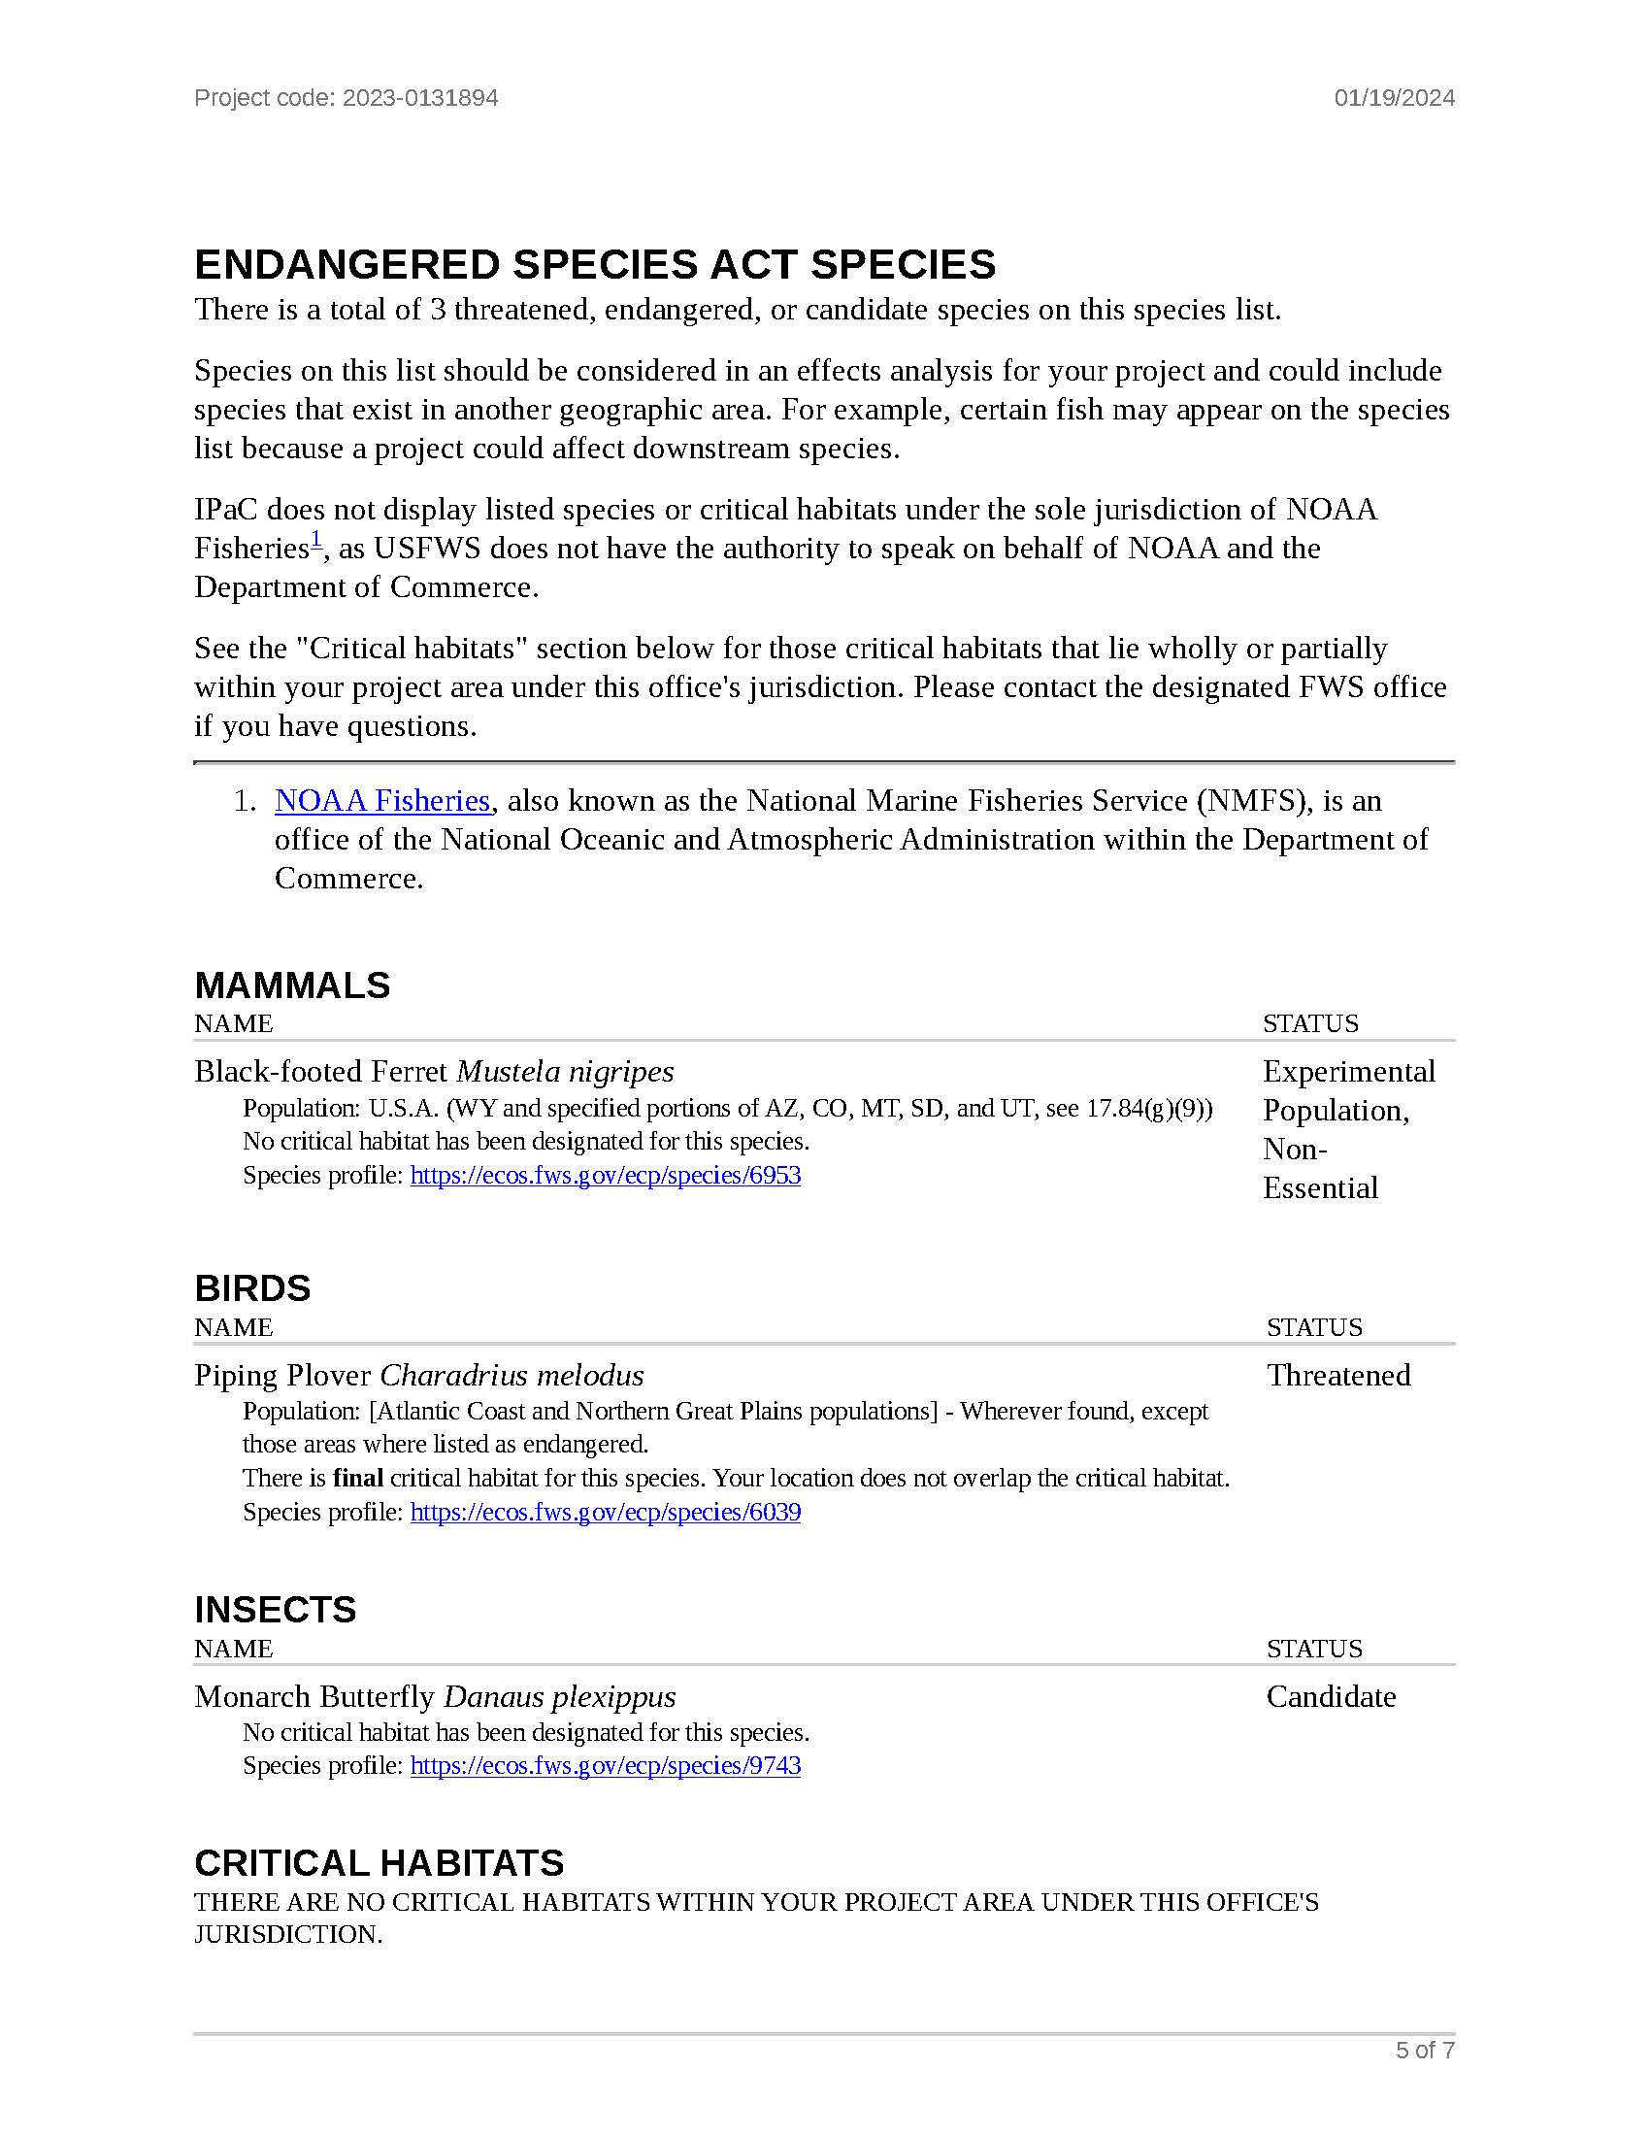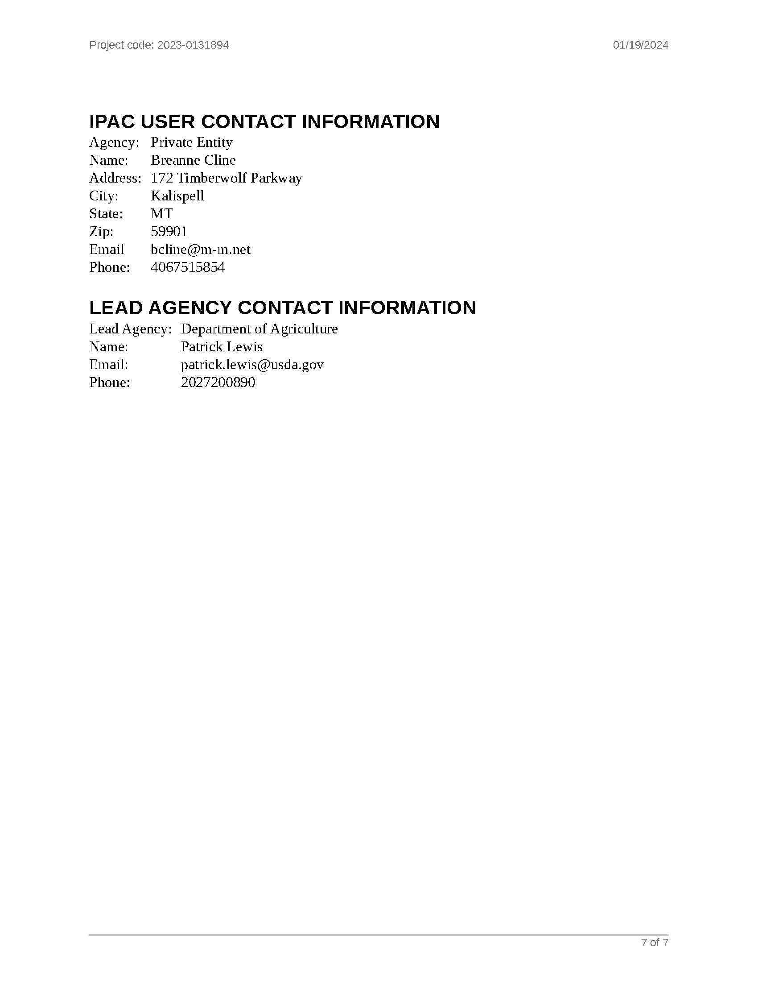

B.5 SAMPLE OTHER INTERESTED PARTIES LETTER

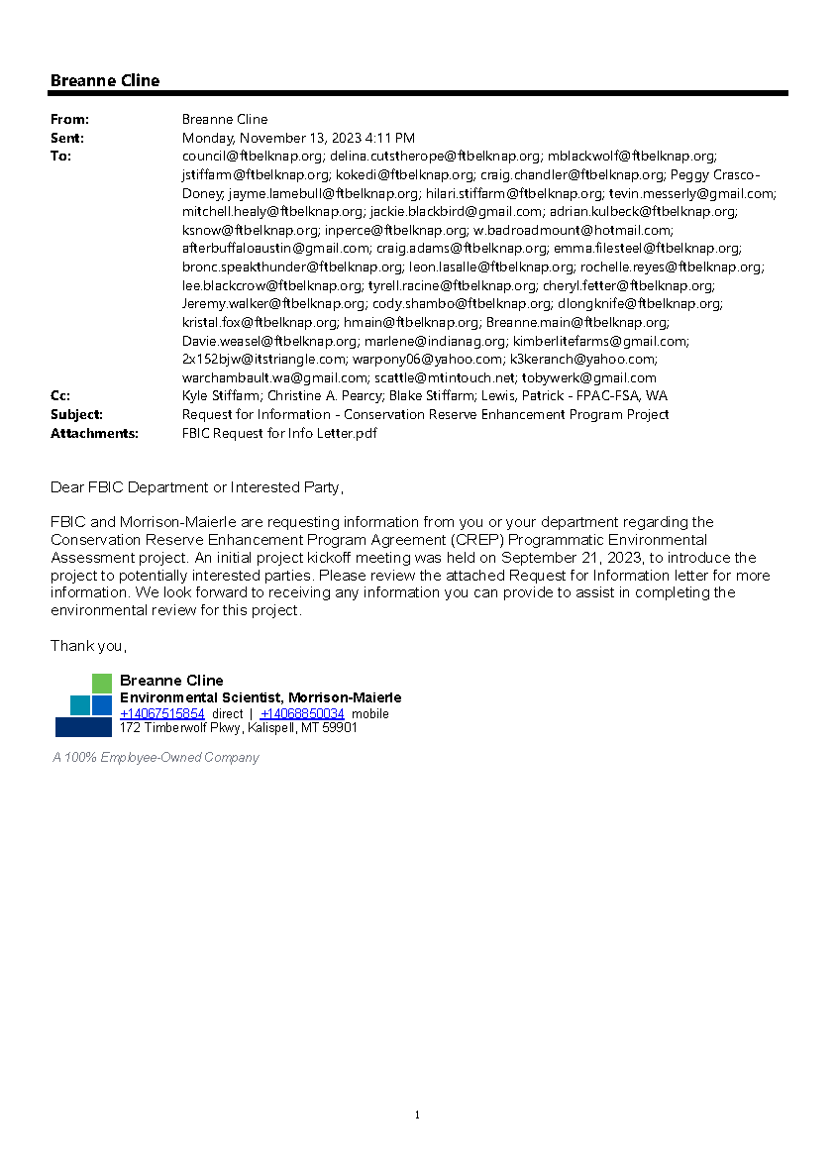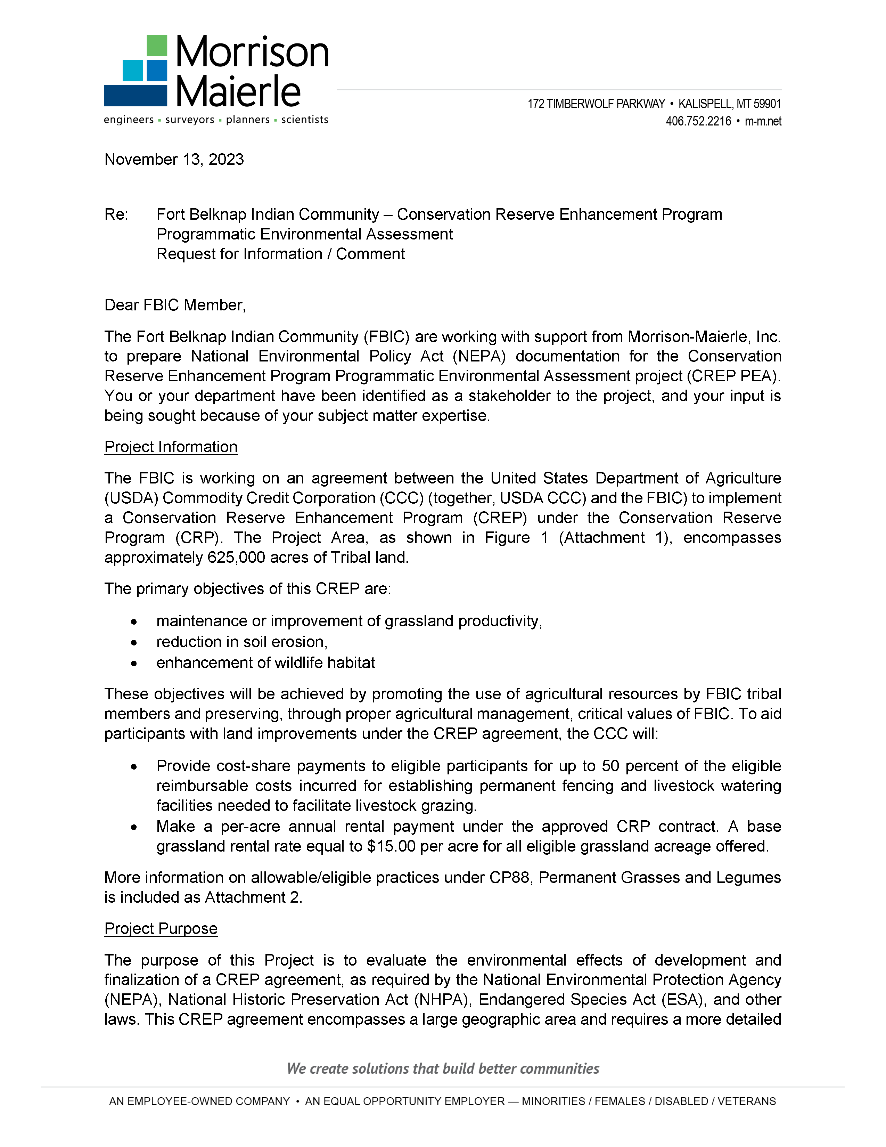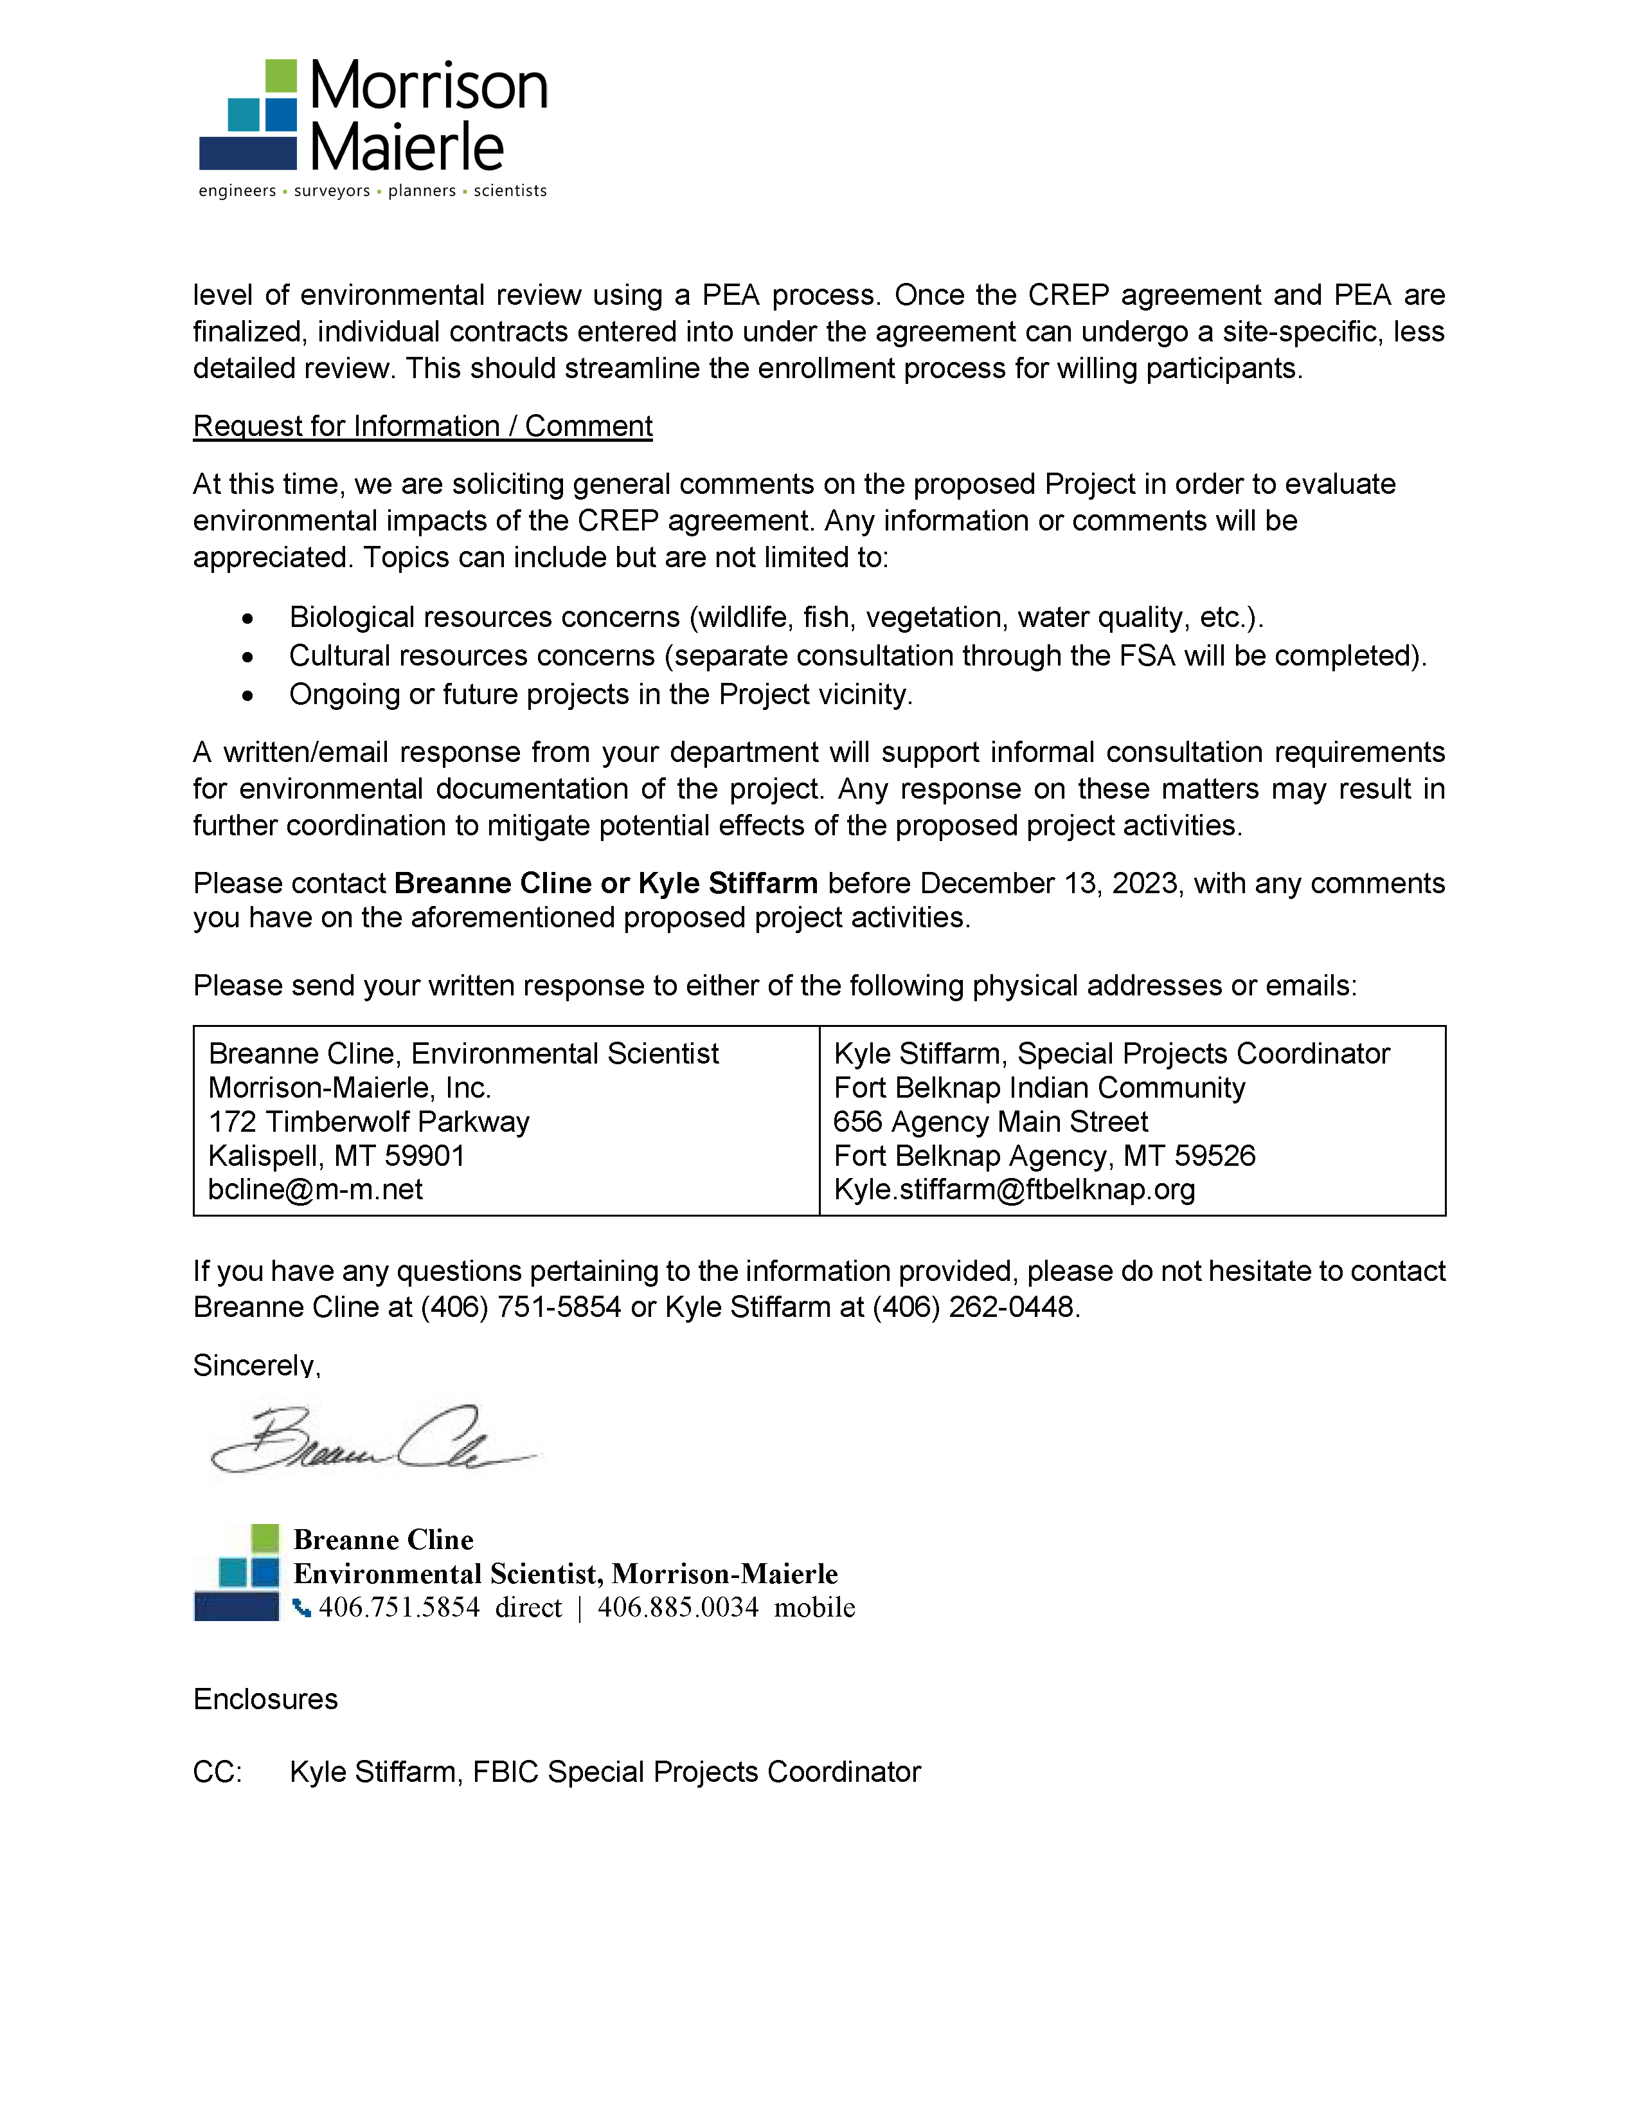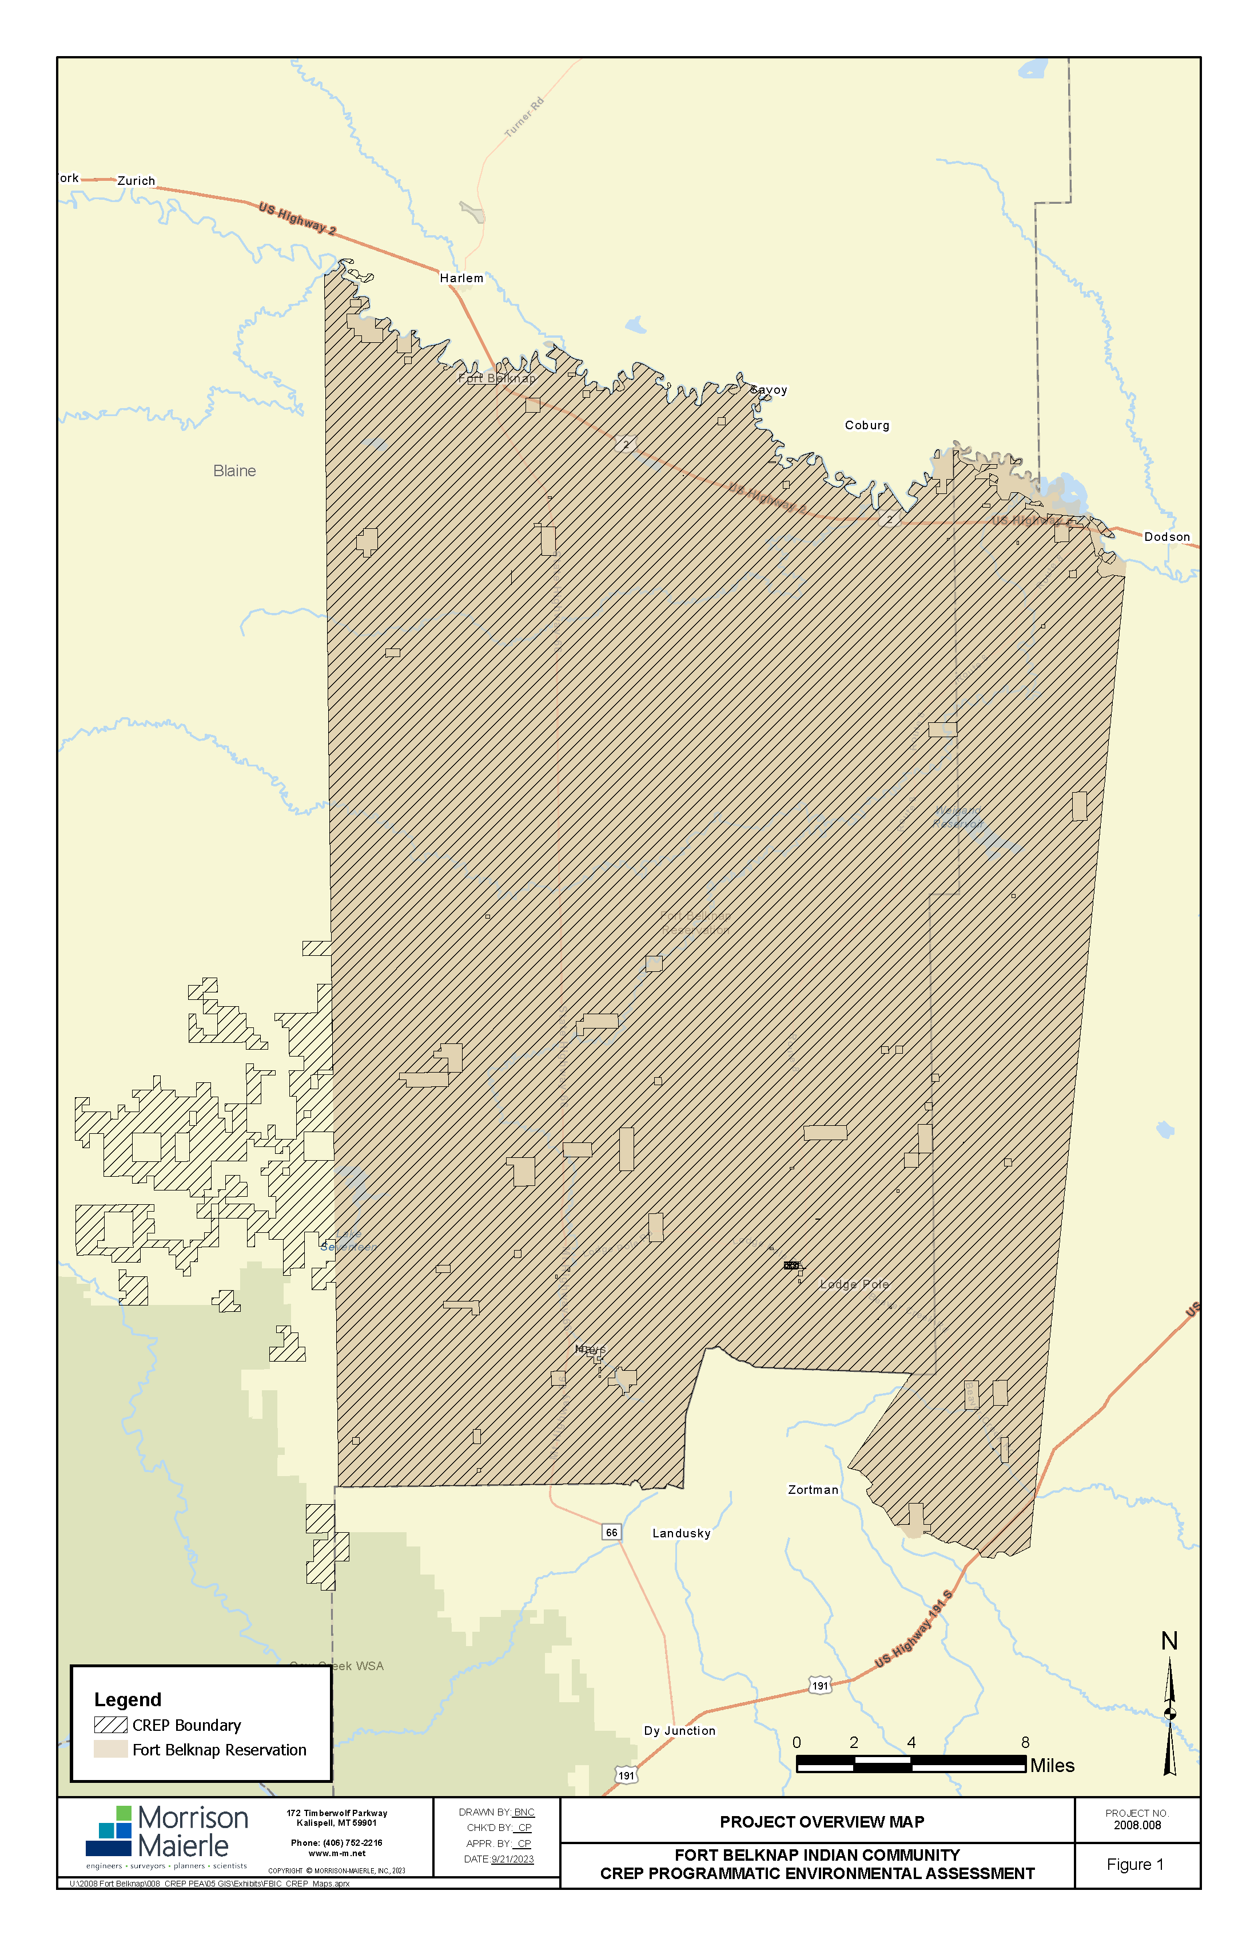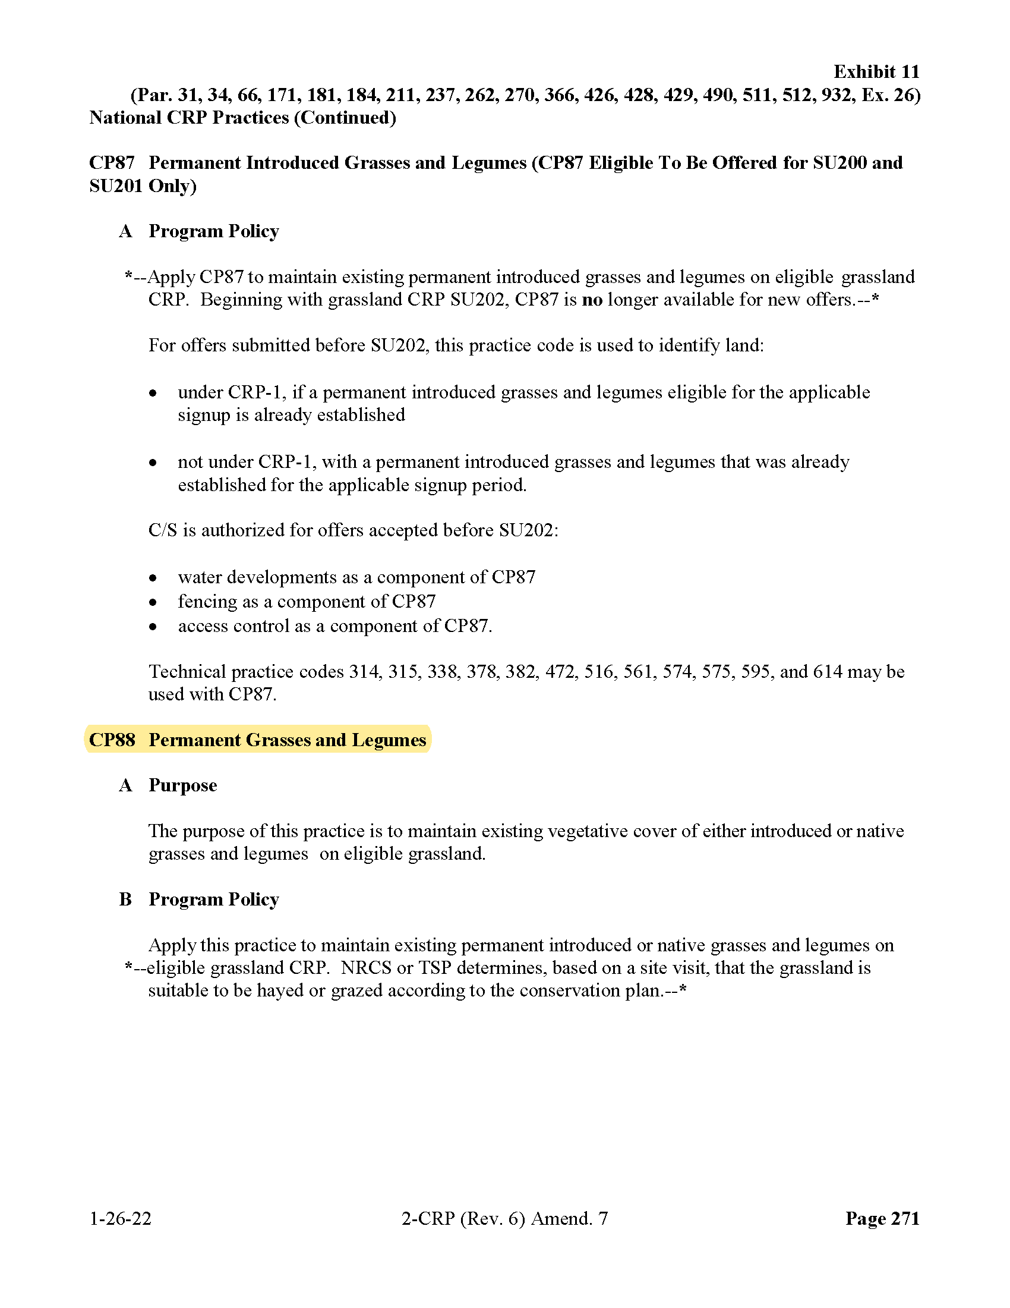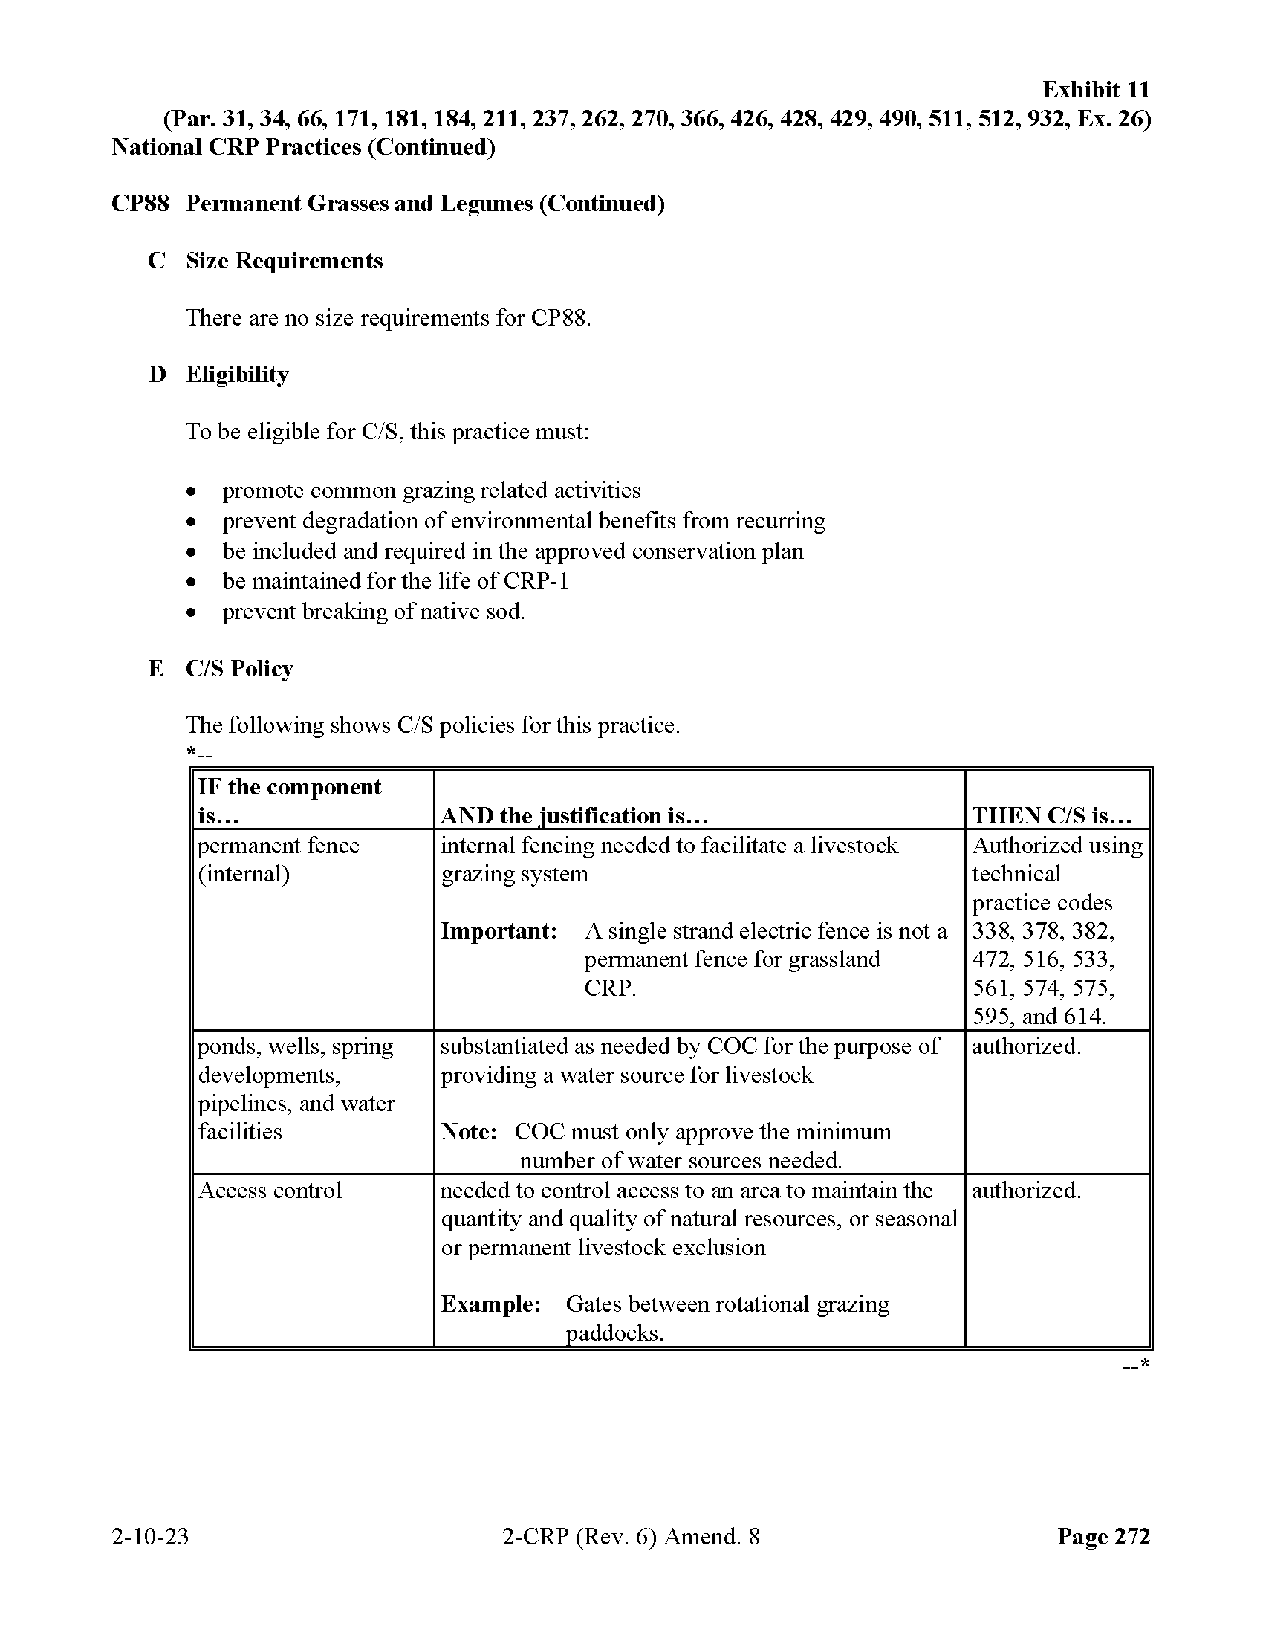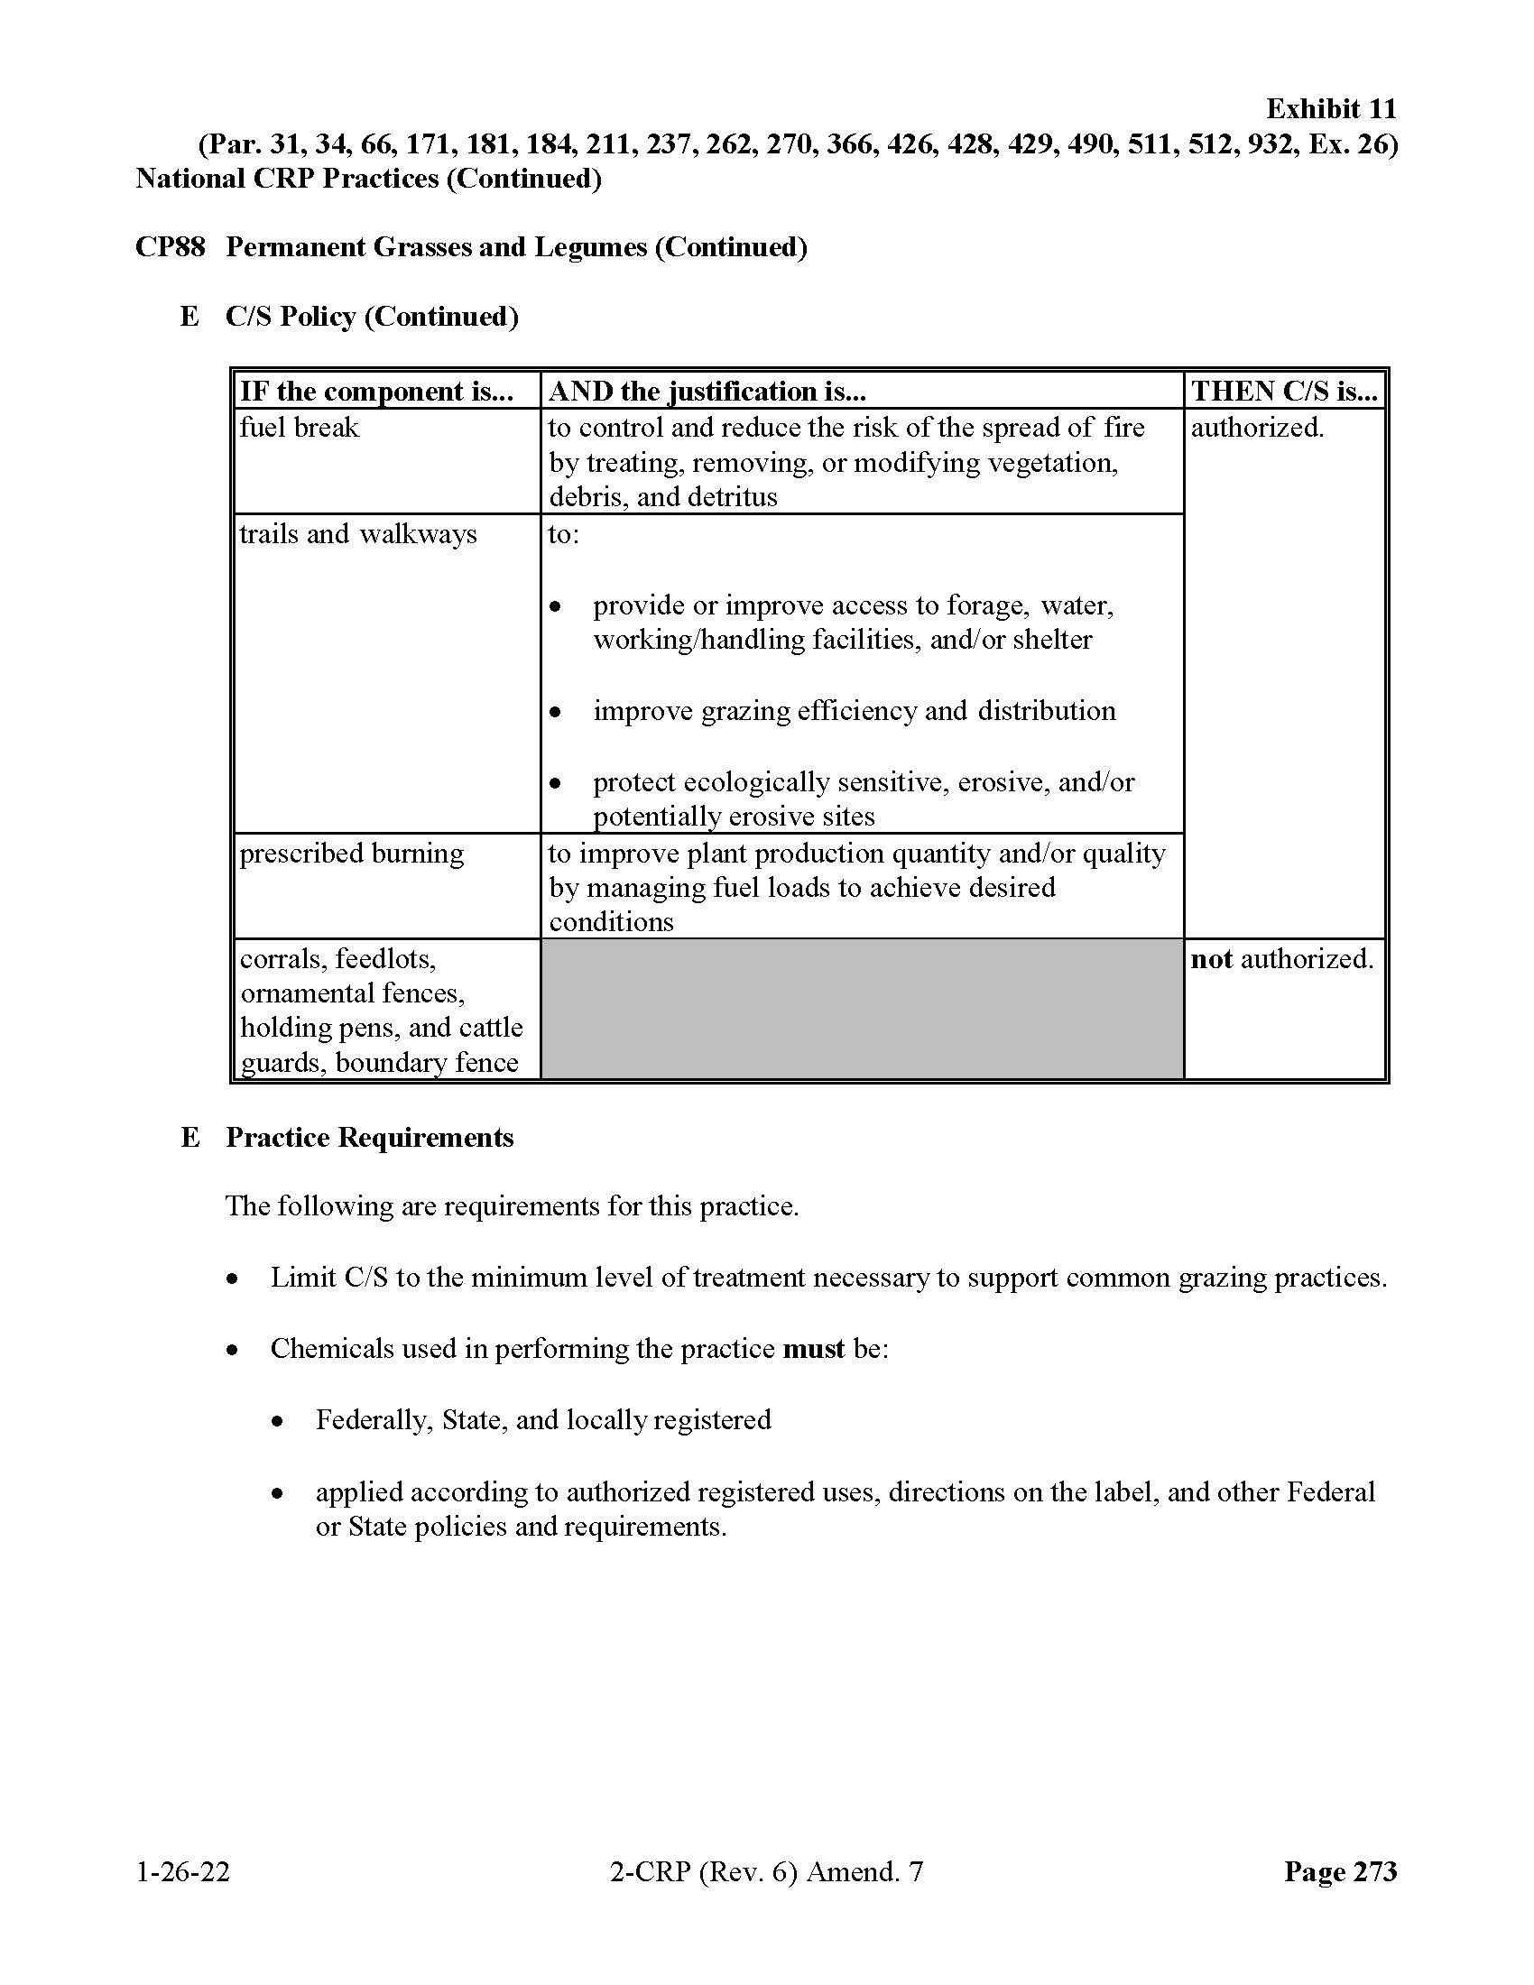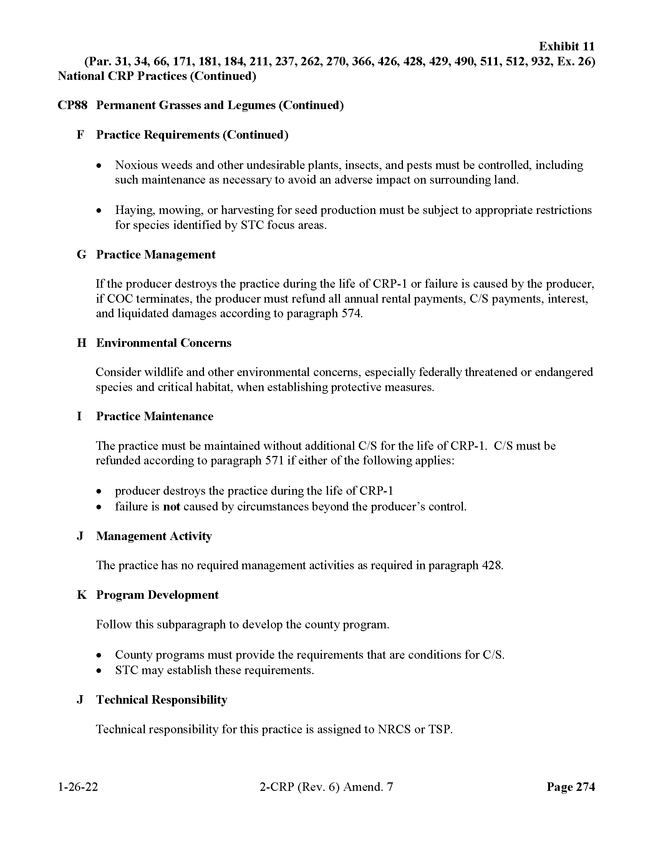
B.6 OTHER INTERESTED PARTIES MAILING LIST
A request for information letter was sent to a list of FBIC department members and other interested parties, including some of the known producers on the Reservation. FBIC departments included, but was not limited to, Tribal Lands, Fish & Wildlife, Environmental Protection, and Cultural.

B.7 SUMMARY OF RESPONSES RECEIVED
Table B-1. Summary of Responses Received
Date | Commenter Name | Commenter Organization / Title | Summary of Comments | Response
1/18/24 | Tevin Messerly | FBIC Tribal Wildlife Biologist | Provided wildlife information for PEA | Information provided for black-footed ferret and piping plover
1/23/24 | Michael Black Wolf | FBIC THPO | Provided FBIC THPO information | Agreement with PEA approach for cultural resources

The FBIC THPO letter is provided on the following pages.
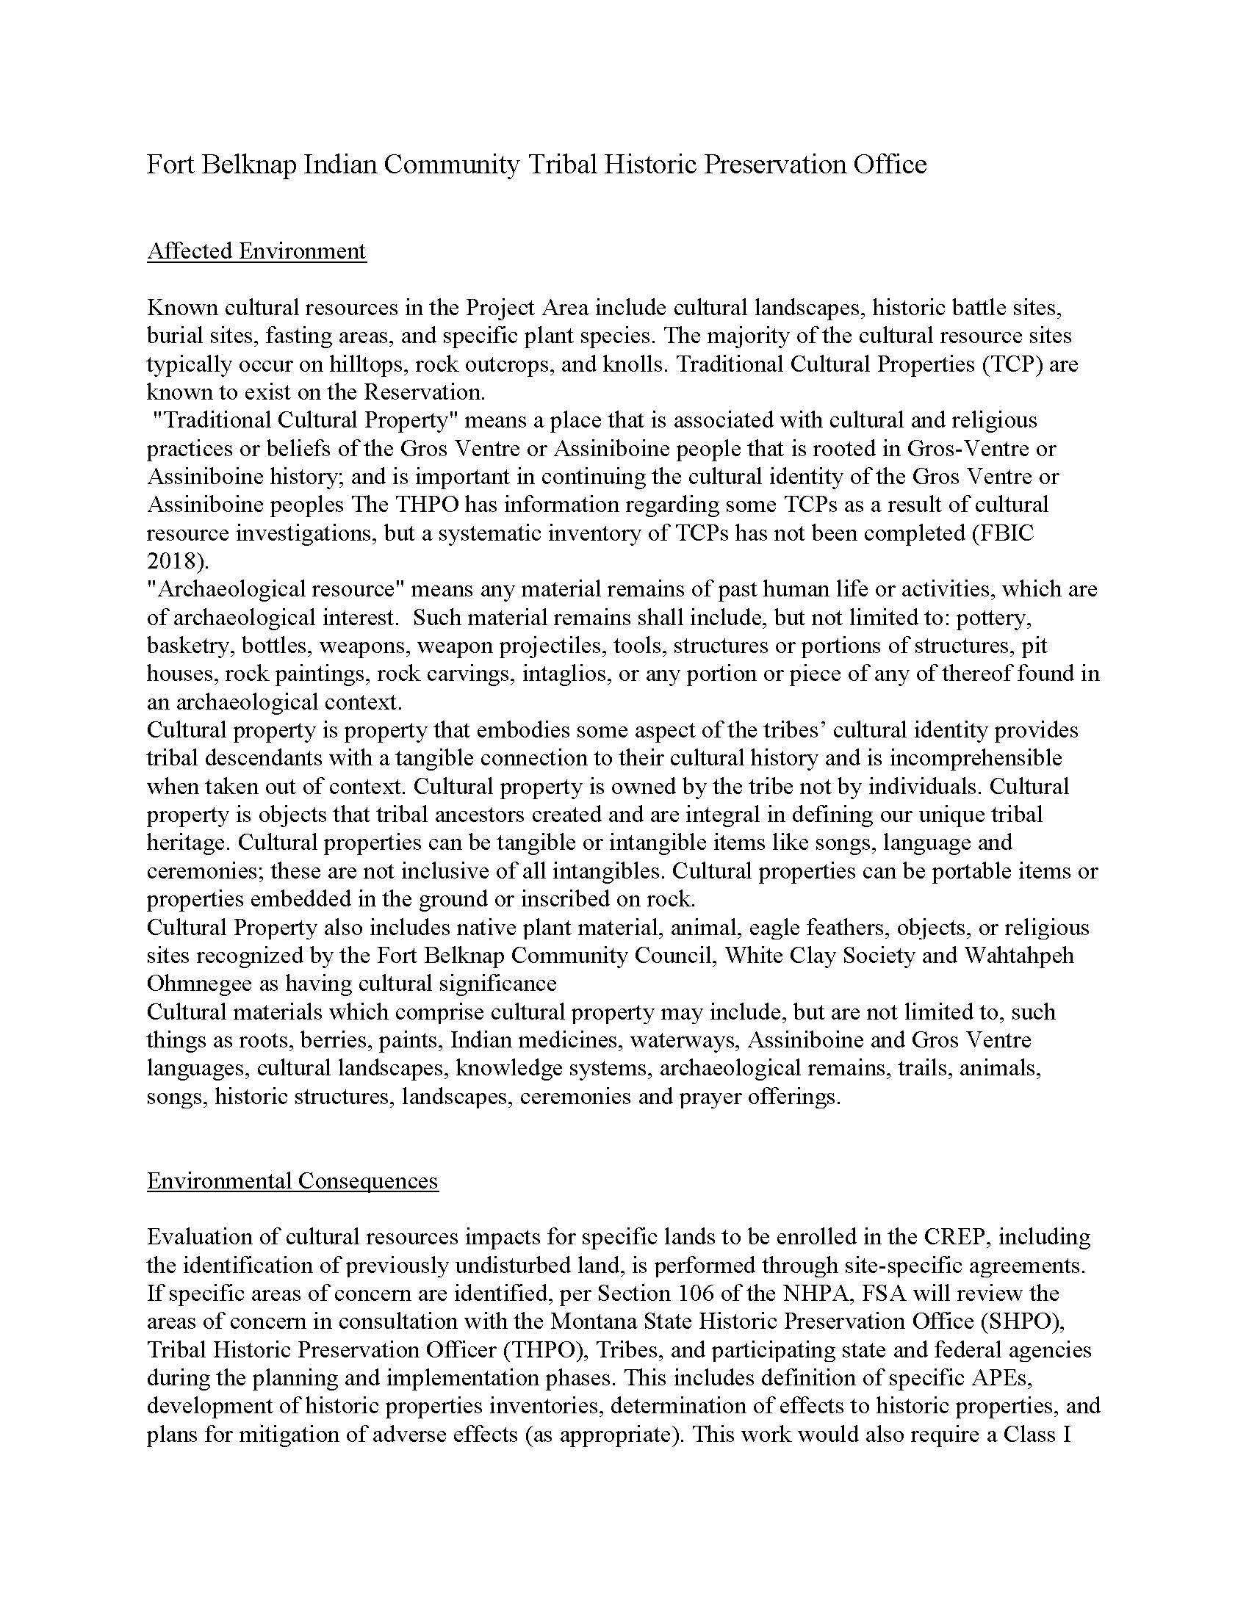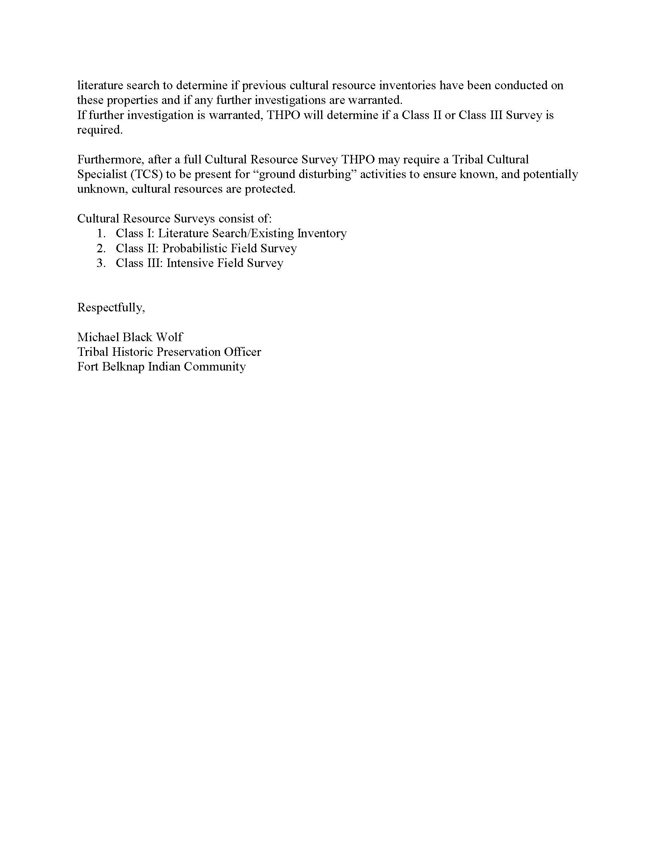
APPENDIX C
LIST OF PREPARERS AND CONTRIBUTORS
This page intentionally left blank
LIST OF PREPARERS AND CONTRIBUTORS
The following individuals assisted in the preparation of this Environmental Assessment:
Breanne Cline
Morrison-Maierle
B.S. Range and Wildlife Management
Years of Experience: 9

Lindsay Chutas
Morrison-Maierle
B.S. Geology
M.S. Earth & Ocean Sciences
Years of Experience: 16

Christine Pearcy
Morrison-Maierle
B.S. Natural Resources & Environmental Sciences
M.S. Earth Science
Years of Experience: 21

GOVERNMENT CONTRIBUTORS
The following individuals contributed to this Environmental Assessment:
Table C-1. List of Government Contributors
Attendee | Affiliation | Title
Kyle Stiffarm | FBIC | Tribal/Federal Agricultural Liason
Blake Stiffarm | FBIC | Gros Ventre Representative - Land Chair
Tevin Messerly | FBIC | Tribal Wildlife Biologist
Michael Black Wolf | FBIC | THPO
Emma Filesteel | FBIC | THPO
Patrick Lewis | FSA | CRP/CREP Specialist for the Western States
Alexander Dubish | FSA | State Environmental Coordinator
FBIC = Fort Belknap Indian Community; FSA = Farm Service Agency

