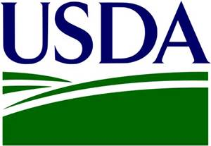
We want your spectacular photographs of Oregon agriculture!
We are excited to announce Oregon FSA’s first annual photo contest to showcase your passion and commitment to agriculture. The photo contest begins today, June 4 and runs through August 8, 2018, and is open to all Oregon FSA employees, Oregon producers, farmers, and ranchers.
For our first photo contest, we’ve come up with four photo categories: Agriculture Landscape, People in Agriculture, A Rural Workday, and Agricultural Animals or Crops, and of course, all photos must represent and exemplify safe farming practices. We are looking for your recent photos taken in Oregon that best represent these categories. Our State Committee members will judge the photos during our August State Committee meeting. The top three finalist photos will be selected from each Oregon FSA county office, and one winner will then be selected from each county office.
The selected photos will be included in our new 2019 Oregon FSA Important Dates calendar, as well as displayed in our county offices, and posted on Oregon FSA’s external website. Also, FSA’s Office of External Affairs asks that all states help rebuild their photo library. All photos submitted during the contest will be added to the photo library for future use in FSA articles, publications and outreach.
Submitting a photo entry is easy! The flyer, entry form, and consent/release form (FSA-463), are available for our external customers at https://www.fsa.usda.gov/state-offices/Oregon/index, and internally on the Oregon FSA SharePoint site/Outreach/2018 Photo Contest folder. Submit each entry by e-mail to Susan.Riffel@or.usda.gov.
We are so excited to have this opportunity to showcase Oregon agriculture and look forward to seeing all of your great photo submissions!

Peggy S. Browne
State Executive Director
Oregon Farm Service Agency

