FSA Length of Service Awards Selection

Please select one of the items listed here, fill in the information below, and send to your Servicing Personnel Office.
Name (as you want it to appear on the certificate): __________________________________________________________
Warehouse Item # ____________
Division, Branch, and Section _________________________________
Room # __________ Phone # _________________________________
Number of Years Service | Keepsake | Warehouse Item Number | Item
5, 10, 15, or 20 | Presidential Mug | 835 | 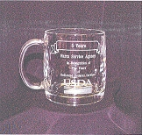
5, 10, 15, or 20 | Business Card Paperweight | 836 | 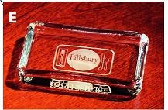
5, 10, 15, or 20 | Card Holder | 844 | 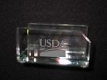
5, 10, 15, or 20 | Marble Card Holder | 847 | 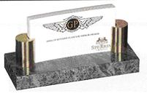
5, 10, 15, or 20 | Memo Clip | 848 | 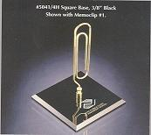
5, 10, 15, or 20 | Jade Glass Pen with Stand | 849 | 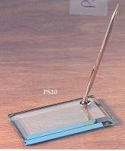
5, 10, 15, or 20 | Letter Opener with Slip Case | 853 | 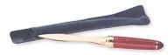
5, 10, 15, or 20 | Flashlight & Keychain with Case | 854 | 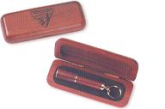
5, 10, 15, or 20 | Business Card Holder with Lid | 855 | 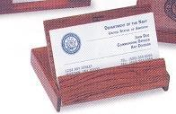
5, 10, 15, or 20 | Ballpoint Pen/Pencil Set with Case | 856 | 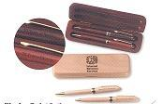
*5 years | (5 yrs engraved) Crystal Mug | 649 | Same as  Item #835
*10 years | (10 yrs engraved) Paper Weight | 650 | Picture Not available
25, 30, 35, or 40 | Crystal Gibraltar | 838 | 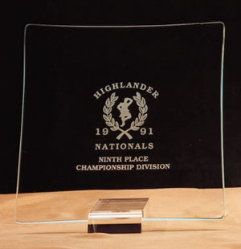
25, 30, 35, or 40 | Jade Angle Clock | 839 | 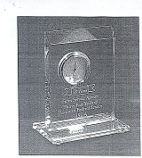
25, 30, 35, or 40 | Picture Frame with Photo | 840 | 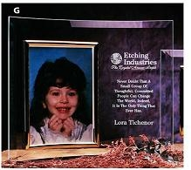
25, 30, 35, or 40 | Crystal Two Pen Holder | 841 | 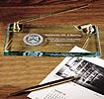
25, 30, 35, or 40 | Dove Ice Server | 842 | 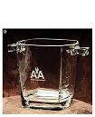
25, 30, 35, or 40 | Baltic Lecturn Set | 843 | 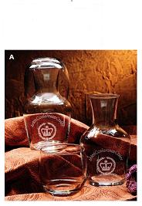
25, 30, 35, or 40 | Beveled Crescent | 845 | 
25, 30, 35, or 40 | Golosina Crystal Jar with Lid | 851 | 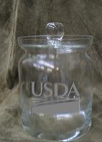
25, 30, 35, or 40 | Balmaral Crystal Vase | 852 | 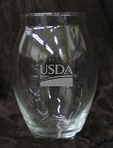
25, 30, 35, or 40 | Planet Desk Clock | 857 | 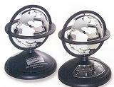
25, 30, 35, or 40 | Calculator | 858 | 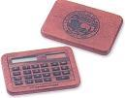
25, 30, 35, or 40 | Frosted Globe Paperweight | 859 | 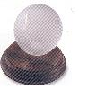
*25 years | (25 years engraved) Crystal Tray | 653 | Same as  Item# 838
*30 years | (30 years engraved) Coasters | 654 | Picture Not Available
*35 years | (35 years engraved) Clock Plaque | 655 | Same as  Item #839
*40 years | (40 years engraved) Crystal Picture Frames | 656 | Same as  Item #840

*Per PM Notice 2549, Limited stock available.
*Offered on a first-come, first-served bases. Item will not be reordered.

