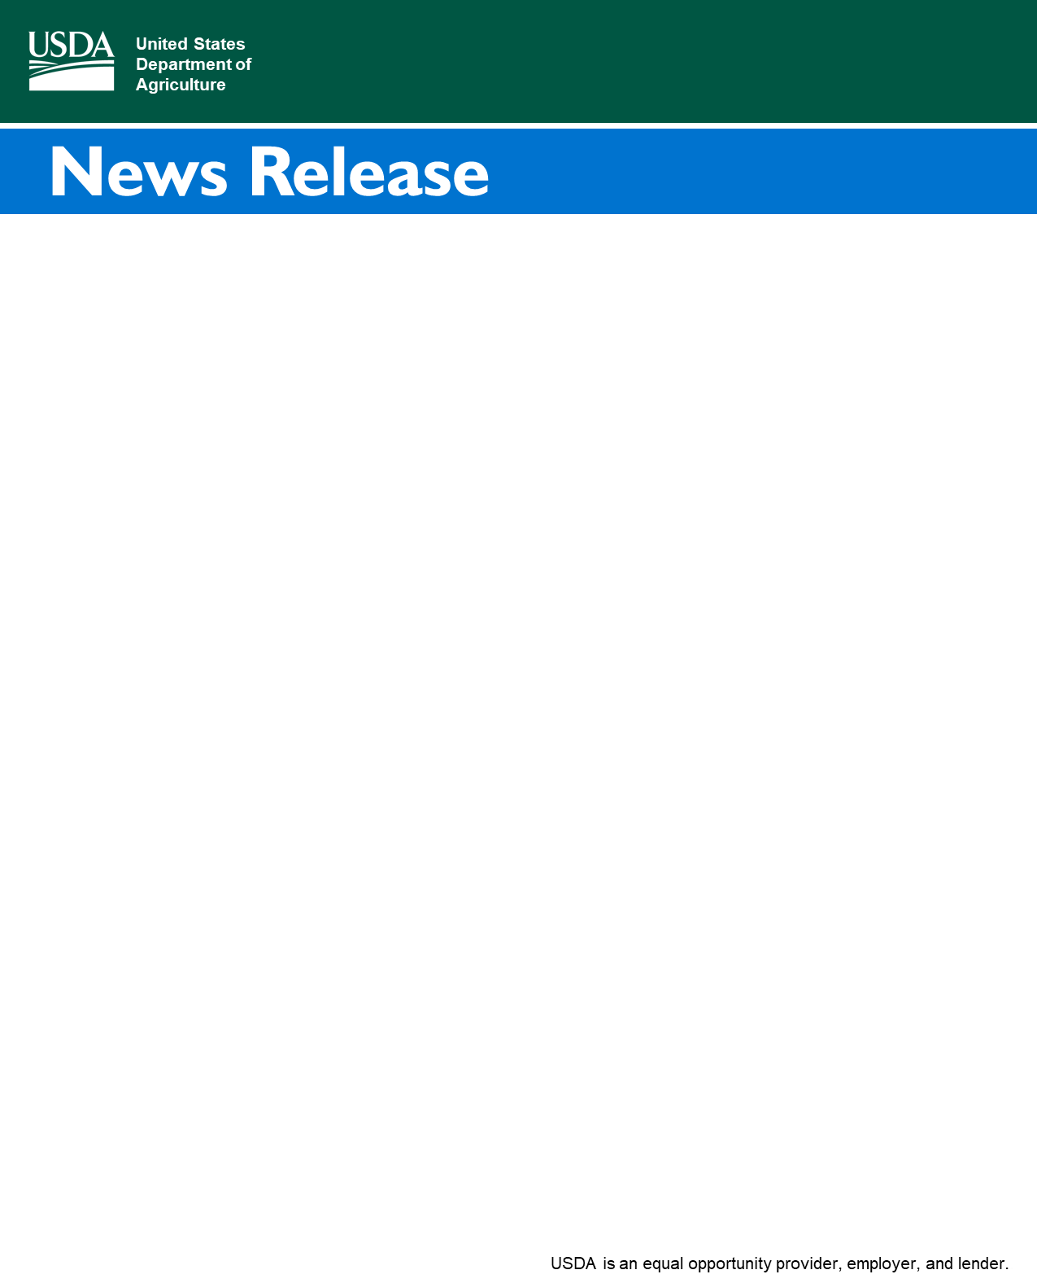

Contact:

[FPAC.BC.Press@usda.gov](mailto:FPAC.BC.Press@usda.gov)

1400 Independence Ave. SW

Washington, DC 20250

Farm Service Agency

**2021 Farm Service Agency County Committee Elections Underway**

*Ballots To Be Mailed to Eligible Voters Beginning This Week*

**WASHINGTON, Nov. 5, 2021**— The U.S. Department of Agriculture (USDA) will begin mailing ballots this week for the Farm Service Agency (FSA) county and urban county committee elections to all eligible agricultural producers and private landowners across the country. Elections are occurring in certain Local Administrative Areas (LAA) for these committee members who make important decisions about how federal farm programs are administered locally. To be counted, producers and landowners must return ballots to their local FSA county office or be postmarked by Dec. 6, 2021.

“Now is your opportunity to elect fellow farmers and ranchers in your community to serve on the local county committee,” said FSA Administrator Zach Ducheneaux. “These committees are a critical piece to the work we do by providing knowledge and judgment as decisions are made about the services we provide. Your voice and vote matters.”

Producers must participate or cooperate in an FSA program to be eligible to vote in the county committee election. A cooperating producer is someone who has provided information about their farming or ranching operation but may not have applied or received FSA program benefits. Also, for County Committee elections, producers who are not of legal voting age, but supervise and conduct the farming operations of an entire farm, are eligible to vote.

Producers can find out if their LAA is up for election and if they are eligible to vote by contacting their local FSA county office. Eligible voters who do not receive a ballot in the mail can request one from their local FSA county office. To find your local USDA Service Center, visit [farmers.gov/service-locator](https://www.farmers.gov/working-with-us/service-center-locator). Visit [fsa.usda.gov/elections](https://www.fsa.usda.gov/news-room/county-committee-elections/index) for more information.

**About Committees**

Each committee has from three to 11 elected members who serve three-year terms of office, and at least one seat representing an LAA is up for election each year. Newly elected committee members will take office Jan. 1, 2022.

**Urban and Suburban County Committees**

Ballots to elect urban committee members were sent beginning Nov. 1, 2021. These elections will serve local urban producers in the same jurisdiction. A fact sheet on the urban county committee election and a list of eligible cities can be found at [fsa.usda.gov/elections](https://www.fsa.usda.gov/news-room/county-committee-elections/index).

The 2018 Farm Bill directed USDA to form urban county committees as well as make other advancements related to urban agriculture, including the establishment of the Office of Urban Agriculture and Innovative Production. Urban county committees will work to encourage and promote urban, indoor and other emerging agricultural production practices. Committee members will provide outreach to ensure urban producers understand USDA programs and serve as the voice of other urban producers. Additionally, the new county committees may address areas such as food access, community engagement, support of local activities to promote and encourage community compost and food waste reduction. Learn more at [farmers.gov/urban](http://www.farmers.gov/urban).

**More Information**

USDA touches the lives of all Americans each day in so many positive ways. In the Biden-Harris Administration, USDA is transforming America’s food system with a greater focus on more resilient local and regional food production, fairer markets for all producers, ensuring access to healthy and nutritious food in all communities, building new markets and streams of income for farmers and producers using climate smart food and forestry practices, making historic investments in infrastructure and clean energy capabilities in rural America, and committing to equity across the Department by removing systemic barriers and building a workforce more representative of America. To learn more, visit [www.usda.gov](http://www.usda.gov/).

#

*USDA is an equal opportunity provider, employer, and lender.*