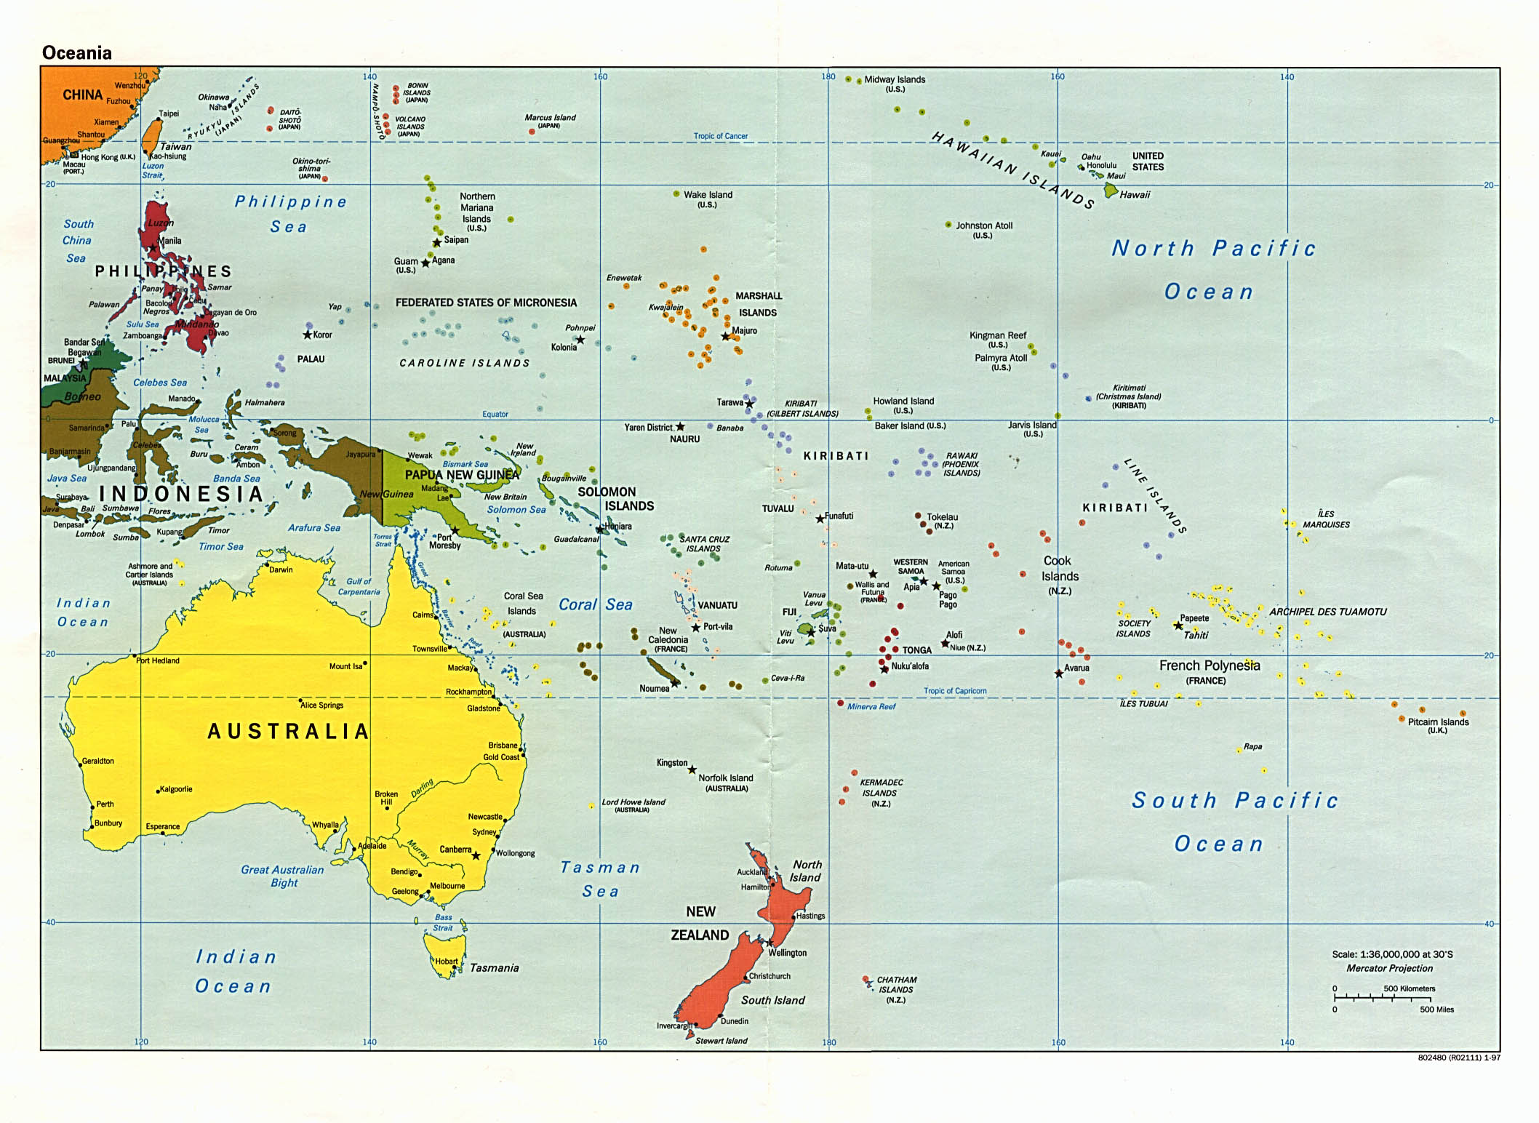
Service Area:
Hawai'i State and Pacific Basin FSA

